Tab 1

01_ambiguity dataset +trees

gpt-3.5-turbo-012

amb_01.txt gpt-3.5-turbo-0125 temperature=1.0
PROMPT Consider the sentence below. Is it syntactically ambiguous If so, provide code for syntactic trees representing each possible parse of the sentence that can be rendered with LaTeX's forest package. Assume X-bar theory.
A passer-by has heard her pump.
REPLY Yes, the sentence is syntactically ambiguous.

Here are two possible parses for the sentence

Parse 1
\begin{forest}
[X'
[Noun
[D
[A]
]
[Noun
[passer]
]
[P]
]
[X
[V'
[V
[heard]
]
[Noun
[D
[her]
]
[Noun
[pump]
]
]
]
]
]
\end{forest}
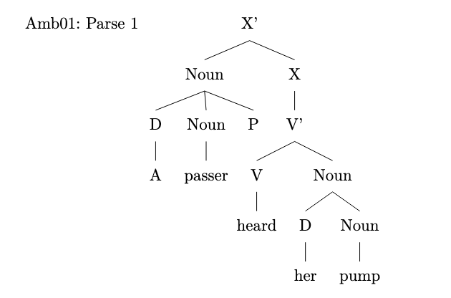
Parse 2
\begin{forest}
[X'
[Noun
[D
[A]
]
[Noun
[passer]
]
]
[X
[V'
[V
[has]
]
[Noun
[D
[her]
]
[Noun
[pump]
]
]
]
]
[P]
[V'
[V
[heard]
]
]
]
\end{forest}
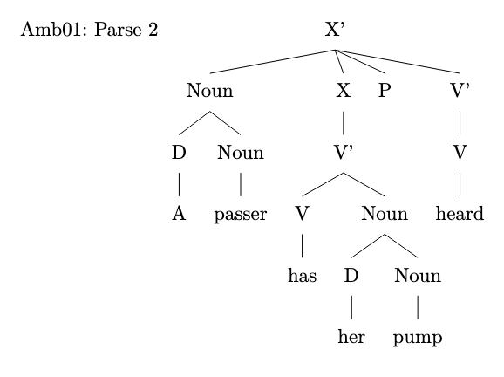

amb_02.txt gpt-3.5-turbo-0125 temperature=1.0
PROMPT Consider the sentence below. Is it syntactically ambiguous If so, provide code for syntactic trees representing each possible parse of the sentence that can be rendered with LaTeX's forest package. Assume X-bar theory.
The opposite team had her duck.
REPLY Yes, the sentence is syntactically ambiguous. It can be interpreted in two different ways

1. The opposite team had her duck (as in a bird)

\begin{forest}
[S
[NP [D [The]] [N [opposite team]]]
[VP [V [had]] [NP [D [her]] [N [duck]]]]
]
\end{forest}
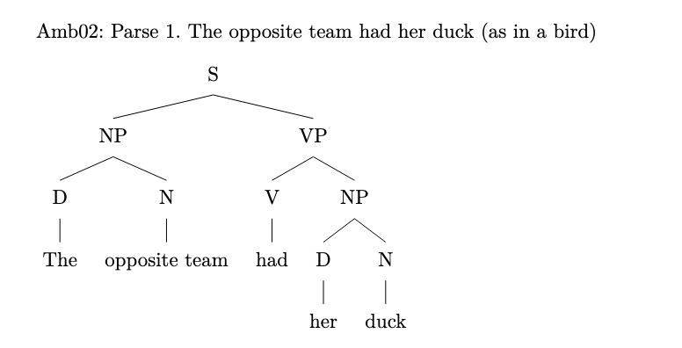
2. The opposite team had her duck (as in crouch or bend down quickly)

\begin{forest}
[S
[NP [D [The]] [N [opposite team]]]
[VP [V [had]] [NP [D [her]] [N [duck]]]]
]
\end{forest}
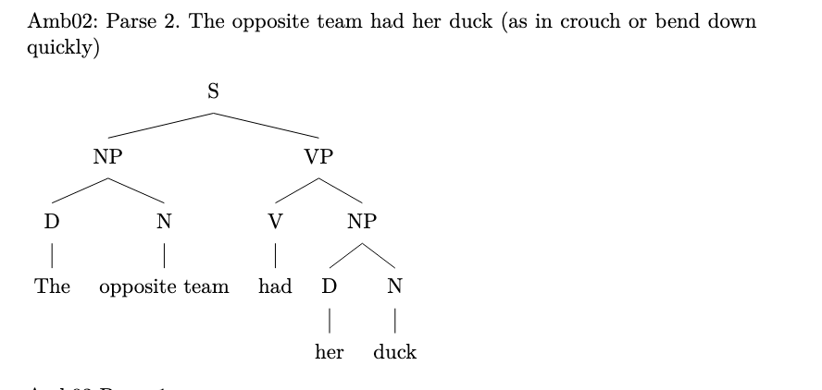

amb_03.txt gpt-3.5-turbo-0125 temperature=1.0
PROMPT Consider the sentence below. Is it syntactically ambiguous If so, provide code for syntactic trees representing each possible parse of the sentence that can be rendered with LaTeX's forest package. Assume X-bar theory.
Eliza wanted her cast out.
REPLY Yes, the sentence Eliza wanted her cast out. is syntactically ambiguous.

Here are the two possible parses of the sentence

1. Parse 1
\begin{forest}
[S
[NP [N [Eliza]]]
[VP
[V [wanted]]
[NP
[Det [her]]
[N [cast]]]
[Prt [out]]]
\end{forest}
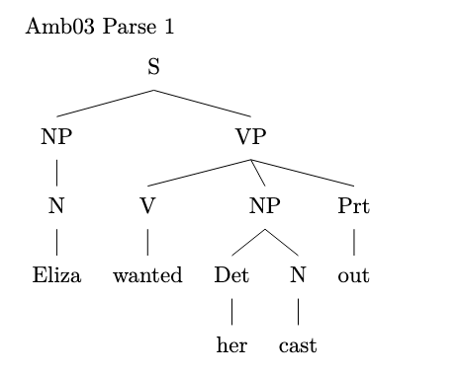
2. Parse 2
\begin{forest}
[S
[NP [N [Eliza]]]
[VP
[V [wanted]]
[NP
[Det [her]]
[N
[N [cast]]
[Prt [out]]]]]
\end{forest}
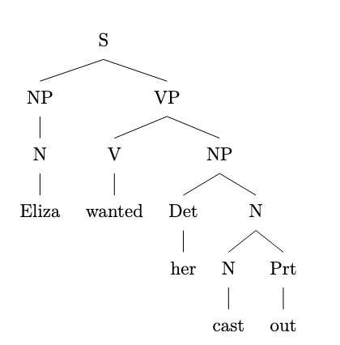

amb_04.txt gpt-3.5-turbo-0125 temperature=1.0
PROMPT Consider the sentence below. Is it syntactically ambiguous If so, provide code for syntactic trees representing each possible parse of the sentence that can be rendered with LaTeX's forest package. Assume X-bar theory.
Tobias kept her wound up.
REPLY Yes, the sentence Tobias kept her wound up is syntactically ambiguous.

Possible parses
1. [Tobias [kept [her [wound [up]]]]]

\begin{forest}
[X$'$
[X
[Tobias]
]
[ZP
[kept]
[YP
[her]
[ZP
[wound]
[up]
]
]
]
]
\end{forest}
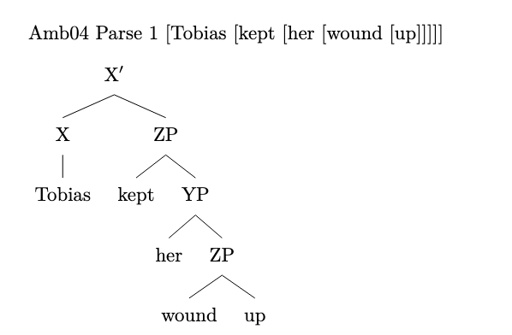
2. [Tobias [kept [her] [wound [up]]]]

\begin{forest}
[X$'$
[X
[Tobias]
]
[ZP
[kept]
[YP
[her]
]
[ZP
[wound]
[up]
]
]
]
\end{forest}
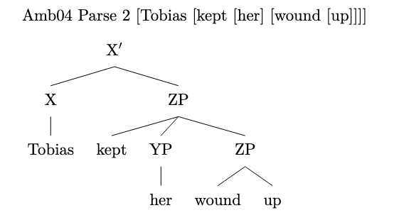

amb_05.txt gpt-3.5-turbo-0125 temperature=1.0
PROMPT Consider the sentence below. Is it syntactically ambiguous If so, provide code for syntactic trees representing each possible parse of the sentence that can be rendered with LaTeX's forest package. Assume X-bar theory.
The new director has had her set.
REPLY Yes, the sentence is syntactically ambiguous. It can be interpreted in two ways

1. The new director [has [had [her set]]]
2. The new director [has [had her] [set]]

Here is the LaTeX code for rendering the two possible parses with the forest package

1. The new director [has [had [her set]]]

documentclass{article}
usepackage[linguistics]{forest}

begin{document}

\begin{forest}
[S
[NP
[Det [The]]
[N [new director]]
]
[VP
[Aux [has]]
[VP
[V [had]]
[NP [Pro [her]]]
[N [set]]
]
]
]
\end{forest}

end{document}
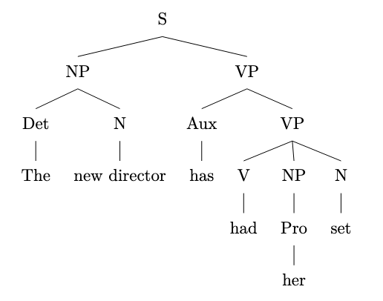
2. The new director [has [had her] [set]]

documentclass{article}
usepackage[linguistics]{forest}

begin{document}

\begin{forest}
[S
[NP
[Det [The]]
[N [new director]]
]
[VP
[Aux [has]]
[VP
[V [had]]
[NP [Pro [her]]]
]
[NP [N [set]]]
]
]
\end{forest}

end{document}
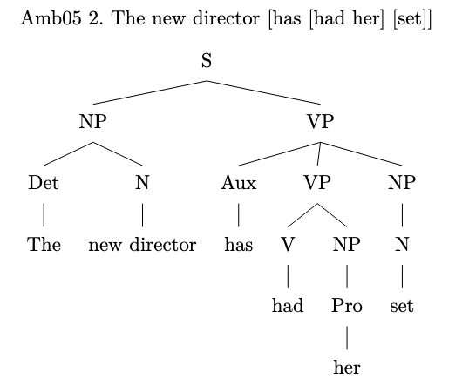

amb_06.txt gpt-3.5-turbo-0125 temperature=1.0
PROMPT Consider the sentence below. Is it syntactically ambiguous If so, provide code for syntactic trees representing each possible parse of the sentence that can be rendered with LaTeX's forest package. Assume X-bar theory.
Without her calling, they will fail.
REPLY Yes, the sentence Without her calling, they will fail. is syntactically ambiguous. It can be interpreted in two ways

1. Without [her calling], they will fail.
2. Without her [calling], they will fail.

Here are the code for the two possible syntactic trees in LaTeX using the forest package

1. Without [her [calling]], they will fail.

\begin{forest}
[TP
[AdvP
[Without]
[DP
[her]
[NP
[V-ing
[calling]
]
]
]
]
[T'
[T
[will]
]
[VP
[V
[fail]
]
]
]
]
\end{forest}
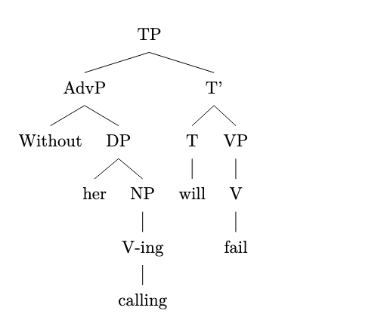
2. Without [her calling], they will fail.

\begin{forest}
[TP
[AdvP
[Without]
[DP
[NP
[her]
[V-ing
[calling]
]
]
]
]
[T'
[T
[will]
]
[VP
[V
[fail]
]
]
]
]
\end{forest}
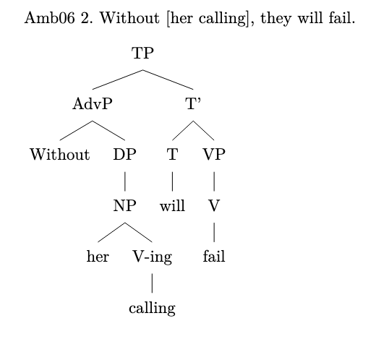

amb_07.txt gpt-3.5-turbo-0125 temperature=1.0
PROMPT Consider the sentence below. Is it syntactically ambiguous If so, provide code for syntactic trees representing each possible parse of the sentence that can be rendered with LaTeX's forest package. Assume X-bar theory.
Her mom was really upset by her whining.
REPLY Yes, the sentence is syntactically ambiguous. It can be interpreted in two ways

1. Possessor-Subject interpretation
(S (NP (PossP (Poss (Her)) (NP (N (mom)))) (VP (V (was)) (AdvP (Adv (really)) (AdjP (Adj (upset)) (PP (P (by)) (NP (PossP (Poss (her)) (NP (N (whining)))))))))

2. Possessive modifier interpretation
(S (NP (PossP (Poss (Her)) (NP (N (mom)))) (VP (V (was)) (AdvP (Adv (really)) (AdjP (Adj (upset)) (PP (P (by)) (NP (PossP (Poss (her)) (NP (N (whining)))))))))

Here are the LaTeX code for each parse tree

1. Possessor-Subject interpretation
\begin{forest}
[S [NP [PossP [Poss [Her]] [NP [N [mom]]]] [VP [V [was]] [AdvP [Adv [really]] [AdjP [Adj [upset]] [PP [P [by]] [NP [PossP [Poss [her]] [NP [N [whining]]]]]]]]]
\end{forest}
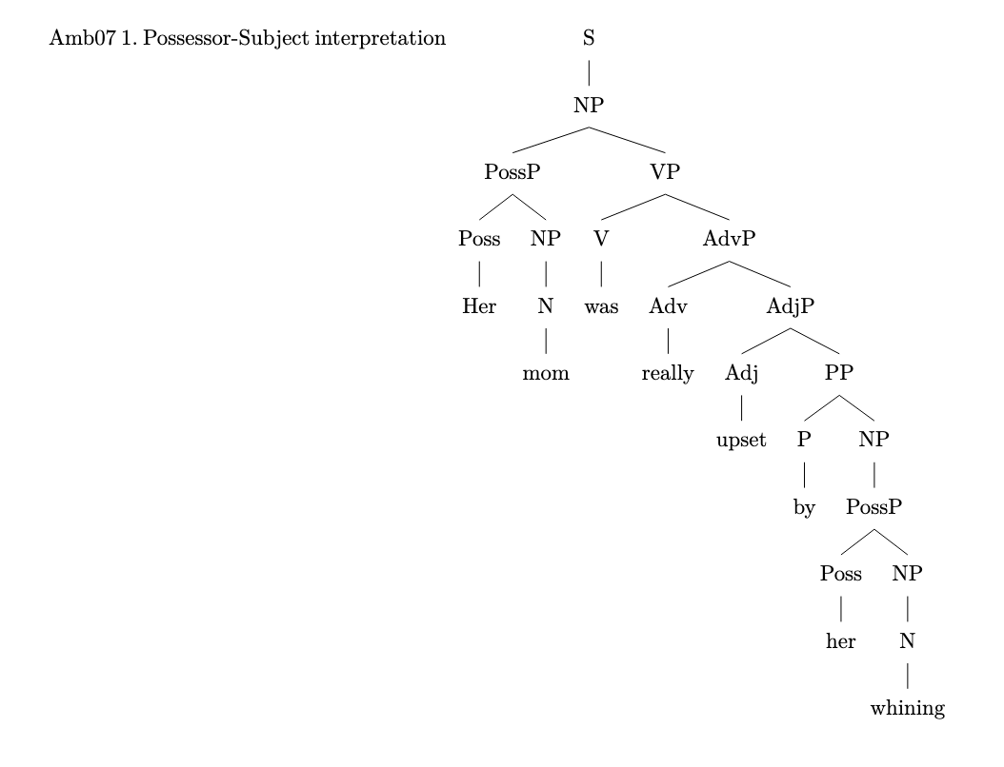
2. Possessive modifier interpretation
\begin{forest}
[S [NP [PossP [Poss [Her]] [NP [N [mom]]]] [VP [V [was]] [AdvP [Adv [really]] [AdjP [Adj [upset]] [PP [P [by]] [NP [PossP [Poss [her]] [NP [N [whining]]]]]]]]]
\end{forest}
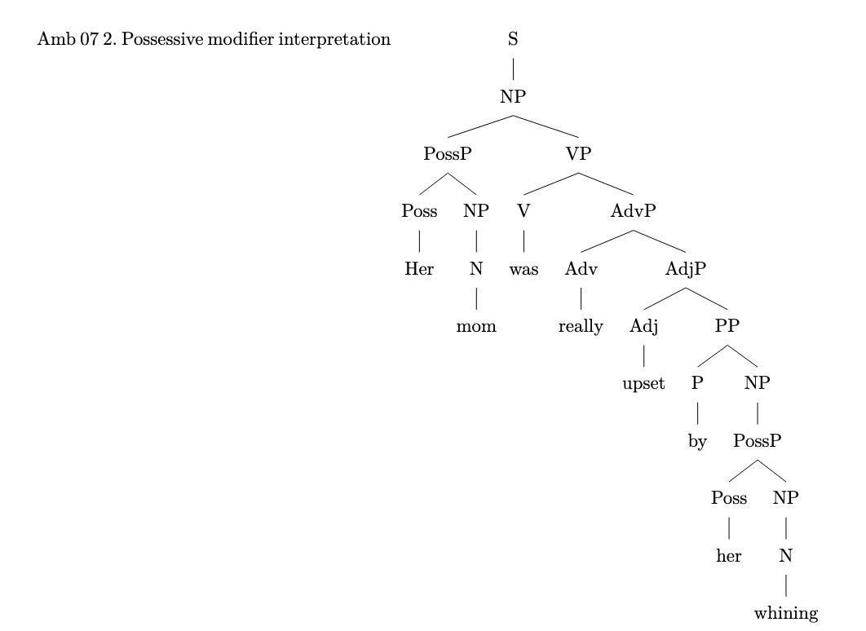

amb_08.txt gpt-3.5-turbo-0125 temperature=1.0
PROMPT Consider the sentence below. Is it syntactically ambiguous If so, provide code for syntactic trees representing each possible parse of the sentence that can be rendered with LaTeX's forest package. Assume X-bar theory.
We'll meet at the Old Stone Hotel.
REPLY Yes, the sentence is syntactically ambiguous because the prepositional phrase at the Old Stone Hotel can be attached to either meet or we'll.

1. We'll [meet [at the Old Stone Hotel]]
2. [We'll meet] [at the Old Stone Hotel]

Here is the code for the two possible parses

1.
\begin{forest}
[S
[NP [We'll]]
[VP
[V [meet]]
[PP
[P [at]]
[NP [D [the] [N [Old] [Stone] [Hotel]]]]
]
]
]
\end{forest}
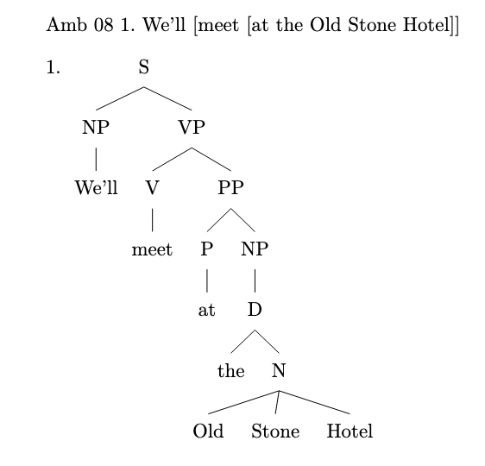
2.
\begin{forest}
[S
[NP [We'll] [meet]]
[PP
[P [at]]
[NP [D [the] [N [Old] [Stone] [Hotel]]]]
]
]
\end{forest}
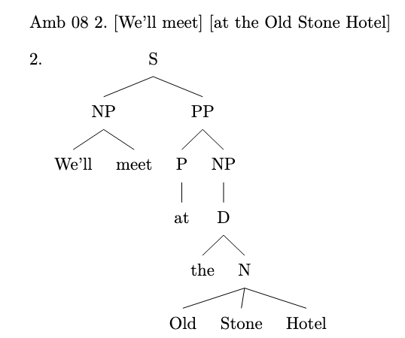

amb_09.txt gpt-3.5-turbo-0125 temperature=1.0
PROMPT Consider the sentence below. Is it syntactically ambiguous If so, provide code for syntactic trees representing each possible parse of the sentence that can be rendered with LaTeX's forest package. Assume X-bar theory.
The wet rodent lab has had a leak.
REPLY Yes, the sentence is syntactically ambiguous.

Possible parses

1. The wet [rodent [lab [has [had a leak]]]]

\begin{forest}
[TP
[DP [D [The]] [NP [Adj [wet]] [N [rodent]]]]
[T' [T [lab]] [VP [V [has]] [VP [V [had]] [DP [D [a]] [NP [N [leak]]]]]]]
]
\end{forest}
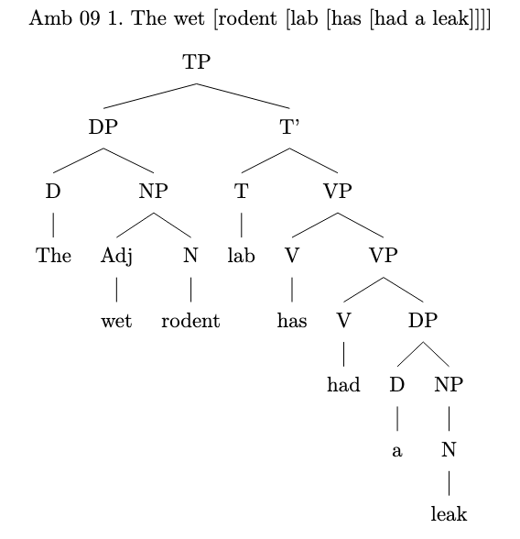
2. The wet [rodent [lab]] [has [had [a leak]]]

\begin{forest}
[TP
[DP [D [The]] [NP [Adj [wet]] [N [rodent]]] [T' [T [lab]]]]
[T' [T [has]] [VP [V [had]] [DP [D [a]] [NP [N [leak]]]]]]
]
\end{forest}
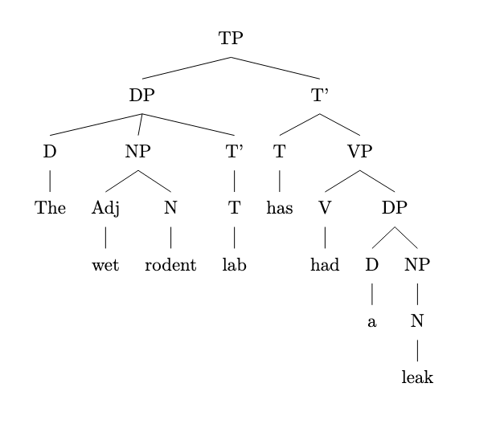

amb_10.txt gpt-3.5-turbo-0125 temperature=1.0
PROMPT Consider the sentence below. Is it syntactically ambiguous If so, provide code for syntactic trees representing each possible parse of the sentence that can be rendered with LaTeX's forest package. Assume X-bar theory.
The new energy theorem confuses me.
REPLY Yes, the sentence is syntactically ambiguous. It can be interpreted in two ways
1. The new energy theorem confuses me.
2. The new energy theorem confuses me.

Here are the syntactic trees representing each possible parse of the sentence using LaTeX's forest package

Parse 1
\begin{forest}
[S
[NP [Det [The]] [Adj [new]] [N [energy] [N [theorem]]]]
[VP [V [confuses]] [NP [me]]]
]
\end{forest}
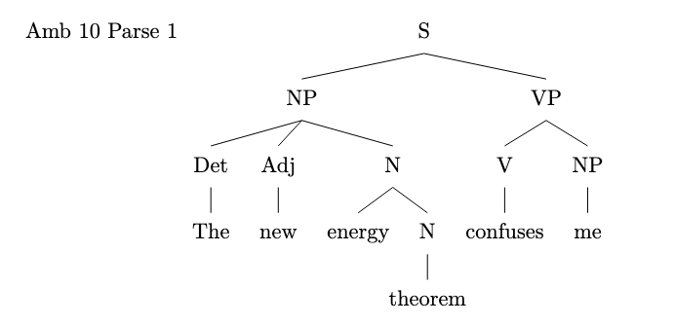
Parse 2
\begin{forest}
[S
[NP [Det [The]] [Adj [new]] [N [energy]] [N [theorem]]]
[VP [V [confuses]] [NP [me]]]
]
\end{forest}
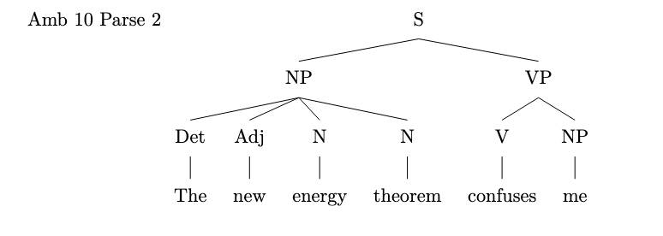

amb_11.txt gpt-3.5-turbo-0125 temperature=1.0
PROMPT Consider the sentence below. Is it syntactically ambiguous If so, provide code for syntactic trees representing each possible parse of the sentence that can be rendered with LaTeX's forest package. Assume X-bar theory.
Less colorful clothing is acceptable at this party.
REPLY Yes, the sentence is syntactically ambiguous. It can be parsed as either Less colorful clothing being the subject of the sentence, or less colorful modifying clothing.

1. Less colorful clothing [NP [AdjP Less colorful] [N clothing]] [VP is acceptable at this party]
2. Less [AdjP less] [NP [Adj colorful] [N clothing]] [VP is acceptable at this party]

Below are the syntax trees for each possible parse

documentclass{article}
usepackage{forest}

begin{document}

\begin{forest}
[S
[NP
[AdjP
[Adj
[Less]
]
[N
[clothing]
]
]
]
[VP
[is]
[AdjP
[Adj
[acceptable]
]
[PP
[P
[at]
]
[NP
[this party]
]
]
]
]
]
\end{forest}
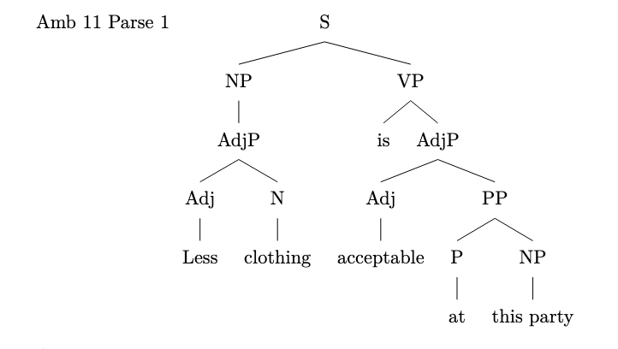
\begin{forest}
[S
[NP
[AdjP
[Adj
[Less]
]
[NP
[Adj
[colorful]
]
[N
[clothing]
]
]
]
]
[VP
[is]
[AdjP
[Adj
[acceptable]
]
[PP
[P
[at]
]
[NP
[this party]
]
]
]
]
]
\end{forest}

end{document}
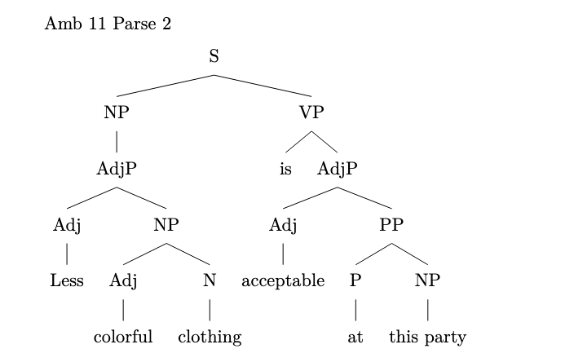

amb_12.txt gpt-3.5-turbo-0125 temperature=1.0
PROMPT Consider the sentence below. Is it syntactically ambiguous If so, provide code for syntactic trees representing each possible parse of the sentence that can be rendered with LaTeX's forest package. Assume X-bar theory.
There are more comfortable seats in the lobby.
REPLY Yes, the sentence is syntactically ambiguous. One possible interpretation is that the seats in the lobby are more comfortable compared to other seats elsewhere. Another possible interpretation is that there are a greater number of comfortable seats in the lobby compared to elsewhere.

Here are the syntactic trees representing each possible parse of the sentence

1. Seats in the lobby are more comfortable
```
\begin{forest}
[S
[NP [N [seats]] [PP [P [in]] [NP [D [the]] [N [lobby]]]]]
[VP [V [are]] [AP [Deg [more]] [A [comfortable]]]]
]
\end{forest}
```
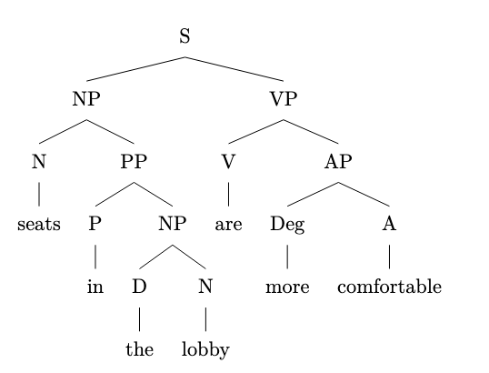
2. More comfortable seats in the lobby
```
\begin{forest}
[S
[NP [Deg [More]] [AP [A [comfortable]]] [N [seats]]]
[PP [P [in]] [NP [D [the]] [N [lobby]]]]
]
\end{forest}
```
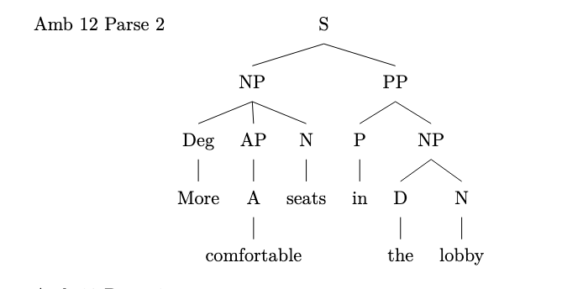

amb_13.txt gpt-3.5-turbo-0125 temperature=1.0
PROMPT Consider the sentence below. Is it syntactically ambiguous If so, provide code for syntactic trees representing each possible parse of the sentence that can be rendered with LaTeX's forest package. Assume X-bar theory.
Eric sent his employee agreements.
REPLY Yes, the sentence Eric sent his employee agreements is syntactically ambiguous because it could be interpreted in two different ways

1. Eric sent agreements to his employee.
2. Eric sent agreements that belong to his employee.

Here are the syntactic trees representing each possible parse of the sentence

1. Eric sent [his [employee [agreements]]]
[
\begin{forest}
[VP
[NP [N' [N [Eric]]]]
[V' [V [sent]]
[NP [D [his]]
[N' [N [employee]]
[N' [agreements]]]]]
\end{forest}
]

AMB 13 PARSE 1 FAILED TO COMPILE. ADDED ONE SQUARE BRACKET:
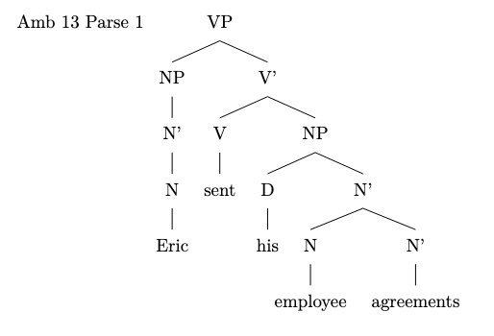
2. Eric sent [his [employee agreements]]
[
\begin{forest}
[VP
[NP [N' [N [Eric]]]]
[V' [V [sent]]
[NP [D [his]]
[N' [N [employee agreements]]]]]
\end{forest}
]
AMB 13 PARSE 2 FAILED TO COMPILE. ADDED ONE SQUARE BRACKET:
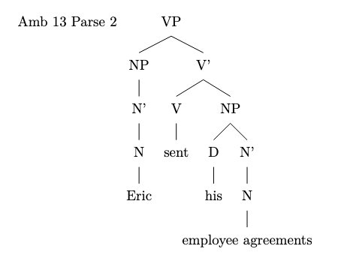

amb_14.txt gpt-3.5-turbo-0125 temperature=1.0
PROMPT Consider the sentence below. Is it syntactically ambiguous If so, provide code for syntactic trees representing each possible parse of the sentence that can be rendered with LaTeX's forest package. Assume X-bar theory.
Mary Brown read the monster tales.
REPLY Yes, the sentence Mary Brown read the monster tales is syntactically ambiguous because it can be parsed in two different ways

1. Mary Brown [read [the monster tales]]
2. [Mary Brown read] [the monster tales]

Here are the two possible syntactic trees using X-bar theory

\begin{forest}
[S
[NP [N Mary Brown, name]]
[VP
[V read]
[NP [Det the] [N monster tales]]
]
]
\end{forest}
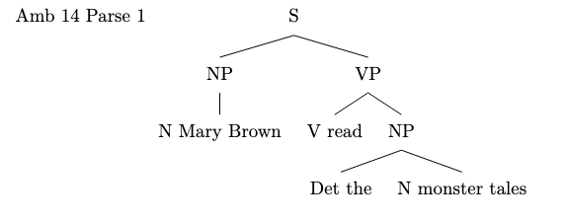
\begin{forest}
[S
[NP [N Mary Brown, name]]
[VP [V read] [NP [Det the] [N monster tales]]]
]
\end{forest}
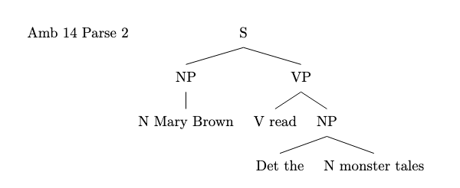

amb_15.txt gpt-3.5-turbo-0125 temperature=1.0
PROMPT Consider the sentence below. Is it syntactically ambiguous If so, provide code for syntactic trees representing each possible parse of the sentence that can be rendered with LaTeX's forest package. Assume X-bar theory.
Rowan fed his pet chicken.
REPLY Yes, the sentence Rowan fed his pet chicken. is syntactically ambiguous. It can be interpreted in two ways

1. Rowan fed his (pet chicken).
2. Rowan (fed his pet) chicken.

Here are the code for the two possible syntactic trees in LaTeX using the forest package

1. Rowan fed his (pet chicken)

\begin{forest}
[S
[NP [N [Rowan]]]
[VP
[V [fed]]
[NP [D [his]] [N [pet chicken]]]
]
]
\end{forest}
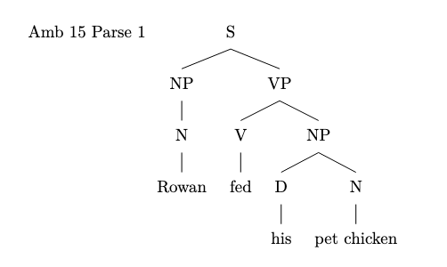
2. Rowan (fed his pet) chicken

\begin{forest}
[S
[NP [N [Rowan]]]
[VP
[V [fed]]
[NP
[D [his]]
[N [pet]]
]
[N [chicken]]
]
]
\end{forest}
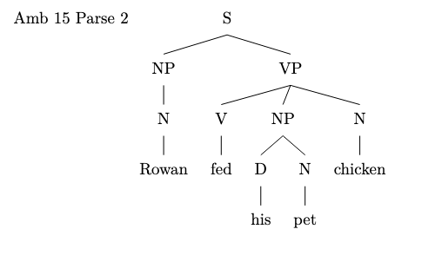

amb_16.txt gpt-3.5-turbo-0125 temperature=1.0
PROMPT Consider the sentence below. Is it syntactically ambiguous If so, provide code for syntactic trees representing each possible parse of the sentence that can be rendered with LaTeX's forest package. Assume X-bar theory.
Susanna called her friend at the hospital.
REPLY Yes, the sentence Susanna called her friend at the hospital. is syntactically ambiguous because it could mean either of the following interpretations

1. Susanna called her friend who is currently at the hospital.
2. Susanna called her friend using the phone at the hospital.

Here are the syntactic trees representing each possible parse of the sentence

1. Susanna called [her friend [at [the hospital]]]
\begin{forest}
[TP
[DP [Susanna] ]
[T$'$
[T [called] ]
[vP
[DP [her friend] ]
[v$'$
[VP
[V [at] ]
[DP [the hospital] ]
]
]
]
]
]
\end{forest}
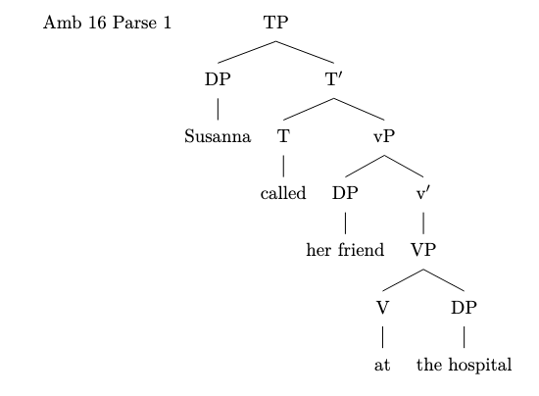
2. [Susanna [called [her friend] [at [the hospital]]]]
\begin{forest}
[TP
[DP [Susanna] ]
[T$'$
[T [called] ]
[vP
[DP [her friend] ]
[vP
[v [at] ]
[DP [the hospital] ]
]
]
]
]
\end{forest}

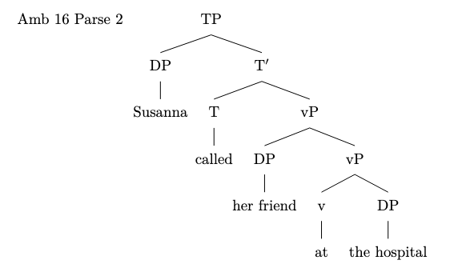

amb_17.txt gpt-3.5-turbo-0125 temperature=1.0
PROMPT Consider the sentence below. Is it syntactically ambiguous If so, provide code for syntactic trees representing each possible parse of the sentence that can be rendered with LaTeX's forest package. Assume X-bar theory.
They visited a household with a child.
REPLY Yes, the sentence They visited a household with a child. is syntactically ambiguous. It can have two possible parses based on the attachment of the prepositional phrase with a child.

1. They visited (a household) (with a child).
2. They visited ((a household) with (a child)).

Here is the code for the two possible syntactic trees representing each parse

Parse 1
\begin{forest}
[TP
[DP [They]]
[T$'$
[T [visited]]
[VP
[DP [D [a]][NP [household]]]
[PP
[P [with]]
[DP [D [a]][NP [child]]]
]
]
]
]
\end{forest}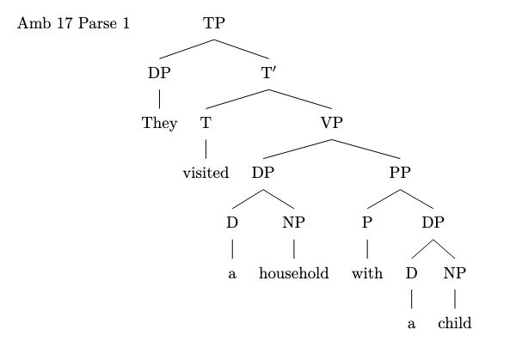

Parse 2
\begin{forest}
[TP
[DP [They]]
[T$'$
[T [visited]]
[VP
[DP [D [a]][NP [household]]]
[PP
[P [with]]
[DP [D [a]][NP [child]]]
]
]
]
]
\end{forest}
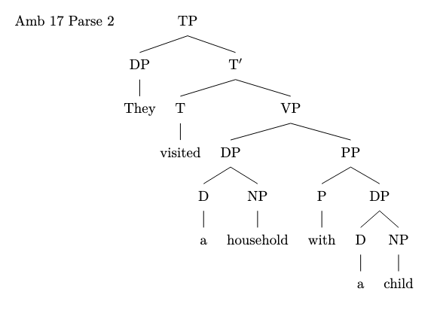

amb_18.txt gpt-3.5-turbo-0125 temperature=1.0
PROMPT Consider the sentence below. Is it syntactically ambiguous If so, provide code for syntactic trees representing each possible parse of the sentence that can be rendered with LaTeX's forest package. Assume X-bar theory.
Julius hid the presents for the children.
REPLY Yes, the sentence is syntactically ambiguous. It can be interpreted in two ways

1. Julius hid the presents that were meant for the children.
2. Julius hid the presents on behalf of the children.

Here are the code snippets for the two possible parses

1. Julius hid the presents that were meant for the children.

\begin{forest}
[S
[NP
[N
[Julius]
]
]
[VP
[V
[hid]
]
[NP
[Det
[the]
]
[N
[presents]
]
[PP
[P
[for]
]
[NP
[Det
[the]
]
[N
[children]
]
]
]
]
]
]
\end{forest}
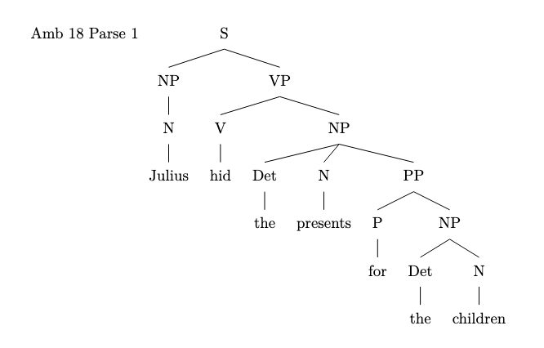
2. Julius hid the presents on behalf of the children.

\begin{forest}
[S
[NP
[N
[Julius]
]
]
[VP
[V
[hid]
]
[NP
[Det
[the]
]
[N
[presents]
]
]
[PP
[P
[for]
]
[NP
[Det
[the]
]
[N
[children]
]
]
]
]
]
\end{forest}

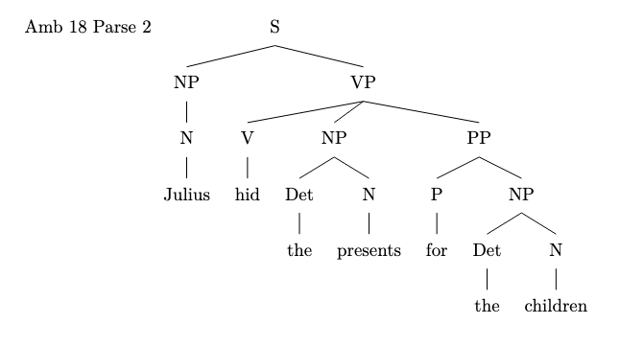

amb_19.txt gpt-3.5-turbo-0125 temperature=1.0
PROMPT Consider the sentence below. Is it syntactically ambiguous If so, provide code for syntactic trees representing each possible parse of the sentence that can be rendered with LaTeX's forest package. Assume X-bar theory.
You shot a pigeon sitting by the roadside.
REPLY Yes, the sentence is syntactically ambiguous.

One possible interpretation is that the pigeon is sitting by the roadside when you shoot it

\begin{forest}
[X$'$
[X
[You]
]
[X$'$
[X
[shot]
]
[X$'$
[X
[a pigeon]
]
[X$'$
[X
[sitting]
]
[by the roadside]
]
]
]
]
\end{forest}
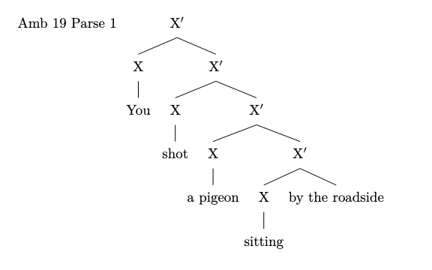
Another possible interpretation is that you are sitting by the roadside when you shoot a pigeon

\begin{forest}
[X$'$
[X
[You]
]
[X$'$
[X
[shot]
]
[X$'$
[X
[a pigeon]
]
[X$'$
[X
[sitting by the roadside]
]
]
]
]
]
\end{forest}
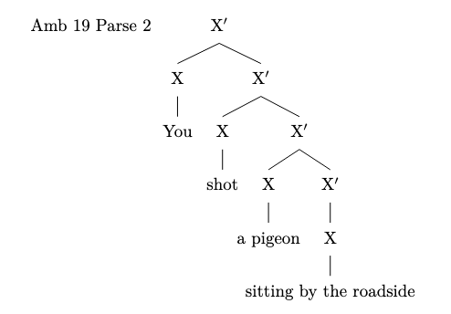

amb_20.txt gpt-3.5-turbo-0125 temperature=1.0
PROMPT Consider the sentence below. Is it syntactically ambiguous If so, provide code for syntactic trees representing each possible parse of the sentence that can be rendered with LaTeX's forest package. Assume X-bar theory.
He glanced at a badger basking in the sunlight.
REPLY Yes, the sentence is syntactically ambiguous because basking in the sunlight can be analyzed as modifying either a badger or the entire VP glanced at a badger.

Here are the two possible parses of the sentence

1. He glanced [PP [P at] [NP [Det a] [N' [Adj badger] [N basking in the sunlight]]]]

2. He [VP [V glanced] [PP [P at] [NP [Det a] [N' [Adj badger] [N basking in the sunlight]]]]]

These parses can be visualized with the following LaTeX code using the forest package

1.
\begin{forest}
[NP
[N'
[Adj [badger]]
[N'
[N [basking in the sunlight]]
]
]
[PP
[P [at]]
[NP
[Det [a]]
[N [badger]]
]
]
]
\end{forest}
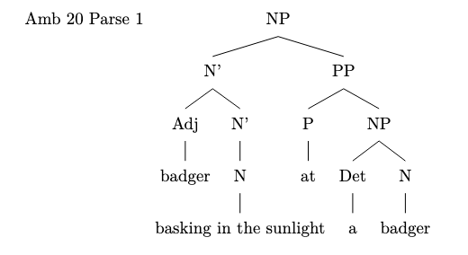
2.
\begin{forest}
[S
[NP [He]]
[VP
[V [glanced]]
[PP
[P [at]]
[NP
[Det [a]]
[N'
[Adj [badger]]
[N [basking in the sunlight]]
]
]
]
]
]
\end{forest}
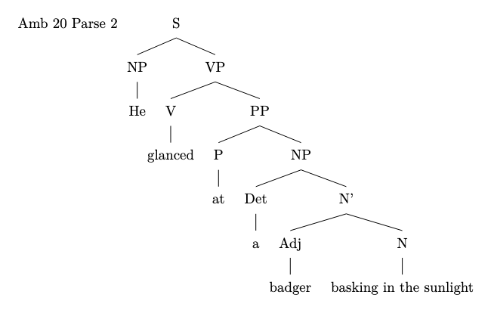

amb_21.txt gpt-3.5-turbo-0125 temperature=1.0
PROMPT Consider the sentence below. Is it syntactically ambiguous If so, provide code for syntactic trees representing each possible parse of the sentence that can be rendered with LaTeX's forest package. Assume X-bar theory.
The envoy to the duke who offended the emperor was executed.
REPLY Yes, the sentence is syntactically ambiguous.

The first possible parse is where who offended the emperor is a relative clause modifying the envoy

[
\begin{forest}
[X$'$ [X [X [The] [N [envoy]]] [X$'$ [X [to] [N [the duke]]] [X$'$ [X [who] [X$'$ [V [offended]] [N [the emperor]]]]]] [V [was executed]]]
\end{forest}
]
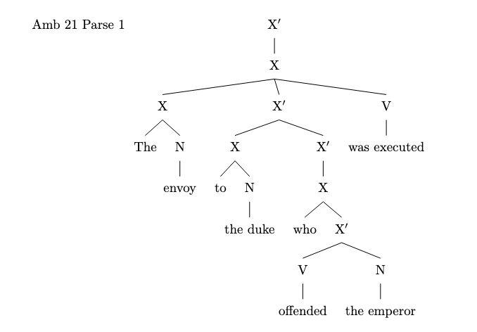
The second possible parse is where who offended the emperor is a relative clause modifying the duke

[
\begin{forest}
[X$'$ [X [X [The] [N [envoy]]] [X$'$ [X [to] [N [the duke]]]] [X$'$ [X [who] [X$'$ [V [offended]] [N [the emperor]]]] [V [was executed]]]]
\end{forest}
]
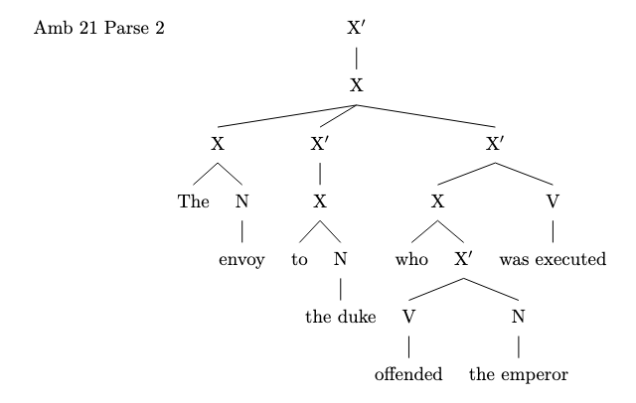

amb_22.txt gpt-3.5-turbo-0125 temperature=1.0
PROMPT Consider the sentence below. Is it syntactically ambiguous If so, provide code for syntactic trees representing each possible parse of the sentence that can be rendered with LaTeX's forest package. Assume X-bar theory.
The critics of the activists who had become controversial were baffled.
REPLY Yes, the sentence is syntactically ambiguous.

Possible parses
1. [The [critics [of [the activists] [who [had [become controversial]]]]] were baffled.]

2. [The [critics [of [the activists [who [had [become controversial]]]]]] were baffled.]

Code for first parse
\begin{forest}
[S
[DP [D [The]] [NP [N [critics]]]]
[VP
[V [were]]
[AdjP [Adj [baffled]]]]
[CP
[C [who]]
[IP
[DP [D [the]] [NP [N [activists]]]]
[VP
[V [had]]
[VP [V [become]] [AdjP [Adj [controversial]]]]]]
]
\end{forest}

AMB 22 parse 1 originally failed to compiled, added square bracket:
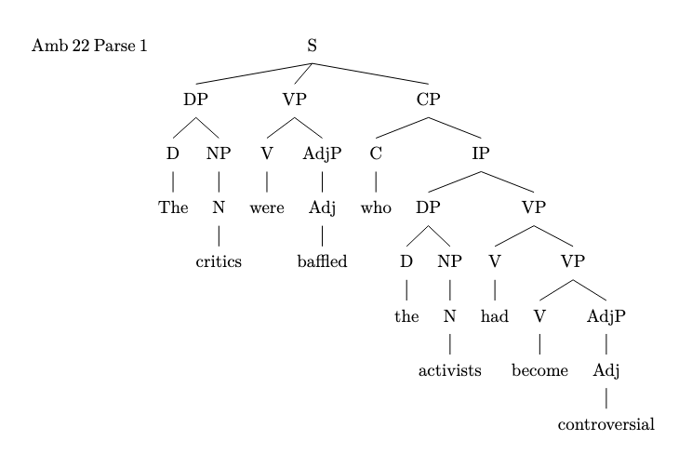
Code for second parse
\begin{forest}
[S
[DP [D [The]] [NP [N [critics]]]]
[VP
[V [were]]
[AdjP [Adj [baffled]]]]
[CP
[C [who]]
[IP
[DP [D [the]] [NP [N [activists [who [had [become controversial]]]]]]]
[VP
[V [had]]
[VP [V [become]] [AdjP [Adj [controversial]]]]]]
]
\end{forest}

AMB 22 parse 2 originally failed to compiled, added square bracket:
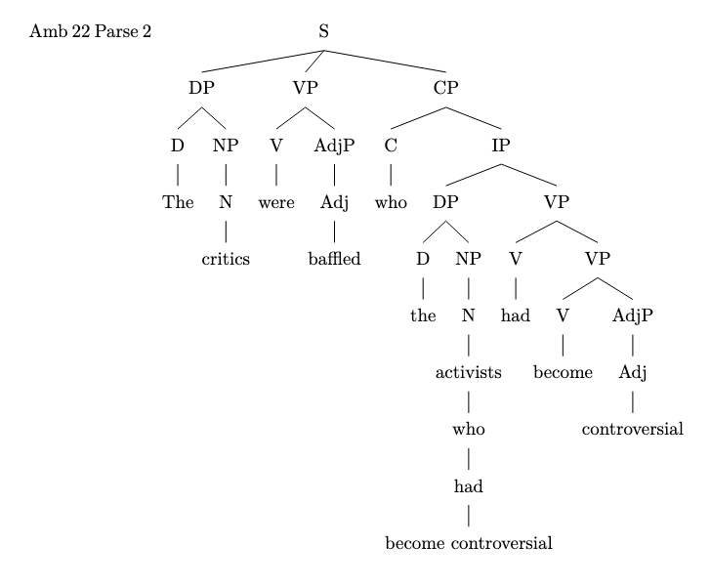

amb_23.txt gpt-3.5-turbo-0125 temperature=1.0
PROMPT Consider the sentence below. Is it syntactically ambiguous If so, provide code for syntactic trees representing each possible parse of the sentence that can be rendered with LaTeX's forest package. Assume X-bar theory.
The girl who was weeping quietly left.
REPLY Yes, the sentence is syntactically ambiguous. Here are two possible parses of the sentence

1. [The girl [who [was [weeping quietly]]] left]

2. [The girl [who [was weeping]] [quietly] left]

Here is the LaTeX code for the first parse tree

documentclass{standalone}
usepackage{forest}

begin{document}

\begin{forest}
[S
[NP
[D [The]]
[N [girl]]
]
[CP
[C [who]]
[TP
[T [was]]
[VP
[V [weeping]]
[AdvP
[Adv [quietly]]
]
]
]
]
[V [left]]
]
\end{forest}
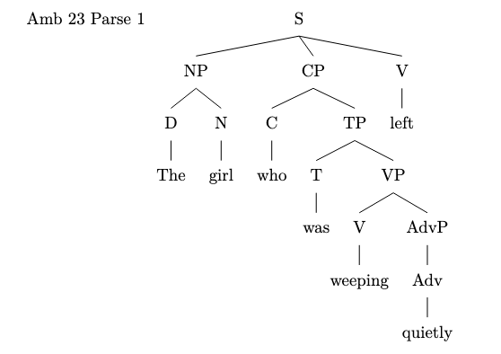
end{document}

And here is the LaTeX code for the second parse tree

documentclass{standalone}
usepackage{forest}

begin{document}

\begin{forest}
[S
[NP
[D [The]]
[N [girl]]
]
[CP
[C [who]]
[TP
[T [was]]
[VP
[V [weeping]]
]
]
]
[AdvP
[Adv [quietly]]
]
[V [left]]
]
\end{forest}

end{document}
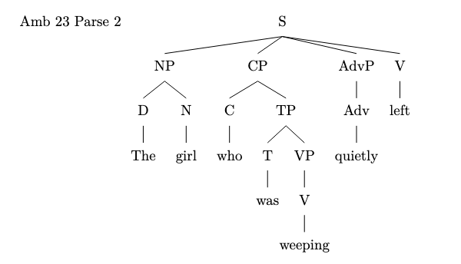

amb_24.txt gpt-3.5-turbo-0125 temperature=1.0
PROMPT Consider the sentence below. Is it syntactically ambiguous If so, provide code for syntactic trees representing each possible parse of the sentence that can be rendered with LaTeX's forest package. Assume X-bar theory.
The Tesla that was about to explode spontaneously swerved.
REPLY Yes, the sentence is syntactically ambiguous.

1. One possible parse
[
\begin{forest}
[S
[NP [D [The]] [N [Tesla]]]
[S'
[CP
[C [that]]
[S
[VP [V [was]] [VP' [VP [V [about]] [PP [P [to]] [VP [V [explode]]]]] [Adv [spontaneously]]]]
]
[VP [V [swerved]]]
]
]
\end{forest}
]

AMB 24 Parse 1 originally failed to compile. Added a square bracket:
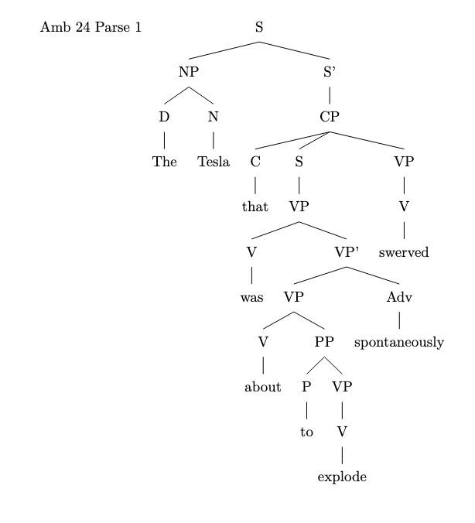
2. Another possible parse
[
\begin{forest}
[S
[NP [D [The]] [N [Tesla]]]
[S'
[CP
[C [that]]
[S
[VP [V [was]] [VP' [V [about]] [VP [VP [V [to]] [V [explode]]] [Adv [spontaneously]]]]]
]
[VP [V [swerved]]]
]
]
\end{forest}
]
AMB 24 Parse 2 originally failed to compile. Added a square bracket:
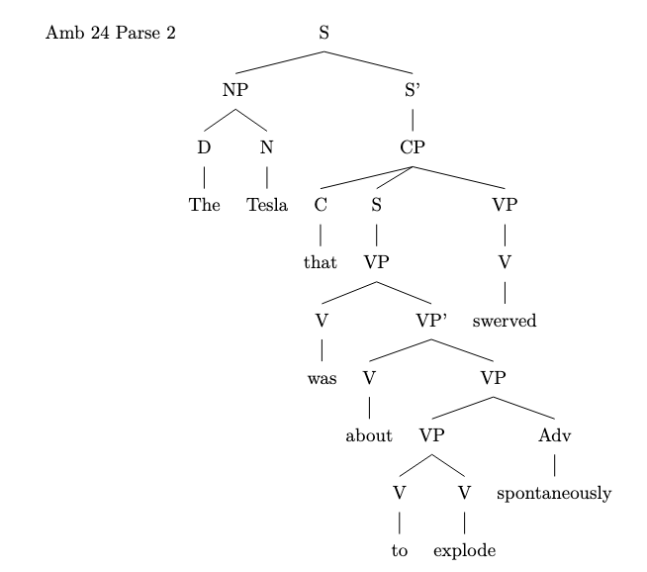

amb_25.txt gpt-3.5-turbo-0125 temperature=1.0
PROMPT Consider the sentence below. Is it syntactically ambiguous If so, provide code for syntactic trees representing each possible parse of the sentence that can be rendered with LaTeX's forest package. Assume X-bar theory.
Lara Croft decided in May she would raid more tombs.
REPLY Yes, the sentence is syntactically ambiguous. One possible interpretation is that Lara Croft made the decision in May to raid more tombs. Another possible interpretation is that Lara Croft would raid more tombs in May.

Parse 1 Lara Croft decided in May [she would raid more tombs].
```
\begin{forest}
[TP
[DP [Lara Croft]]
[T$'$
[T [decided]]
[VP
[PP [in May]]
[TP
[DP [she]]
[T$'$
[T [would]]
[VP [V [raid]] [DP [more tombs]]]
]
]
]
]
]
\end{forest}
```
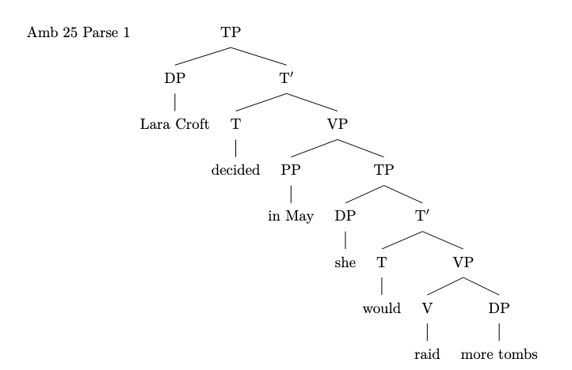
Parse 2 Lara Croft decided [in May she would raid more tombs].
```
\begin{forest}
[TP
[DP [Lara Croft]]
[T$'$
[T [decided]]
[VP
[PP [in May]]
[TP
[DP [she]]
[T$'$
[T [would]]
[VP [V [raid]] [DP [more tombs]]]
]
]
]
]
]
\end{forest}
```
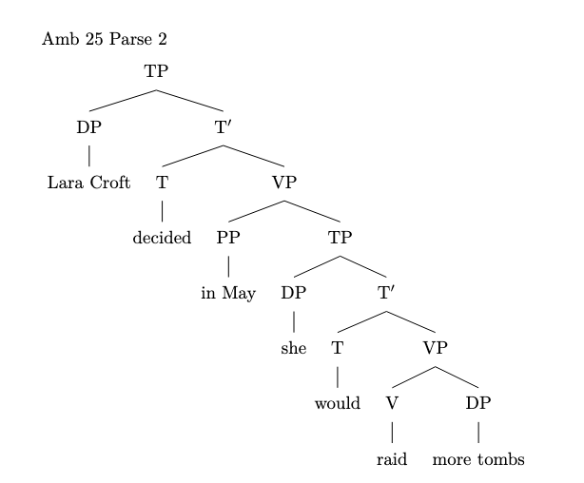

amb_26.txt gpt-3.5-turbo-0125 temperature=1.0
PROMPT Consider the sentence below. Is it syntactically ambiguous If so, provide code for syntactic trees representing each possible parse of the sentence that can be rendered with LaTeX's forest package. Assume X-bar theory.
Alex swore on Saturday he would visit his grandfather.
REPLY Yes, the sentence is syntactically ambiguous.

1. One possible interpretation is that Alex swore on Saturday, and the purpose of his swearing was to promise that he would visit his grandfather.
2. Another possible interpretation is that Alex swore on Saturday that he would visit his grandfather.

Here are the syntactic trees for each interpretation

1. Alex swore on Saturday he would visit his grandfather.
\begin{forest}
[TP
[NP [N Alex]]
[T$overline{text{ASPECT}}$
[T swore]
[PP
[P on]
[NP [N Saturday]]
]
[TP
[NP [N he]]
[T$overline{text{ASPECT}}$
[T would]
[VP
[V visit]
[NP [N his grandfather]]
]
]
]
]
]
\end{forest}
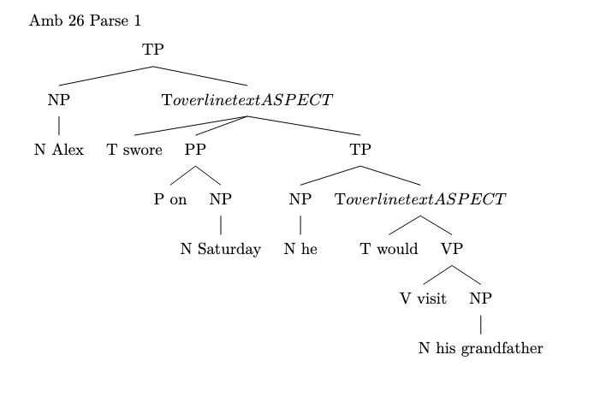
2. Alex swore on Saturday he would visit his grandfather.
\begin{forest}
[TP
[NP [N Alex]]
[T$overline{text{ASPECT}}$
[T swore]
[PP
[P on]
[NP [N Saturday]]
]
[CP
[C that]
[TP
[NP [N he]]
[T$overline{text{ASPECT}}$
[T would]
[VP
[V visit]
[NP [N his grandfather]]
]
]
]
]
]
]
\end{forest}

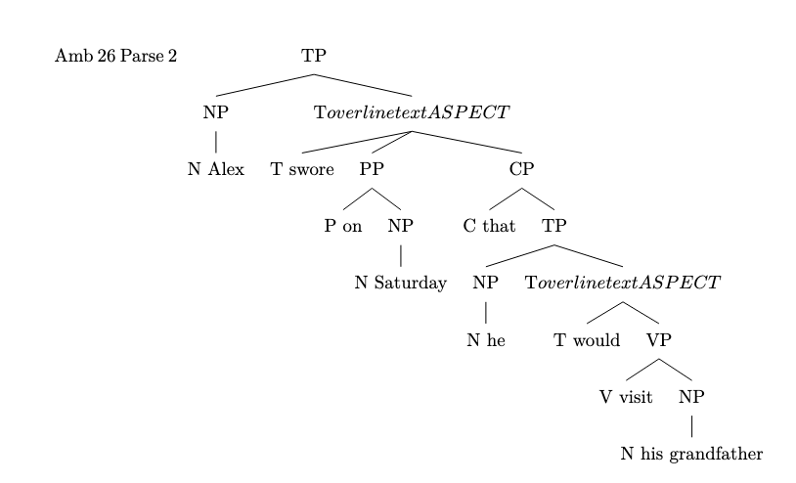

amb_27.txt gpt-3.5-turbo-0125 temperature=1.0
PROMPT Consider the sentence below. Is it syntactically ambiguous If so, provide code for syntactic trees representing each possible parse of the sentence that can be rendered with LaTeX's forest package. Assume X-bar theory.
He told me he ate the leftovers yesterday.
REPLY Yes, the sentence is syntactically ambiguous. It could parse as either He [told [me [he [ate [the leftovers] yesterday]]]] or as He [told [me [he [ate [the leftovers yesterday]]]]].

Here are the code for both syntactic trees

1. First parse He [told [me [he [ate [the leftovers] yesterday]]]]

\begin{forest}
[S
[NP [He]]
[VP
[V [told]]
[NP [me]]
[S
[NP [he]]
[VP
[V [ate]]
[NP [the leftovers]]
[AdvP [yesterday]]
]
]
]
]
\end{forest}
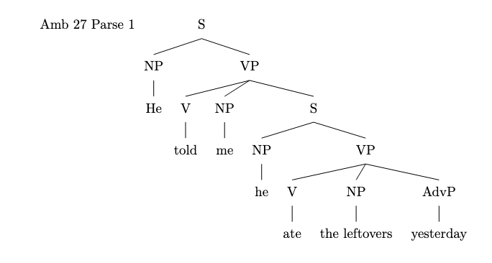
2. Second parse He [told [me [he [ate [the leftovers yesterday]]]]]

\begin{forest}
[S
[NP [He]]
[VP
[V [told]]
[NP [me]]
[S
[NP [he]]
[VP
[V [ate]]
[NP [the leftovers yesterday]]
]
]
]
]
\end{forest}
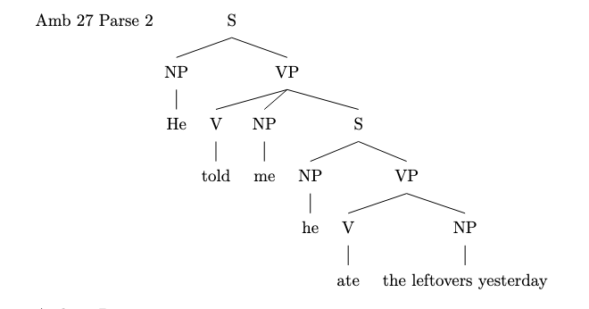

amb_28.txt gpt-3.5-turbo-0125 temperature=1.0
PROMPT Consider the sentence below. Is it syntactically ambiguous If so, provide code for syntactic trees representing each possible parse of the sentence that can be rendered with LaTeX's forest package. Assume X-bar theory.
He dreamed that he'd shown up to school late the day of a test.
REPLY Yes, the sentence is syntactically ambiguous because it can be parsed in two different ways

1. He [ dreamed [ that [ he'd [ shown up [ to school late ] ] ] ] [ the day of [ a test ] ] ]

2. He [ dreamed [ that [ he'd [ shown up [ to [ school late ] ] ] ] ] [ the day of [ a test ] ] ]

Code for the first parse tree

\begin{forest}
[S
[NP
[He]
]
[VP
[V
[dreamed]
]
[CP
[C
[that]
]
[TP
[NP
[he'd]
]
[VP
[V
[shown up]
]
[PP
[P
[to]
]
[NP
[school late]
]
]
]
]
]
]
[PP
[P
[the day of]
]
[NP
[a test]
]
]
]
\end{forest}
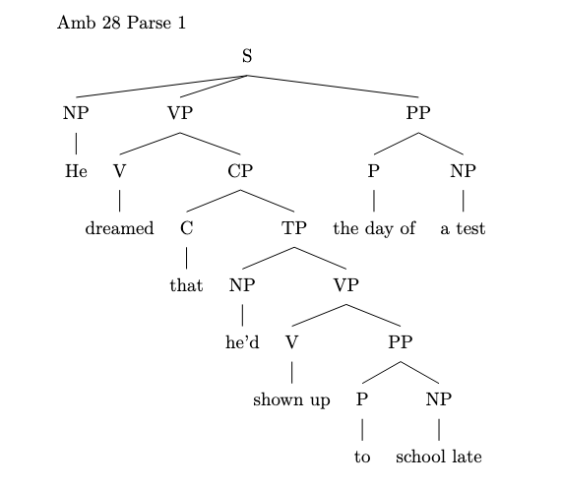
Code for the second parse tree

\begin{forest}
[S
[NP
[He]
]
[VP
[V
[dreamed]
]
[CP
[C
[that]
]
[TP
[NP
[he'd]
]
[VP
[V
[shown up]
]
[PP
[P
[to]
]
[NP
[school late]
]
]
]
]
]
[PP
[P
[the day of]
]
[NP
[a test]
]
]
]
]
\end{forest}
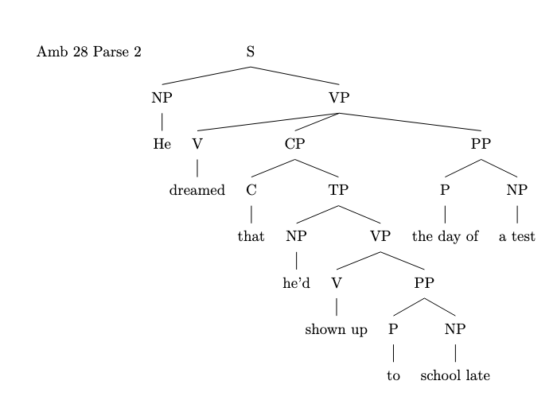

amb_29.txt gpt-3.5-turbo-0125 temperature=1.0
PROMPT Consider the sentence below. Is it syntactically ambiguous If so, provide code for syntactic trees representing each possible parse of the sentence that can be rendered with LaTeX's forest package. Assume X-bar theory.
I knew I wanted to speak to my lawyer but she was away from the phone.
REPLY Yes, the sentence is syntactically ambiguous. One possible interpretation is that I wanted to speak to my lawyer but she was away from the phone. Another possible interpretation is that I knew I wanted to speak to my lawyer, but she was away from the phone.

Below are the two possible parse trees for each interpretation

1. I wanted to speak to my lawyer but she was away from the phone.
\begin{forest}
[X'
[XI]
[X$'$
[Xwanted]
[YP
[Yto]
[ZP
[Zmy]
[Z$'$
[Zlawyer]
[CP
[Cbut]
[TP
[NPshe]
[T$'$
[Twas]
[VP
[away]
[PP
[Pfrom]
[NPthe phone]
]
]
]
]
]
]
]
]
]
]
\end{forest}
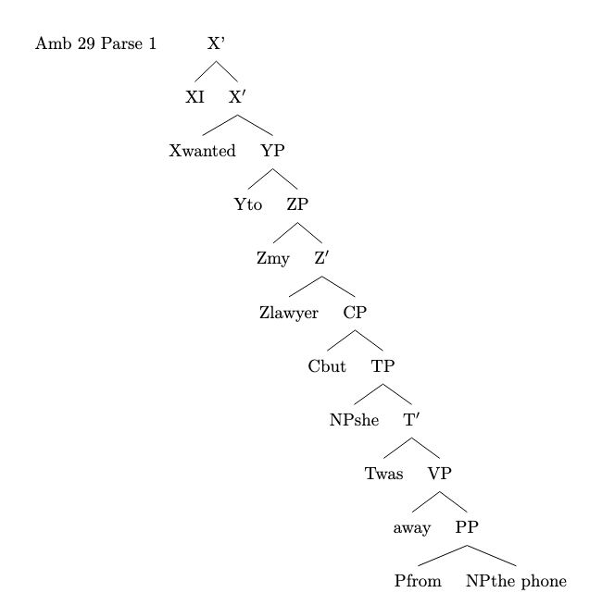
2. I knew I wanted to speak to my lawyer, but she was away from the phone.
\begin{forest}
[X'
[X
[XI]
[X$'$
[Xknew]
[CP
[CI]
[TP
[Xwanted]
[VP
[to speak to my lawyer, but she was away from the phone]
]
]
]
]
]
]
\end{forest}
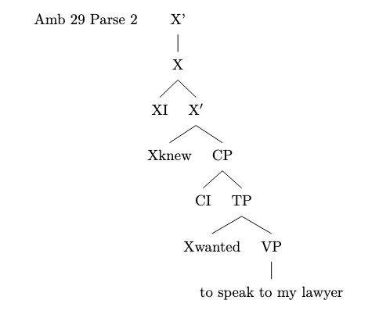

amb_30.txt gpt-3.5-turbo-0125 temperature=1.0
PROMPT Consider the sentence below. Is it syntactically ambiguous If so, provide code for syntactic trees representing each possible parse of the sentence that can be rendered with LaTeX's forest package. Assume X-bar theory.
Francisco believed his peers were idiots and they resented him.
REPLY Yes, the sentence Francisco believed his peers were idiots and they resented him is syntactically ambiguous.

One possible interpretation is that Francisco believed both that his peers were idiots and that they resented him

[
\begin{forest}
[S
[NP
[N
[N
[Francisco]
]
]
]
[VP
[V
[believed]
]
[CP
[C
[that]
]
[S
[NP
[possessive pronoun
[his]
]
[N
[peers]
]
]
[VP
[V
[were]
]
[Adj
[idiots]
]
]
[Coord
[and]
[S
[NP
[they]
]
[VP
[V
[resented]
]
[NP
[him]
]
]
]
]
]
]
]
]
\end{forest}
]
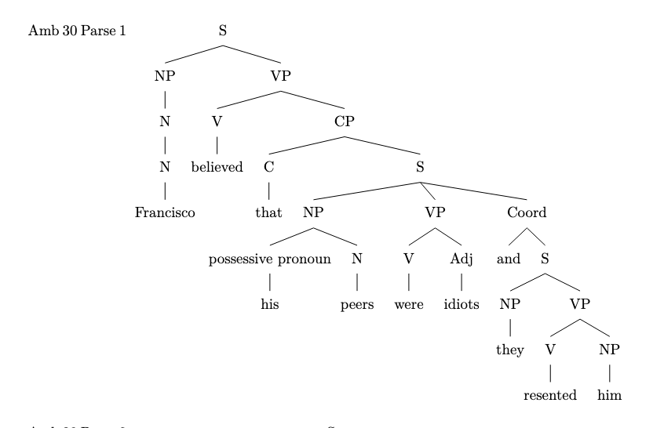
Another interpretation is that Francisco believed his peers were idiots, and his peers resented him

[
\begin{forest}
[S
[NP
[N
[N
[Francisco]
]
]
]
[VP
[V
[believed]
]
[CP
[C
[that]
]
[S
[NP
[possessive pronoun
[his]
]
[N
[peers]
]
]
[VP
[V
[were]
]
[Adj
[idiots]
]
]
]
]
]
[Coord
[and]
[S
[NP
[they]
]
[VP
[V
[resented]
]
[NP
[him]
]
]
]
]
]
\end{forest}
]

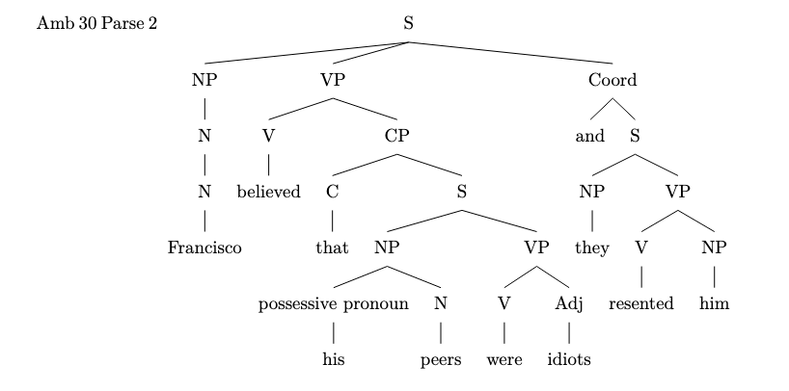
Messages generated with 9567 tokens

gpt-4-0314

amb_01.txt gpt-4-0314 temperature=1.0
PROMPT: Consider the sentence below. Is it syntactically ambiguous? If so, provide code for syntactic trees representing each possible parse of the sentence that can be rendered with LaTeX's forest package. Assume X-bar theory.
"A passer-by has heard her pump."
REPLY: Yes, the sentence is syntactically ambiguous. There are two possible interpretations:

1. "A passer-by has heard her (operate the) pump." - In this case, "pump" operates as a direct object of the verb "heard."
2. "A passer-by has (over)heard (while standing) by her pump." - In this case, "by her pump" functions as a prepositional phrase modifying the verb "heard."

Here are the LaTeX code for the syntactic trees representing each possible parse using the forest package and X-bar theory:

1. First interpretation:
```
\documentclass{standalone}
\usepackage{forest}
\begin{document}
\begin{forest}
for tree={
parent anchor=south,
child anchor=north,
edge path={\noexpand\path[\forestoption{edge}](!u.parent anchor)--(.child anchor)\forestoption{edge label};}}
[TP
[DP[A passer-by,roof]]
[T'
[\textit{has}]
[VP
[V'
[\textit{heard}]
[DP[her pump,roof]]
]
]
]
]
\end{forest}
\end{document}
```
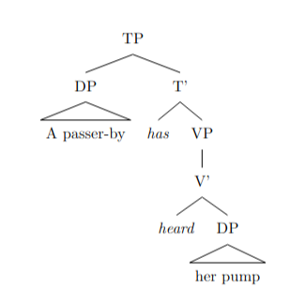

2. Second interpretation:
```
\documentclass{standalone}
\usepackage{forest}
\begin{document}
\begin{forest}
for tree={
parent anchor=south,
child anchor=north,
edge path={\noexpand\path[\forestoption{edge}](!u.parent anchor)--(.child anchor)\forestoption{edge label};}}
[TP
[DP[A passer-by,roof]]
[T'
[\textit{has}]
[VP
[V'
[\textit{heard}]
[PP
[P'
[\textit{by}]
[DP[her pump,roof]]
]
]
]
]
]
]
\end{forest}
\end{document}
```

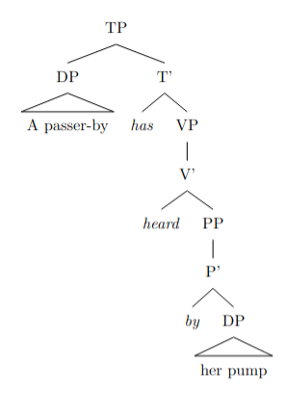

These codes will generate the syntactic trees for the two interpretations of the sentence.

amb_02.txt gpt-4-0314 temperature=1.0
PROMPT: Consider the sentence below. Is it syntactically ambiguous? If so, provide code for syntactic trees representing each possible parse of the sentence that can be rendered with LaTeX's forest package. Assume X-bar theory.
"The opposite team had her duck."
REPLY: Yes, the sentence "The opposite team had her duck" is syntactically ambiguous. There are two possible interpretations:

1. The opposite team caused her to duck (implying motion).
2. The opposite team possessed her duck (implying ownership of a duck).

Here are the LaTeX codes for syntactic trees representing each possible parse of the sentence using the forest package and X-bar theory.

For interpretation 1 (causing motion):

```
\usepackage{forest}
...
\begin{forest}
[TP
[DP [D [The] ] [NP [Adj [opposite] ] [N [team] ] ] ]
[T' [T [had] ]
[VP [DP [D [her] ] ] [V' [V [ ] ] [VP [DP [N [duck] ] ] ] ] ]
]
]
\end{forest}
```

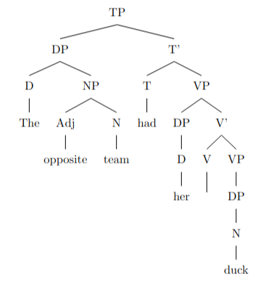
For interpretation 2 (possession of a duck):

```
\usepackage{forest}
...
\begin{forest}
[TP
[DP [D [The] ] [NP [Adj [opposite] ] [N [team] ] ] ]
[T' [T [had] ]
[VP [V [ ] ]
[DP [D [her] ] [NP [N [duck] ] ] ]
]
]
]
\end{forest}
```

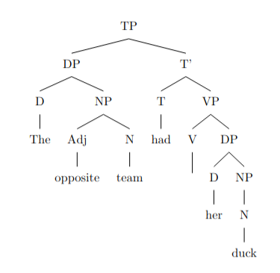

Both interpretations have different structures in the VP node. The first interpretation contains a nested VP, while the second one has a single DP attached to the V'.

amb_03.txt gpt-4-0314 temperature=1.0
PROMPT: Consider the sentence below. Is it syntactically ambiguous? If so, provide code for syntactic trees representing each possible parse of the sentence that can be rendered with LaTeX's forest package. Assume X-bar theory.
"Eliza wanted her cast out."
REPLY: Yes, the sentence "Eliza wanted her cast out." is syntactically ambiguous. Here are the two possible parses for this sentence:

Parse 1: Eliza wanted [her (to be) cast out].
In this parse, Eliza wanted someone (her) to be cast out.

\begin{forest}
[CP
[DP
[NNP, name=subj [Eliza]]]
[C'
[C]
[TP
[B
[T [SM [wanted]]]
[VP
[T, name=tsubj]
[V'
[V]
[CP
[DP
[PRP, name=obj [her]]]
[C'
[C]
[TP
[T]
[VP
[V [part [cast]]]
[SC
[DP, name=tobj]
[PCP [PPartP [out]]]
]
]
]
]
]
]
]], B!<(subj)||tree=(\tree_dist,1), B->tsubj, ]}
]
\end{forest}

Manually added final bracket (AM)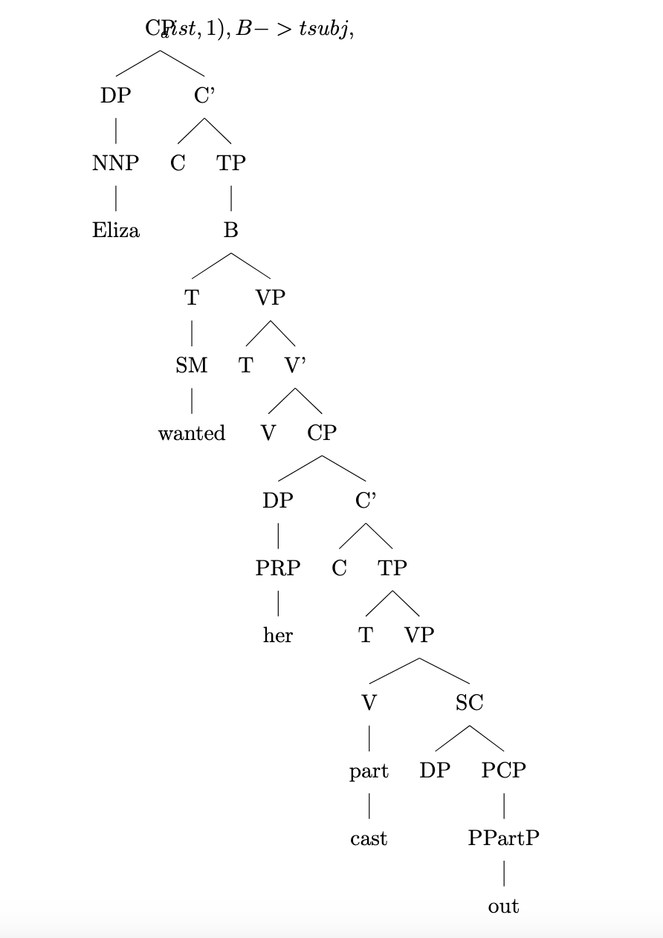

Parse 2: Eliza wanted (to cast) her (object) out.
In this parse, Eliza wanted to cast someone (her) out.

\begin{forest}
[CP
[DP
[NNP, name=subj [Eliza]]]
[C'
[C]
[TP
[B
[T [SM [wanted]]]
[VP
[T, name=tsubj]
[V'
[V]
[CP
[C]
[TP
[T]
[VP
[V [PRP, name=obj [her]]]
[PP
[P [out]]
]
]
]
]
]
]], B!<(subj)||tree=(\tree_dist,1), B->tsubj, ]}
]
\end{forest}

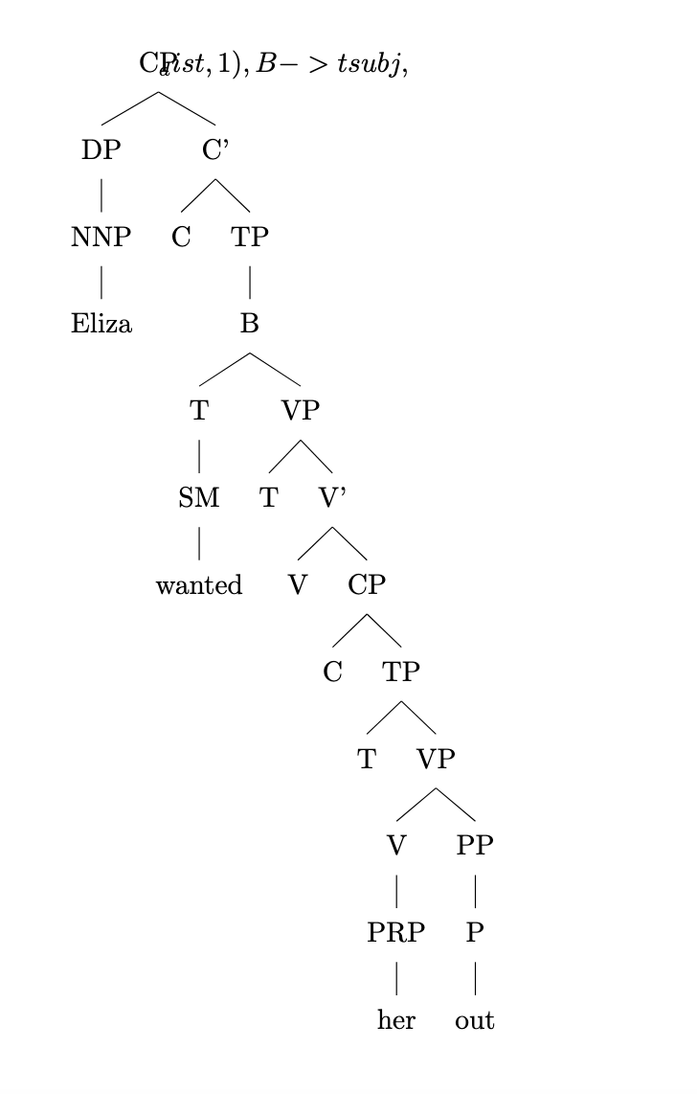

These two parses represent the syntactic ambiguity in the sentence "Eliza wanted her cast out."

amb_04.txt gpt-4-0314 temperature=1.0
PROMPT: Consider the sentence below. Is it syntactically ambiguous? If so, provide code for syntactic trees representing each possible parse of the sentence that can be rendered with LaTeX's forest package. Assume X-bar theory.
"Tobias kept her wound up."
REPLY: Yes, the sentence "Tobias kept her wound up" is syntactically ambiguous. There are two possible parses for this sentence:

1. Tobias kept (her wound) up - where "her wound" is an object that Tobias keeps in an elevated position
2. Tobias kept her (wound up) - where "wound up" describes the state of the girl (her emotions, maybe anxious or tense)

Here are the corresponding syntactic trees represented using X-bar theory and code that can be rendered with LaTeX's forest package:

1. Tobias kept (her wound) up:

```
\begin{forest}
[TP
[NP [N [Tobias]]]
[VP
[V [kept]]
[NP
[Det [her]]
[N [wound]]
]
[P [up]]
]
]
\end{forest}
```
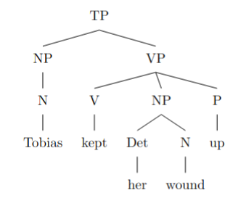

2. Tobias kept her (wound up):

```
\begin{forest}
[TP
[NP [N [Tobias]]]
[VP
[V [kept]]
[NP [PRO [her]]]
[AdjP
[Adj [wound]]
[P [up]]
]
]
]
\end{forest}
```
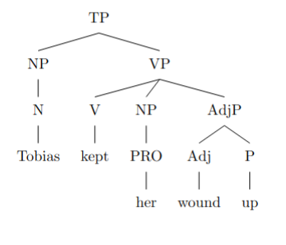

amb_05.txt gpt-4-0314 temperature=1.0
PROMPT: Consider the sentence below. Is it syntactically ambiguous? If so, provide code for syntactic trees representing each possible parse of the sentence that can be rendered with LaTeX's forest package. Assume X-bar theory.
"The new director has had her set."
REPLY: Yes, the sentence is syntactically ambiguous. It can be interpreted in two ways:

1. The new director has had her own set.
2. The new director has put someone (or something) in a predetermined position or condition.

Here are the codes for the syntactic trees representing each possible parse of the sentence using X-bar theory and LaTeX's forest package:

1. The new director has had her own set:

```
\begin{forest}
[TP [DP [D [The]] [AdjP [Adj [new]]] [N [director]]] [T' [T [has]] [VP [V [had]] [DP [D [her]] [N [set]]]]]]
\end{forest}
```
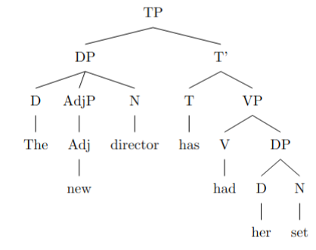
2. The new director has put someone (or something) in a predetermined position or condition:

```
\begin{forest}
[TP [DP [D [The]] [AdjP [Adj [new]]] [N [director]]] [T' [T [has]] [VP [V [had]] [DP [D [her]]] [VP [V [set]]]]]]
\end{forest}
```
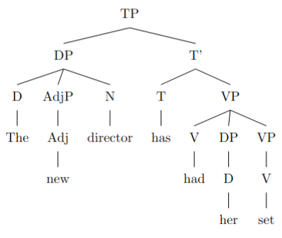

amb_06.txt gpt-4-0314 temperature=1.0
PROMPT: Consider the sentence below. Is it syntactically ambiguous? If so, provide code for syntactic trees representing each possible parse of the sentence that can be rendered with LaTeX's forest package. Assume X-bar theory.
"Without her calling, they will fail."
REPLY: Yes, the sentence is syntactically ambiguous. There are two possible parses for this sentence:

1. "Without her calling" is a modifier of "they will fail". In this interpretation, the sentence means that if she doesn't call, they will fail.

2. "Without her" is a modifier of "calling". In this interpretation, the sentence means that they will fail without her being involved in the calling.

Here are the LaTeX code and syntax trees for both interpretations using the forest package:

1. Interpretation one:
```
\begin{forest}
[TP
[PP
[P [Without]]
[NP
[N' [N [her]]]
[VP [V [calling]]]
]
]
[T'
[T [will]]
[VP
[V [fail]]
[NP [N [they]]]
]
]
]
\end{forest}
```

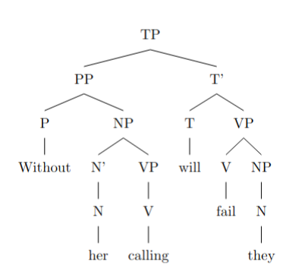
2. Interpretation two:
```
\begin{forest}
[TP
[T [will]]
[VP
[V [fail]]
[NP
[N [they]]
[PP
[P [Without]]
[NP
[NP [N [her]]]
[NP [N [calling]]]
]
]
]
]
]
\end{forest}
```
These two syntax trees represent the different possible parses of the sentence "Without her calling, they will fail" under the assumption of X-bar theory.

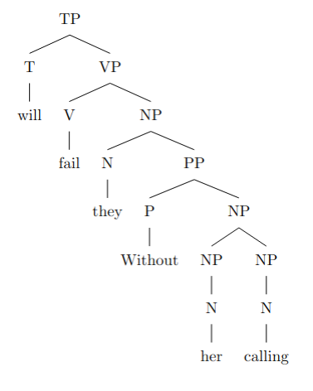

amb_07.txt gpt-4-0314 temperature=1.0
PROMPT: Consider the sentence below. Is it syntactically ambiguous? If so, provide code for syntactic trees representing each possible parse of the sentence that can be rendered with LaTeX's forest package. Assume X-bar theory.
"Her mom was really upset by her whining."
REPLY: Yes, the sentence is syntactically ambiguous. There are two possible ways to parse the sentence:

1. "Her whining" is a nominal phrase, the cause of the mother's being upset.
2. "Whining" is the manner in which the mother was upset.

Here are the code for syntactic trees representing each possible parse:

Parse 1:
\begin{forest}
[CP
[DP [D' [D [Her]] [NP [N' [N [mom]]]]]]
[C'
[C [was]]
[VP
[V' [V [really upset]]]
[PP
[P [by]]
[DP [D' [D [her]] [NP [N' [N [whining]]]]]]
]
]
]
]
\end{forest}

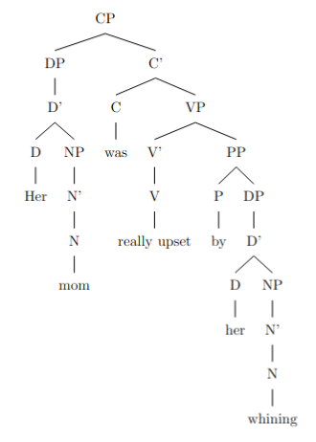

Parse 2:
\begin{forest}
[CP
[DP [D' [D [Her]] [NP [N' [N [mom]]]]]]
[C'
[C [was]]
[VP
[AdvP [Adv [really]]]
[V'
[V [upset]]
[PP
[P [by]]
[DP [D' [D [her]] [NP [N' [N [whining]]]]]]
]
]
]
]
]
\end{forest}

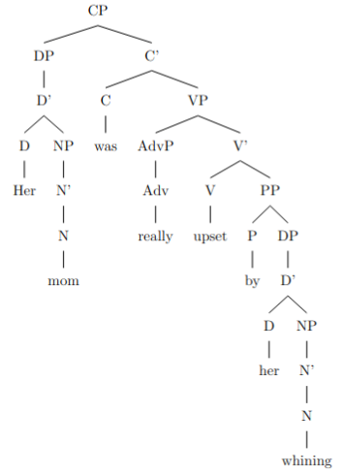

amb_08.txt gpt-4-0314 temperature=1.0
PROMPT: Consider the sentence below. Is it syntactically ambiguous? If so, provide code for syntactic trees representing each possible parse of the sentence that can be rendered with LaTeX's forest package. Assume X-bar theory.
"We'll meet at the Old Stone Hotel."
REPLY: Yes, the sentence is syntactically ambiguous. It can either be understood as meeting at a hotel named "Old Stone" or meeting at a hotel that is characterized as both old and made of stone. Here are two possible syntactic trees representing each interpretation:

1. Meeting at "Old Stone Hotel":

```
\begin{forest}
[TP
[DP [D [We]]]
[T'
[T [\textsc{will}]]
[VP
[V [meet]]
[PP
[P [at]]
[DP
[D_{adj} [D [the]]]
[NP
[AP [A_{adj} [A [Old]]] ]
[N'
[N [Stone Hotel]]
]
]
]
]
]
]
]
\end{forest}
```
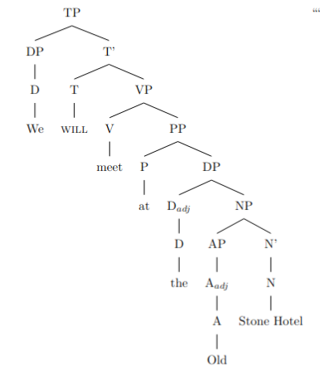
2. Meeting at a hotel that is old and made of stone:

```
\begin{forest}
[TP
[DP [D [We]]]
[T'
[T [\textsc{will}]]
[VP
[V [meet]]
[PP
[P [at]]
[DP
[D_{adj} [D [the]]]
[NP
[AP [A_{adj} [A [Old]]] ]
[N'
[AP [A_{adj} [A [Stone]]] ]
[N [Hotel]]
]
]
]
]
]
]
]
\end{forest}
```

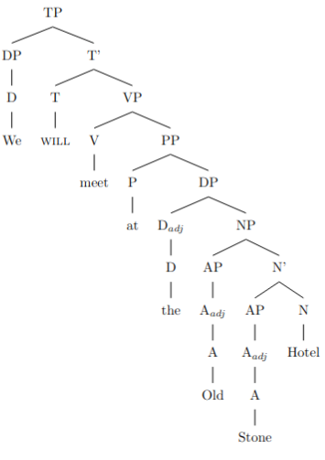

Both trees are using X-bar theory.

amb_09.txt gpt-4-0314 temperature=1.0
PROMPT: Consider the sentence below. Is it syntactically ambiguous? If so, provide code for syntactic trees representing each possible parse of the sentence that can be rendered with LaTeX's forest package. Assume X-bar theory.
"The wet rodent lab has had a leak."
REPLY: Yes, the sentence is syntactically ambiguous. The ambiguity comes from the phrase "wet rodent lab," which can be interpreted as a laboratory for wet rodents or as a wet laboratory for rodents. Here are the two syntactic trees representing each possible parse:

1. A laboratory for wet rodents:

```
\documentclass{standalone}
\usepackage{forest}
\begin{document}
\begin{forest}
[TP
[DP
[D
[The]
]
[NP
[AdjP
[Adj
[wet]
]
]
[N'
[N
[rodent]
]
[N
[lab]
]
]
]
]
[T'
[T
[has had]
]
[VP
[V'
[V
[a leak]
]
]
]
]
]
\end{forest}
\end{document}
```
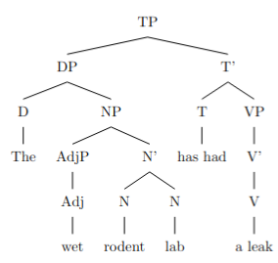
2. A wet laboratory for rodents:

```
\documentclass{standalone}
\usepackage{forest}
\begin{document}
\begin{forest}
[TP
[DP
[D
[The]
]
[NP
[N
[wet rodent]
]
[N'
[N
[lab]
]
]
]
]
[T'
[T
[has had]
]
[VP
[V'
[V
[a leak]
]
]
]
]
]
\end{forest}
\end{document}
```
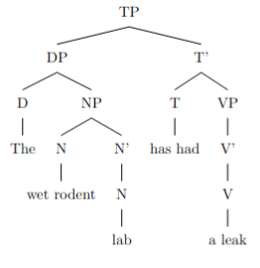

amb_10.txt gpt-4-0314 temperature=1.0
PROMPT: Consider the sentence below. Is it syntactically ambiguous? If so, provide code for syntactic trees representing each possible parse of the sentence that can be rendered with LaTeX's forest package. Assume X-bar theory.
"The new energy theorem confuses me."
REPLY: Yes, the sentence is syntactically ambiguous. Here are two possible syntactic trees, rendered with LaTeX's forest package, based on X-bar theory:

1. In the first reading, "new energy" is considered a compound noun.

\begin{forest}
[TP
[DP
[D\\The]
[NP
[N'
[N\\new energy]
]
]
]
[T'
[T\\ ]
[VP
[V'
[V\\theorem]
[VP
[V'
[V\\confuses]
[DP
[D\\ ]
[NP
[N\\me]
]
]
]
]
]
]
]
\end{forest}

Failed to compile; manually added final bracket (AM)
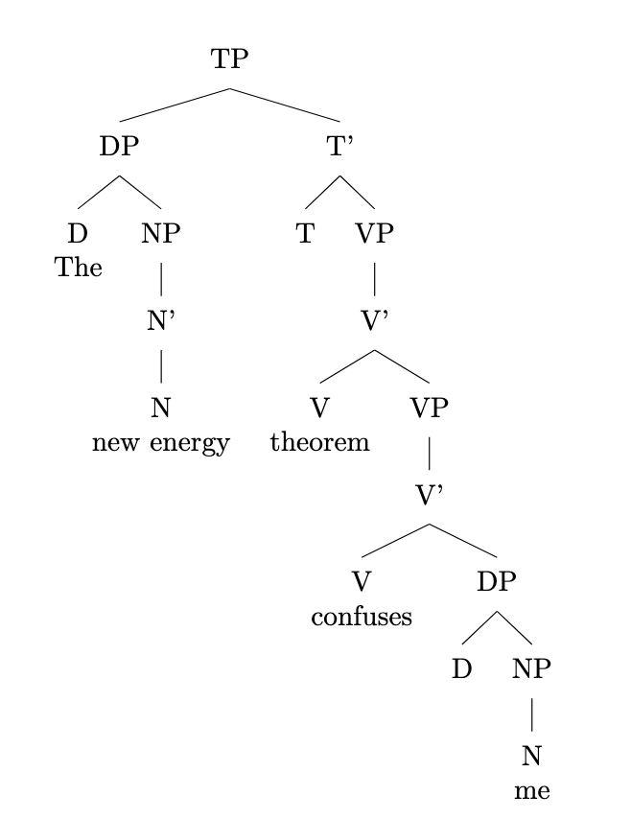

2. In the second reading, "new" modifies "energy."

\begin{forest}
[TP
[DP
[D\\The]
[NP
[AdjP
[Adj\\new]
]
[N'
[N\\energy]
]
]
]
[T'
[T\\ ]
[VP
[V'
[V\\theorem]
[VP
[V'
[V\\confuses]
[DP
[D\\ ]
[NP
[N\\me]
]
]
]
]
]
]
]
\end{forest}

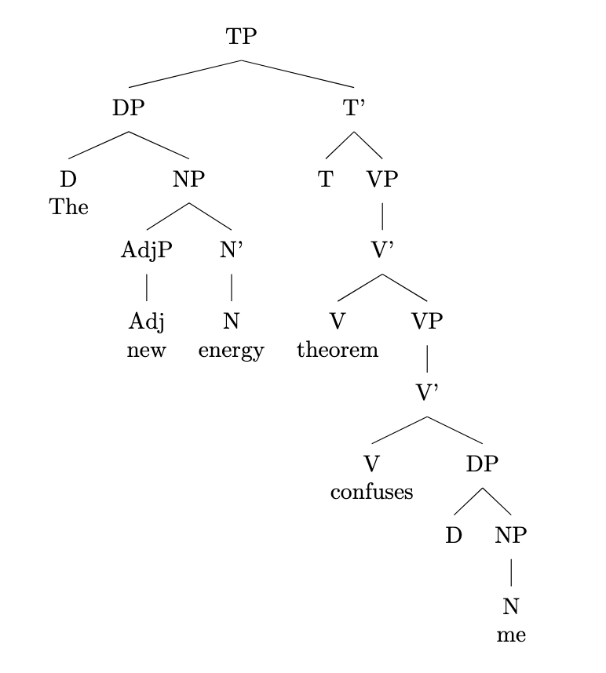

In the first parse, "new energy" is considered a compound noun, while in the second parse, "new" is an adjective modifying "energy."

amb_11.txt gpt-4-0314 temperature=1.0
PROMPT: Consider the sentence below. Is it syntactically ambiguous? If so, provide code for syntactic trees representing each possible parse of the sentence that can be rendered with LaTeX's forest package. Assume X-bar theory.
"Less colorful clothing is acceptable at this party."
REPLY: Yes, the sentence is syntactically ambiguous. There are two possible parses:

1. "Less colorful" is a compound adjective modifying "clothing" - the sentence means that clothing with less color is acceptable.
2. "Less" is an adverb meaning "to a lesser extent" that modifies the adjective "colorful clothing" - the sentence means that colorful clothing is acceptable, but to a lesser extent.

Here are the code for the syntactic trees in LaTeX with the forest package, for each parse:

1. "Less colorful" as a compound adjective:

```
\begin{forest}
[TP
[NP
[AdjP
[Adj [less]]
[Adj [colorful]]
]
[N [clothing]]
]
[VP
[Aux [is]]
[AdjP
[Adj [acceptable]]
[PP
[P [at]]
[NP
[D [this]]
[N [party]]
]
]
]
]
]
\end{forest}
```
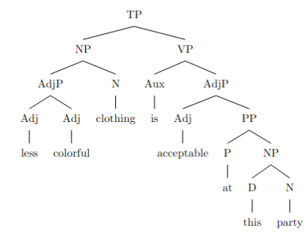
2. "Less" as an adverb modifying "colorful clothing":

```
\begin{forest}
[TP
[NP
[N [clothing]]
]
[VP
[Aux [is]]
[AdjP
[Adv [less]]
[Adj [acceptable]]
[PP
[P [at]]
[NP
[D [this]]
[N [party]]
]
]
]
]
]
\end{forest}
```

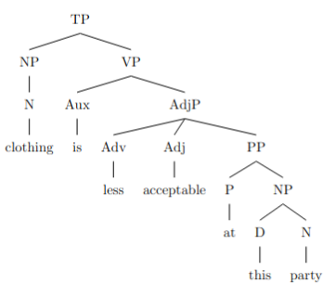

Both trees represent two different ways of parsing the sentence, corresponding to the two interpretations given above.

amb_12.txt gpt-4-0314 temperature=1.0
PROMPT: Consider the sentence below. Is it syntactically ambiguous? If so, provide code for syntactic trees representing each possible parse of the sentence that can be rendered with LaTeX's forest package. Assume X-bar theory.
"There are more comfortable seats in the lobby."
REPLY: Yes, the sentence is syntactically ambiguous. Here are two possible syntactic trees, representing each possible parse, which can be rendered with LaTeX's forest package.

1. Interpretation: There is a greater number of comfortable seats in the lobby.
```
\begin{forest}
[TP
[DP
[\textit{There}]
]
[T'
[T
[\textit{are}]
]
[VP
[QP
[\textit{more}]
]
[V'
[AdjP
[\textit{comfortable}]
]
[V
[\textit{seats}]
]
]
[PP
[P
[\textit{in}]
]
[NP
[\textit{the lobby}]
]
]
]
]
]
\end{forest}
```

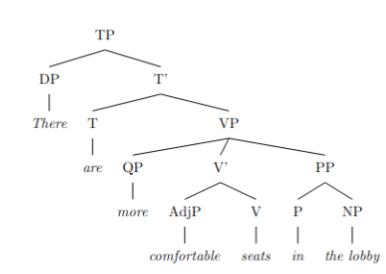

2. Interpretation: The seats in the lobby are more comfortable (than some other seats).
```
\begin{forest}
[TP
[DP
[\textit{There}]
]
[T'
[T
[\textit{are}]
]
[VP
[NP
[\textit{seats}]
]
[PP
[P
[\textit{in}]
]
[NP
[\textit{the lobby}]
]
]
[V'
[AdjP
[Deg
[\textit{more}]
]
[Adj
[\textit{comfortable}]
]
]
]
]
]
]
\end{forest}
```

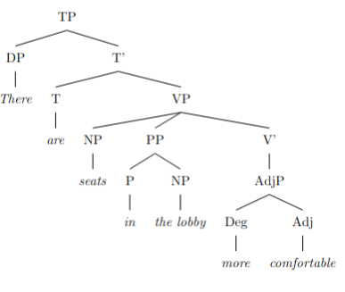

amb_13.txt gpt-4-0314 temperature=1.0
PROMPT: Consider the sentence below. Is it syntactically ambiguous? If so, provide code for syntactic trees representing each possible parse of the sentence that can be rendered with LaTeX's forest package. Assume X-bar theory.
"Eric sent his employee agreements."
REPLY: Yes, the sentence "Eric sent his employee agreements" is syntactically ambiguous. There are two possible ways to parse the sentence:

1. Eric sent (agreements related to his employee).
2. Eric sent (his employee) (some agreements).

Here are the corresponding syntactic trees in the format of the LaTeX forest package:

1.
\begin{forest}
[TP
[NP [N [Eric]]]
[VP [V [sent]]
[NP
[Det [his]]
[N'
[N [employee]]
[N' [N [agreements]]]
]
]
]
]
\end{forest}

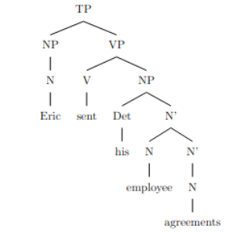
2.
\begin{forest}
[TP
[NP [N [Eric]]]
[VP [V [sent]]
[DP
[D [his]]
[NP [N [employee]]]
]
[NP [N [agreements]]]
]
]
\end{forest}

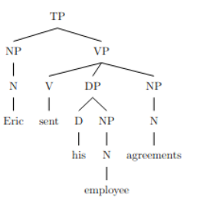

amb_14.txt gpt-4-0314 temperature=1.0
PROMPT: Consider the sentence below. Is it syntactically ambiguous? If so, provide code for syntactic trees representing each possible parse of the sentence that can be rendered with LaTeX's forest package. Assume X-bar theory.
"Mary Brown read the monster tales."
REPLY: Yes, the sentence is syntactically ambiguous. There are at least two possible interpretations: (1) "Mary Brown" as a whole refers to the subject who read the monster tales, and (2) "Mary" is the subject, who read the "Brown monster tales." Here are the code snippets for the two syntactic trees:

1) "Mary Brown" as the subject who read the monster tales:
```
\begin{forest}
[TP
[NP
[NNP [Mary]]
[NNP [Brown]]
]
[T'
[VP
[V [read]]
[NP [Det [the]] [N' [N [monster]] [N [tales]]]]
]
]
]
\end{forest}
```
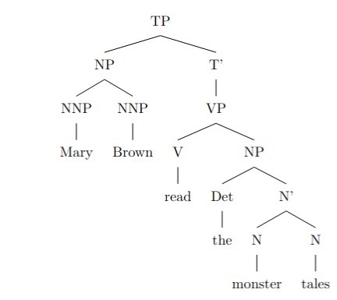
2) "Mary" as the subject, who read the "Brown monster tales":
```
\begin{forest}
[TP
[NP
[NNP [Mary]]
]
[T'
[VP
[V [read]]
[NP
[Det [the]]
[N'
[N [monster]]
[N'
[NN [Brown]]
[N [tales]]
]
]
]
]
]
]
\end{forest}
```

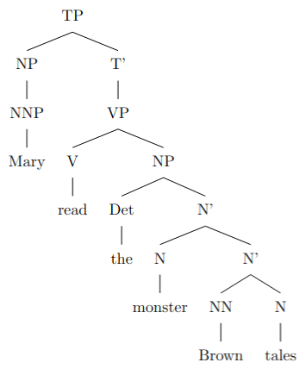

amb_15.txt gpt-4-0314 temperature=1.0
PROMPT: Consider the sentence below. Is it syntactically ambiguous? If so, provide code for syntactic trees representing each possible parse of the sentence that can be rendered with LaTeX's forest package. Assume X-bar theory.
"Rowan fed his pet chicken."
REPLY: Yes, the sentence "Rowan fed his pet chicken" is syntactically ambiguous. There are two possible interpretations:

1. Rowan gave food to his pet, which is a chicken.
2. Rowan fed his pet using chicken as the food.

Here are the syntactic trees for each parse in LaTeX's forest package format:

Parse 1 (feeding the pet chicken):
```
\begin{forest}
[TP
[DP
[D]
[NP
[{Rowan},roof]
]
]
[T'
[T
[\textit{tensed}]
]
[VP
[V
[{fed},roof]
]
[DP
[PossP
[DP
[D]
[NP
[{his},roof]
]
]
[Poss'
[Poss
[\textit{poss}]
]
[NP
[{pet},roof]
]
]
]
[N'
[N
[{chicken},roof]
]
]
]
]
]
]
\end{forest}
```
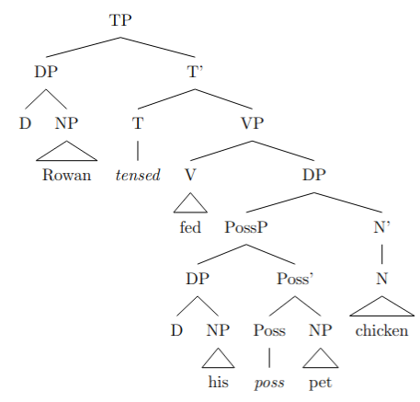

Parse 2 (feeding the pet with chicken as food):
```
\begin{forest}
[TP
[DP
[D]
[NP
[{Rowan},roof]
]
]
[T'
[T
[\textit{tensed}]
]
[VP
[V
[{fed},roof]
]
[DP
[PossP
[DP
[D]
[NP
[{his},roof]
]
]
[Poss'
[Poss
[\textit{poss}]
]
[NP
[{pet},roof]
]
]
]
]
[DP
[N'
[N
[{chicken},roof]
]
]
]
]
]
]
\end{forest}
```
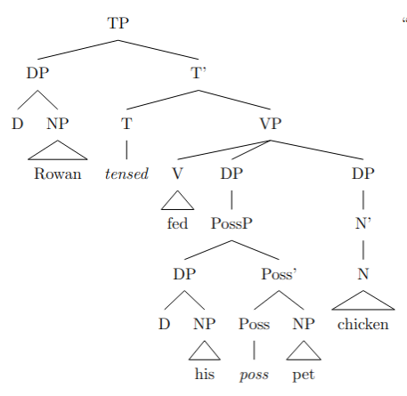

amb_16.txt gpt-4-0314 temperature=1.0
PROMPT: Consider the sentence below. Is it syntactically ambiguous? If so, provide code for syntactic trees representing each possible parse of the sentence that can be rendered with LaTeX's forest package. Assume X-bar theory.
"Susanna called her friend at the hospital."
REPLY: Yes, the sentence is syntactically ambiguous. It has two possible parses:

1. Susanna called [her friend] [at the hospital]: Susanna called her friend who was at the hospital.
2. [Susanna called her friend] [at the hospital]: Susanna was at the hospital when she called her friend.

Here are the code snippets for the two syntactic trees:

1. Susanna called [her friend] [at the hospital]:
```
\begin{forest}
[TP
[NP [Susanna, triangle]]
[T'
[V [called, triangle]]
[VP
[NP [her friend, triangle]]
[PP [at the hospital, triangle]]
]
]
]
\end{forest}
```
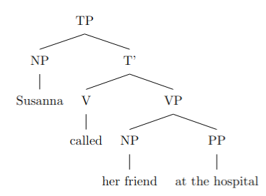

2. [Susanna called her friend] [at the hospital]:
```
\begin{forest}
[TP
[NP [Susanna, triangle]]
[T'
[V [called, triangle]]
[VP
[V' [NP [her friend, triangle]]]
[PP [at the hospital, triangle]]
]
]
]
\end{forest}
```

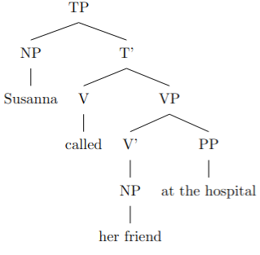

amb_17.txt gpt-4-0314 temperature=1.0
PROMPT: Consider the sentence below. Is it syntactically ambiguous? If so, provide code for syntactic trees representing each possible parse of the sentence that can be rendered with LaTeX's forest package. Assume X-bar theory.
"They visited a household with a child."
REPLY: Yes, the sentence is syntactically ambiguous. The ambiguity arises from the prepositional phrase "with a child" – it can either modify "visited" (meaning that the visiting people were accompanied by a child during the visit) or "a household" (meaning that the household they visited has a child living in it). Below are the LaTeX code for the two possible syntactic trees:

Parse 1 (the visitors were accompanied by a child):

```
\documentclass{standalone}
\usepackage[linguistics]{forest}

\begin{document}
\begin{forest}
[TP
[DP [They, roof]]
[T'
[V [visited]]
[VP
[DP [a household, roof]]
[PP [with]
[DP [a child,roof]]
]
]
]
]
\end{forest}
\end{document}
```
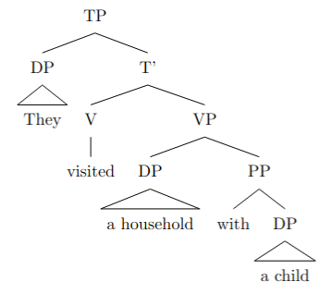
Parse 2 (the visited household has a child living in it):

```
\documentclass{standalone}
\usepackage[linguistics]{forest}

\begin{document}
\begin{forest}
[TP
[DP [They, roof]]
[T'
[V [visited]]
[VP
[DP [a household]
[PP [with]
[DP [a child,roof]]
]
]
]
]
]
\end{forest}
\end{document}
```

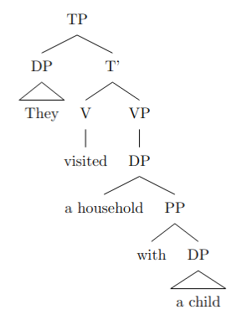

amb_18.txt gpt-4-0314 temperature=1.0
PROMPT: Consider the sentence below. Is it syntactically ambiguous? If so, provide code for syntactic trees representing each possible parse of the sentence that can be rendered with LaTeX's forest package. Assume X-bar theory.
"Julius hid the presents for the children."
REPLY: Yes, the sentence is syntactically ambiguous. There are two possible parse trees that can be rendered with LaTeX's forest package. One interpretation is that Julius hid the presents that were intended for the children. The other interpretation is that Julius hid the presents somewhere for the children to find them.

Here are code snippets for each parse tree:

Tree 1: Julius hid the presents that were intended for the children.

```
\begin{forest}
[TP
[NP
[NN [Julius]]
]
[T'
[VP
[V [hid]]
[NP
[Det [the]]
[N'
[N [presents]]
[PP
[P [for]]
[NP
[Det [the]]
[N' [N [children]]]
]
]
]
]
]
]
]
\end{forest}
```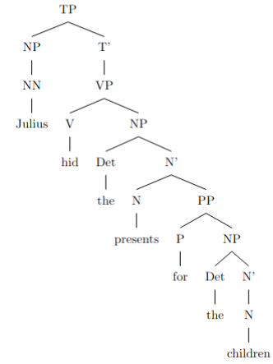

Tree 2: Julius hid the presents somewhere for the children to find them.

```
\begin{forest}
[TP
[NP
[NN [Julius]]
]
[T'
[VP
[V [hid]]
[NP
[Det [the]]
[N' [N [presents]]]
]
[PP
[P [for]]
[NP
[Det [the]]
[N' [N [children]]]
]
]
]
]
]
\end{forest}
```

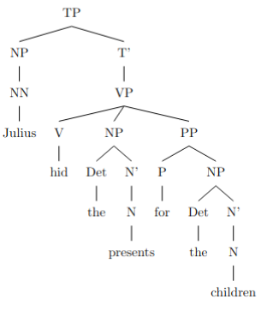

These two trees represent the two possible syntactic interpretations of the sentence "Julius hid the presents for the children".

amb_19.txt gpt-4-0314 temperature=1.0
PROMPT: Consider the sentence below. Is it syntactically ambiguous? If so, provide code for syntactic trees representing each possible parse of the sentence that can be rendered with LaTeX's forest package. Assume X-bar theory.
"You shot a pigeon sitting by the roadside."
REPLY: Yes, the sentence is syntactically ambiguous. There are two possible interpretations: (1) You shot a pigeon and the pigeon was sitting by the roadside. (2) You shot a pigeon while you were sitting by the roadside.

Here are the code for the syntactic trees representing each possible parse using LaTeX's forest package and X-bar theory:

1. You shot a pigeon (which was) sitting by the roadside:

```
\begin{forest}
[TP
[DP [You] ]
[T'
[T [shot] ]
[VP
[V']
[DP
[D [a] ]
[NP
[N [pigeon] ]
[N'
[N [sitting] ]
[PP
[P [by] ]
[DP
[D [the] ]
[NP [roadside] ]
]
]
]
]
]
]
]
]
\end{forest}
```
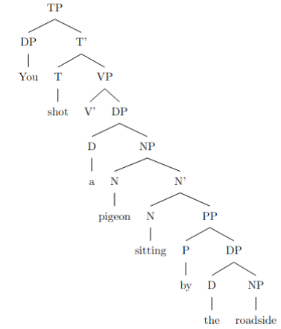
2. You (while) sitting by the roadside shot a pigeon:

```
\begin{forest}
[TP
[DP [You] ]
[T'
[T [shot] ]
[VP
[N'
[N [sitting] ]
[PP
[P [by] ]
[DP
[D [the] ]
[NP [roadside] ]
]
]
]
[V'
[DP
[D [a] ]
[NP [pigeon] ]
]
]
]
]
\end{forest}
```

DID NOT COMPILE; ADDED BRACKETS (AM)
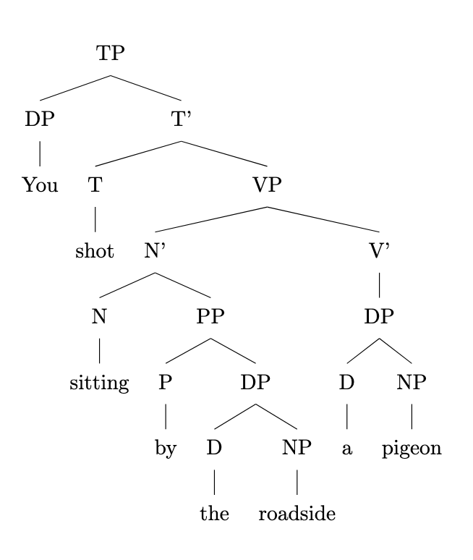

These trees represent the two different interpretations of the sentence.

amb_20.txt gpt-4-0314 temperature=1.0
PROMPT: Consider the sentence below. Is it syntactically ambiguous? If so, provide code for syntactic trees representing each possible parse of the sentence that can be rendered with LaTeX's forest package. Assume X-bar theory.
"He glanced at a badger basking in the sunlight."
REPLY: Yes, the sentence is syntactically ambiguous. There are two possible ways to parse the sentence:

1. "He glanced at a badger" that was "basking in the sunlight."
2. "He glanced" while "a badger basking in the sunlight."

Here are the codes for the syntactic trees representing each possible parse of the sentence using the forest package in LaTeX:

1. Parse 1:
```
\begin{forest}
[TP
[DP [He]]
[T'
[T [glanced]]
[VP
[V' [V [at]]]
[DP
[NP [a] [badger]]
[VP
[V' [V [b] [asking]]]
[PP [P [in]] [DP [D [the]] [NP [sunlight]]]]
]
]
]
]
]
\end{forest}
```
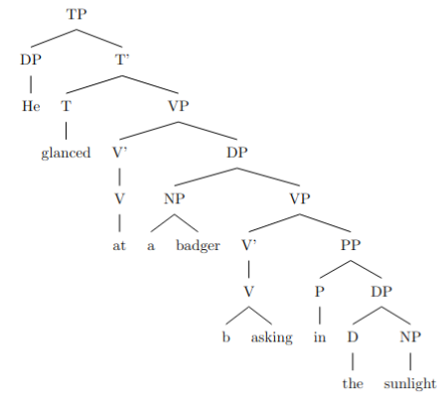
2. Parse 2:
```
\begin{forest}
[TP
[DP [He]]
[T'
[T [glanced]]
[VP
[V' [V [at]] [DP [a] [badger]]]
[VP
[V' [V [b] [asking]]]
[PP [P [in]] [DP [D [the]] [NP [sunlight]]]]
]
]
]
]
\end{forest}
```

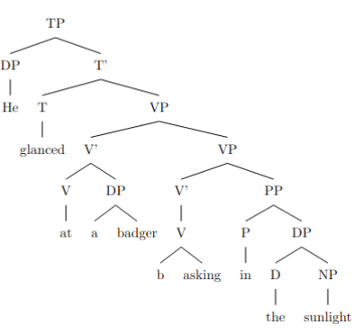

Note that the given sentence structure is a simplification and may not be fully precise in the representation of X-bar theory.

amb_21.txt gpt-4-0314 temperature=1.0
PROMPT: Consider the sentence below. Is it syntactically ambiguous? If so, provide code for syntactic trees representing each possible parse of the sentence that can be rendered with LaTeX's forest package. Assume X-bar theory.
"The envoy to the duke who offended the emperor was executed."
REPLY: Yes, the sentence is syntactically ambiguous. Here are two possible parses using X-bar theory, rendered using LaTeX's forest package:

1. In this parse, "who offended the emperor" modifies "the duke":

```
\usepackage{forest}
\begin{forest}
[CP
[NP
[NP
[D
[the]
]
[N'
[N
[envoy]
]
[PP
[P
[to]
]
[NP
[D
[the]
]
[NP
[N
[duke]
]
[CP
[C
[who]
]
[IP
[NP
[pro]
]
[I'
[I
[-ed]
]
[VP
[V
[offend]
]
[NP
[D
[the]
]
[N'
[N
[emperor]
]
]
]
]
]
]
]
]
]
]
]
]
[I')
[I
[FullPast]
]
[VP
[V[_0]
[be]
]
[VP
[V
[execute]
]
[NP
[pro]
]
]
]
]
]
]
\end{forest}
```
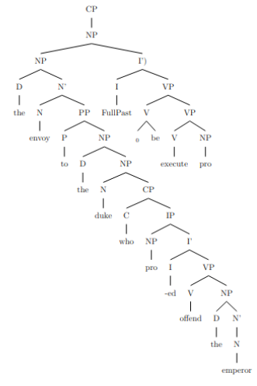
2. In this parse, "who offended the emperor" modifies "the envoy":

```
\usepackage{forest}
\begin{forest}
[CP
[NP
[NP
[D
[the]
]
[N'
[N
[envoy]
]
]
]
[CP
[C
[who]
]
[IP
[NP
[pro]
]
[I'
[I
[-ed]
]
[VP
[V
[offend]
]
[NP
[D
[the]
]
[N'
[N
[emperor]
]
]
]
]
]
]
]
]
[IP
[NP
[pro]
]
[I'
[I
[FullPast]
]
[VP
[V
[be]
]
[VP
[V
[execute]
]
[PP
[P
[to]
]
[NP
[D
[the]
]
[N'
[N
[duke]
]
]
]
]
]
]
]
]
]
\end{forest}
```

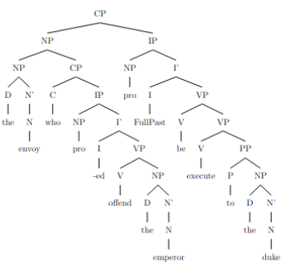

amb_22.txt gpt-4-0314 temperature=1.0
PROMPT: Consider the sentence below. Is it syntactically ambiguous? If so, provide code for syntactic trees representing each possible parse of the sentence that can be rendered with LaTeX's forest package. Assume X-bar theory.
"The critics of the activists who had become controversial were baffled."
REPLY: Yes, the sentence is syntactically ambiguous. There are two possible parse structures for the sentence:

1. The critics are baffled, and the critics are 'of the activists who had become controversial':
```
\begin{forest}
[TP [DP [D [The]] [NP [NP [N [critics]]] [PP [P [of]] [NP [DP [the]] [NP [N [activists]] [CP [C [who]] [TP [T [had]] [VP [V [become]] [AP [A [controversial]]]]]]]]]]] [T' [T [were]] [VP [V [baffled]]]]]
\end{forest}
```
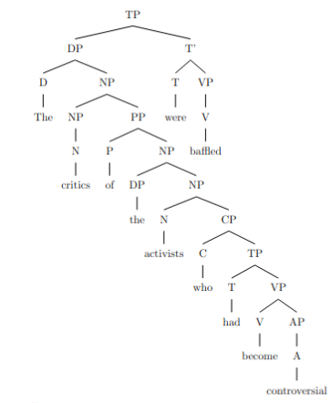

2. The critics are baffled, and the activists are 'who had become controversial':
```
\begin{forest}
[TP [DP [D [The]] [NP [N [critics]] [PP [P [of]] [NP [DP [the]] [NP [N [activists]]]]]]]] [T' [T [who]] [TP [T [had]] [VP [V [become]] [AP [A [controversial]]]]]] [T' [T [were]] [VP [V [baffled]]]]]
\end{forest}
```

COMPILE ISSUE; UPDATED TREE: DELETED EXTRA BRACKET (AM)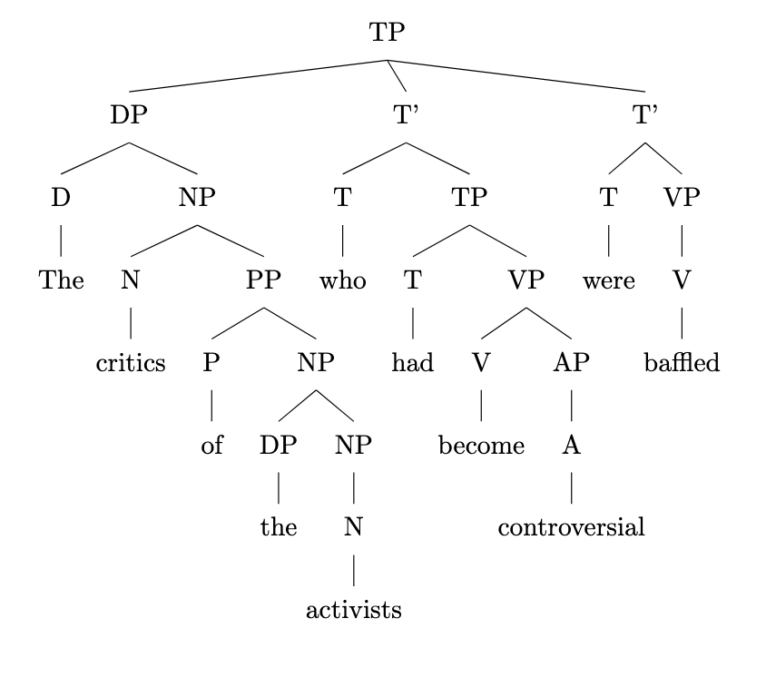

In both cases, the critics are baffled but the attachment point of the relative clause "who had become controversial" differs, either modifying the activists in the first case or modifying the whole noun phrase "critics of the activists" in the second case.

amb_23.txt gpt-4-0314 temperature=1.0
PROMPT: Consider the sentence below. Is it syntactically ambiguous? If so, provide code for syntactic trees representing each possible parse of the sentence that can be rendered with LaTeX's forest package. Assume X-bar theory.
"The girl who was weeping quietly left."
REPLY: Yes, the sentence is syntactically ambiguous. There are two possible parses for the sentence:

1. The girl who was weaping quietly left. (The girl left, and she was weeping quietly.)
2. The girl who was weeping quietly left. (The girl was weeping, and she left quietly.)

Here are the syntactic trees representing each possible parse in LaTeX's forest package format:

% parse 1
\begin{forest}
[CP
[C'
[C]
[TP
[DP [D [the]] [NP [N [girl]] [CP [C [who]] [TP [T [was]] [VP [V [weeping]] [AdvP [Adv [quietly]]]]]]]]
[T'
[T]
[VP
[V [left]]
]
]
]
]
]
\end{forest}
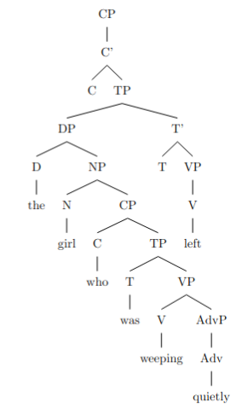
% parse 2
\begin{forest}
[CP
[C'
[C]
[TP
[DP [D [the]] [NP [N [girl]] [CP [C [who]] [TP [T [was]] [VP [V [weeping]]]]]]]
[T'
[T]
[VP
[V [left]]
[AdvP [Adv [quietly]]]
]
]
]
]
]
\end{forest}

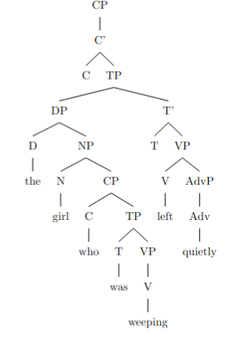

amb_24.txt gpt-4-0314 temperature=1.0
PROMPT: Consider the sentence below. Is it syntactically ambiguous? If so, provide code for syntactic trees representing each possible parse of the sentence that can be rendered with LaTeX's forest package. Assume X-bar theory.
"The Tesla that was about to explode spontaneously swerved."
REPLY: Yes, the sentence is syntactically ambiguous. There are two possible interpretations:

1. The "about to explode" applies to the Tesla itself: the Tesla, which was about to explode, swerved spontaneously. In this case, "about to explode" modifies the noun "Tesla."

2. The "about to explode" applies to the action of swerving spontaneously: the Tesla swerved spontaneously "in a manner" that it was about to explode. In this case, "about to explode" modifies the verb phrase "spontaneously swerved."

Here are the syntactic trees for both interpretations:

```latex
\begin{forest}
[TP
[DP
[D[The]]
[NP
[N[Tesla]]
[PP
[RelP[that]]
[VP
[Aux[was]]
[VP
[AdvP[about]]
[V[to]]
[V[explode]]
]
]
]
]
]
[VP
[AdvP[spontaneously]]
[V[swerve]]
]
]
\end{forest}
```
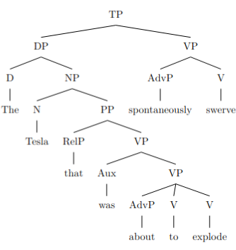
```latex
\begin{forest}
[TP
[DP
[D[The]]
[NP[Tesla]]
]
[VP
[Aux[was]]
[VP
[RelP[that]]
[VP
[AdvP[about]]
[V[to]]
[V[explode]]
]
[VP[spontaneously]
[V[swerve]]
]
]
]
]
\end{forest}
```

Please note that you need to include the forest package (`\usepackage{forest}`) in the preamble of your LaTeX document for these trees to be rendered successfully.

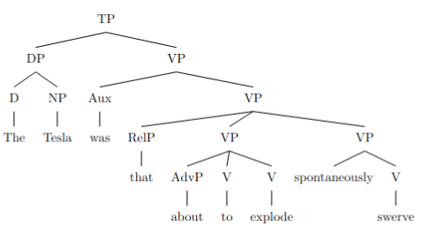

amb_25.txt gpt-4-0314 temperature=1.0
PROMPT: Consider the sentence below. Is it syntactically ambiguous? If so, provide code for syntactic trees representing each possible parse of the sentence that can be rendered with LaTeX's forest package. Assume X-bar theory.
"Lara Croft decided in May she would raid more tombs."
REPLY: Yes, the sentence is syntactically ambiguous. There can be two different interpretations of this sentence:

1. Lara Croft made a decision in the month of May that she would raid more tombs.
2. Lara Croft decided that she would raid more tombs that are located in the month of May.

Here are the syntactic trees representing each possible parse using X-bar theory, formatted with LaTeX's forest package:

1. Decision in May:
```
\usepackage{forest}
\begin{forest}
[CP
[DP, name=subject [Lara Croft, triangle]]
[C’
[C]
[TP
[T’
[T [decided]]
[VP
[PP [in May, triangle]]
[V’
[V]
[CP
[C [$\varnothing$]]
[TP
[DP]
[T’
[T [would]]
[VP
[V [raid]]
[DP
[QP [more, triangle]]
[N’
[N [tombs, triangle]]
]
]
]
]
]
]
]
]
]
]
]
]
\end{forest}
```
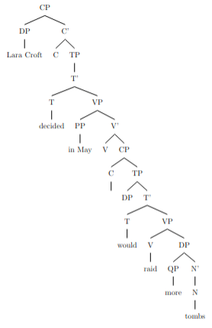
2. Raiding tombs in May:
```
\usepackage{forest}
\begin{forest}
[CP
[DP, name=subject [Lara Croft, triangle]]
[C’
[C]
[TP
[T’
[T [decided]]
[VP
[V]
[CP
[C [$\varnothing$]]
[TP
[DP]
[T’
[T [would]]
[VP
[V [raid]]
[DP
[QP [more, triangle]]
[N’
[N [tombs, triangle]]
[PP [in May, triangle]]
]
]
]
]
]
]
]
]
]
]
]
\end{forest}
```

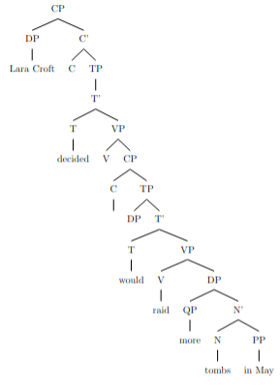

amb_26.txt gpt-4-0314 temperature=1.0
PROMPT: Consider the sentence below. Is it syntactically ambiguous? If so, provide code for syntactic trees representing each possible parse of the sentence that can be rendered with LaTeX's forest package. Assume X-bar theory.
"Alex swore on Saturday he would visit his grandfather."
REPLY: Yes, the sentence is syntactically ambiguous. The ambiguity lies in whether "on Saturday" modifies the verb "swore" or the verb "visit." There are two possible parse trees representing each interpretation:

1. "on Saturday" modifies "swore"

\documentclass{standalone}
\usepackage{forest}
\begin{document}
\begin{forest}
[TP
[NP [N [Alex]]]
[T'
[T [swore]]
[VP
[PP [P [on]] [NP [N [Saturday]]]]
[V'
[V]
[ComplementizerP [Complementizer [he]]
[TP
[T [would]]
[VP
[V [visit]]
[NP [D [his]] [N [grandfather]] ]
]
]
]
]
]
]
]
\end{forest}
\end{document}
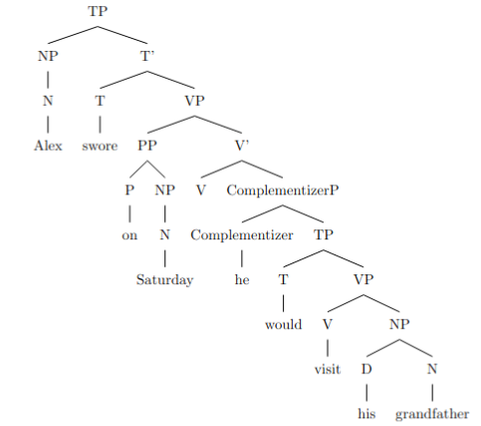
2. "on Saturday" modifies "visit"

\documentclass{standalone}
\usepackage{forest}
\begin{document}
\begin{forest}
[TP
[NP [N [Alex]]]
[T'
[T [swore]]
[VP
[V']
[V]
[ComplementizerP [Complementizer [he]]
[TP
[T [would]]
[VP
[V [visit]]
[PP [P [on]] [NP [N [Saturday]]]]
[NP [D [his]] [N [grandfather]] ]
]
]
]
]
]
]
\end{forest}
\end{document}

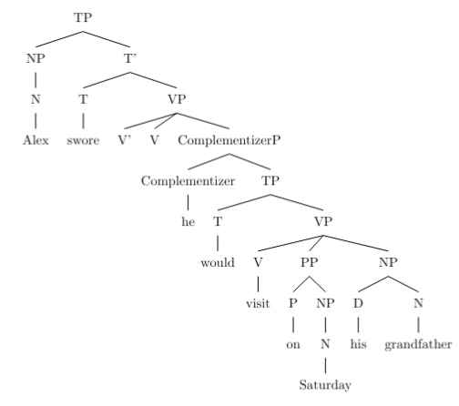

In the first parse tree, "on Saturday" is a sister to the ComplementizerP that contains "he would visit," making it a modifier for "swore." In the second parse tree, "on Saturday" is a sister to the NP "his grandfather," making it a modifier for "visit."

amb_27.txt gpt-4-0314 temperature=1.0
PROMPT: Consider the sentence below. Is it syntactically ambiguous? If so, provide code for syntactic trees representing each possible parse of the sentence that can be rendered with LaTeX's forest package. Assume X-bar theory.
"He told me he ate the leftovers yesterday."
REPLY: Yes, the sentence "He told me he ate the leftovers yesterday." is syntactically ambiguous. There are two possible parses for this sentence:

1. He told me yesterday that he ate the leftovers.
2. He told me that he ate the leftovers yesterday.

Here are the forest package codes for representing the syntactic trees for each parse:

1. He told me yesterday that he ate the leftovers:
```
\begin{forest}
[CP
[C'
[C ]
[TP
[NP [PRP [He] ]]
[T'
[T [VBD [told] ]]
[VP
[V'
[V ]
[NP [PRP [me] ]]
]
[CP
[C [that] ]
[TP
[NP [PRP [he] ]]
[T'
[T [VBD [ate] ]]
[VP
[NP [DT [the] ] [NN [leftovers] ]]
[PP
[P [IN[yesterday]]]
]
]
]
]
]
]
]
]
]
]
\end{forest}
```
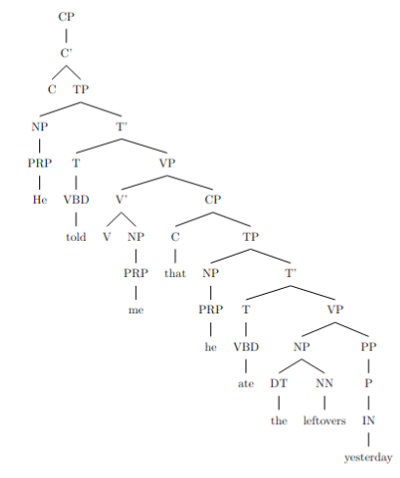
2. He told me that he ate the leftovers yesterday:
```
\begin{forest}
[CP
[C'
[C ]
[TP
[NP [PRP [He] ]]
[T'
[T [VBD [told] ]]
[VP
[V'
[V ]
[NP [PRP [me] ]]
]
[CP
[C [that] ]
[TP
[NP [PRP [he] ]]
[T'
[T [VBD [ate] ]]
[VP
[NP [DT [the] ] [NN [leftovers] ]]
[PP
[P [IN[yesterday]]]
]
]
]
]
]
]
]
]
]
]
\end{forest}
```
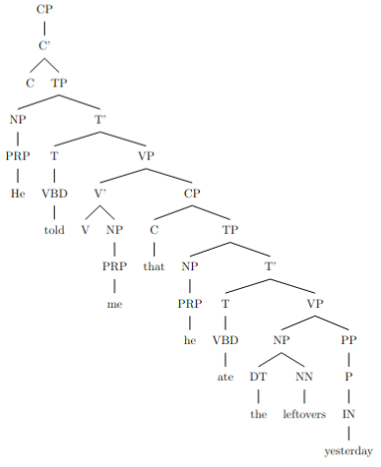
These code snippets can be used in a LaTeX document with the forest package to produce the syntactic trees for the respective parses.

amb_28.txt gpt-4-0314 temperature=1.0
PROMPT: Consider the sentence below. Is it syntactically ambiguous? If so, provide code for syntactic trees representing each possible parse of the sentence that can be rendered with LaTeX's forest package. Assume X-bar theory.
"He dreamed that he'd shown up to school late the day of a test."
REPLY: Yes, the sentence is syntactically ambiguous. There are two possible parses for the sentence:

1. He dreamed that [(he'd shown up to school late) the day of a test].
2. He dreamed that [he'd shown up to school late (the day of a test)].

Here are the corresponding syntactic trees in LaTeX's forest package:

1.
```
\begin{forest}
[CP
[NP
[He]
]
[C'
[C
[dreamed]
]
[CP
[C'
[C
[that]
]
[VP
[V'
[V
[he'd shown up to school late]
]
[NP
[the day of a test]
]
]
]
]
]
]
]
\end{forest}
```
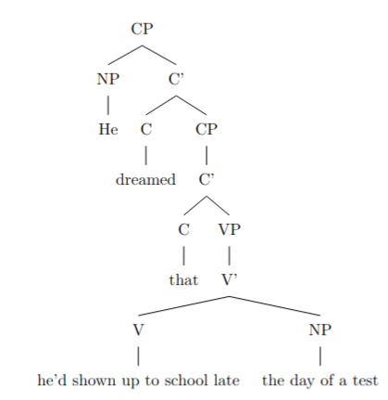
2.
```
\begin{forest}
[CP
[NP
[He]
]
[C'
[C
[dreamed]
]
[CP
[C'
[C
[that]
]
[VP
[V'
[V
[he'd shown up]
]
[PP
[P'
[P
[to school late]
]
[NP
[the day of a test]
]
]
]
]
]
]
]
]
]
\end{forest}
```
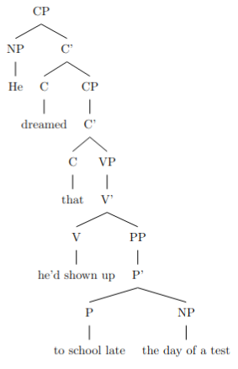
Note: Due to potential limitations in the formatting of the forest package here, you may need to adjust the tree structure according to your desired X-bar theory implementation.

amb_29.txt gpt-4-0314 temperature=1.0
PROMPT: Consider the sentence below. Is it syntactically ambiguous? If so, provide code for syntactic trees representing each possible parse of the sentence that can be rendered with LaTeX's forest package. Assume X-bar theory.
"I knew I wanted to speak to my lawyer but she was away from the phone."
REPLY: Yes, the sentence is syntactically ambiguous. There are two possible ways to parse it.

1. "I knew (that) I wanted to speak to my lawyer, but she was away from the phone." Here, "but she was away from the phone" is a separate clause and contrasts "I wanted to speak to my lawyer."

2. "I knew I wanted to speak to my lawyer but (that) she was away from the phone." In this parse, "but she was away from the phone" is the complement of "I knew." The speaker knew two things: that they wanted to speak to their lawyer and that she was away from the phone.

Here are the syntax trees representing each possible parse rendered with LaTeX's forest package and X-bar theory (omitting some details for simplicity):

First parse:
```
\begin{forest}
[CP
[C]
[IP
[I\\knew, tier=pos1]
[CP
[C] [IP
[I\\wanted, tier=pos1]
[VP [V\\to] [VP [V\\speak] [PP [P\\to] [NP [D\\my] [N\\lawyer]]]]]
]
]
[CoordP
[Coord\\but]
[CP
[C] [IP
[NP [Pron\\she]]
[I' [I\\was] [VP [V] [AP [A\\away] [PP [P\\from] [NP [N\\the] [N\\phone]]]]]]
]
]
]
]
\end{forest}
```
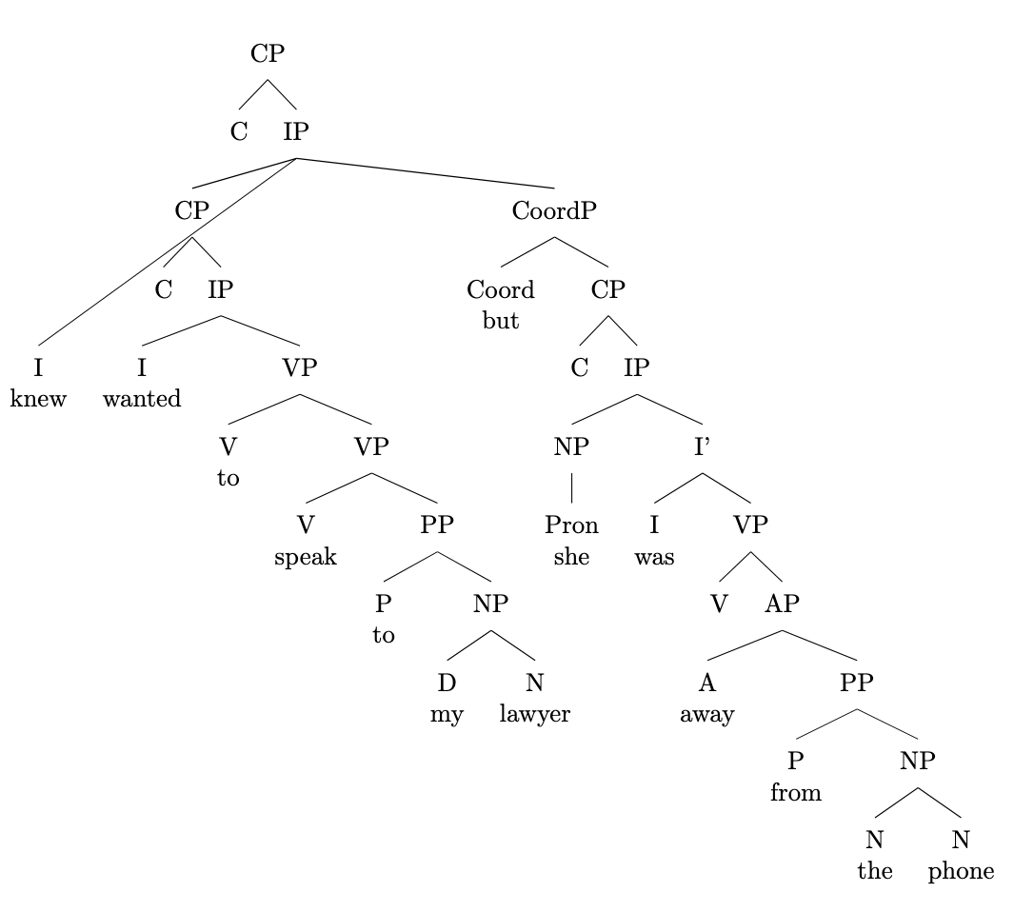
DID NOT COMPILE; ADDED BRACKET (AM)

Second parse:
```
\begin{forest}
[CP
[C]
[IP
[I\\knew, tier=pos1]
[CoordP
[CP
[C] [IP
[I\\wanted, tier=pos1]
[VP [V\\to] [VP [V\\speak] [PP [P\\to] [NP [D\\my] [N\\lawyer]]]]]
]
]
]
[Coord\\but]
[CP
[C] [IP
[NP [Pron\\she]]
[I' [I\\was] [VP [V] [AP [A\\away] [PP [P\\from] [NP [N\\the] [N\\phone]]]]]]
]
]
]
]
\end{forest}
```
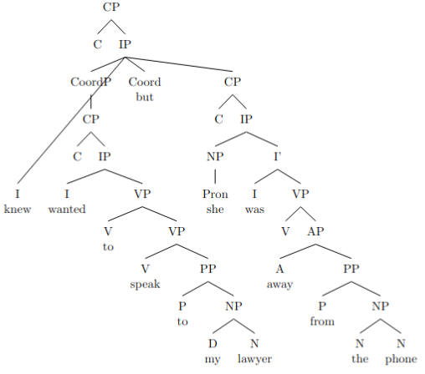

amb_30.txt gpt-4-0314 temperature=1.0
PROMPT: Consider the sentence below. Is it syntactically ambiguous? If so, provide code for syntactic trees representing each possible parse of the sentence that can be rendered with LaTeX's forest package. Assume X-bar theory.
"Francisco believed his peers were idiots and they resented him."
REPLY: Yes, the sentence is syntactically ambiguous. Here are two possible parses of the sentence:

Parse 1 (Francisco believed both propositions):
\begin{forest}
[CP
[C]
[TP
[DP
[D][Francisco]
]
[T'
[T][believed]
[CP
[C]
[TP
[ConjP
[TP
[DP
[D][his]
[N'[N][peers]]
]
[T'
[T][were]
[AdjP[Adj][idiots]]
]
]
[Conj'[Conj][and]
[TP
[DP[D][they]]
[T'
[T][resented]
[DP
[D][him]
]
]
]
]
]
]
]
]
]
\end{forest}

FAILED TO COMPILE; ADDED BRACKET (AM)

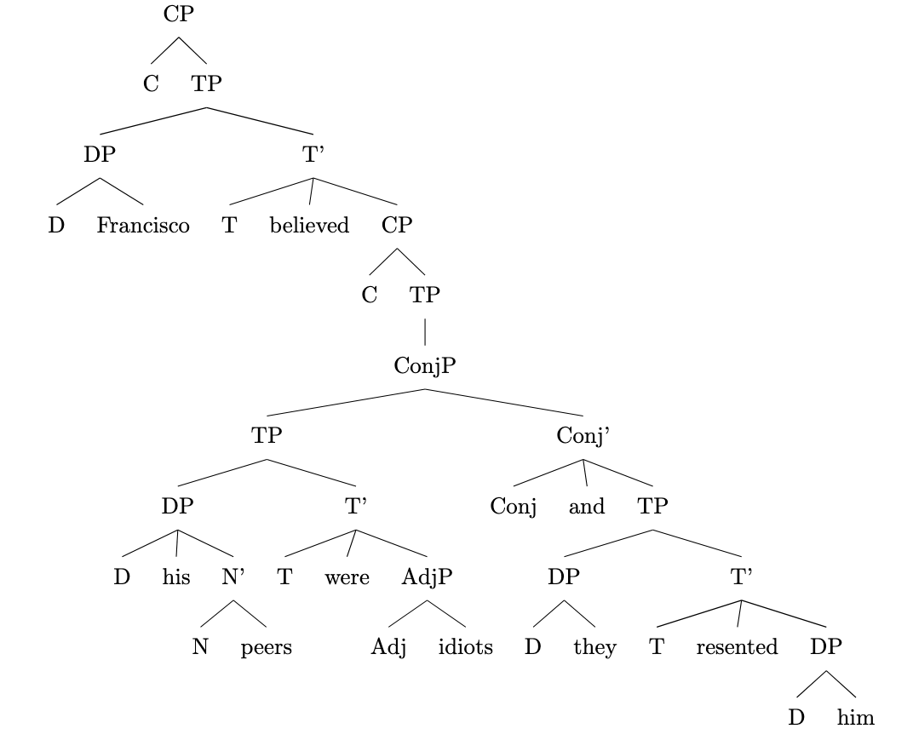
Parse 2 (Francisco only believed the first proposition, and the peers resented him based on that):
\begin{forest}
[CP
[C]
[TP
[DP
[D][Francisco]
]
[T'
[T][believed]
[CP
[C]
[TP
[DP
[D][his]
[N'[N][peers]]
]
[T'
[T][were]
[AdjP
[ConjP
[Adj'[Adj][idiots]]
[Conj'[Conj][and]
[TP
[DP[D][they]]
[T'
[T][resented]
[DP
[D][him]
]
]
]
]
]
]
]
]
]
]
]
\end{forest}

FAILED TO COMPILE; ADDED BRACKET (AM)
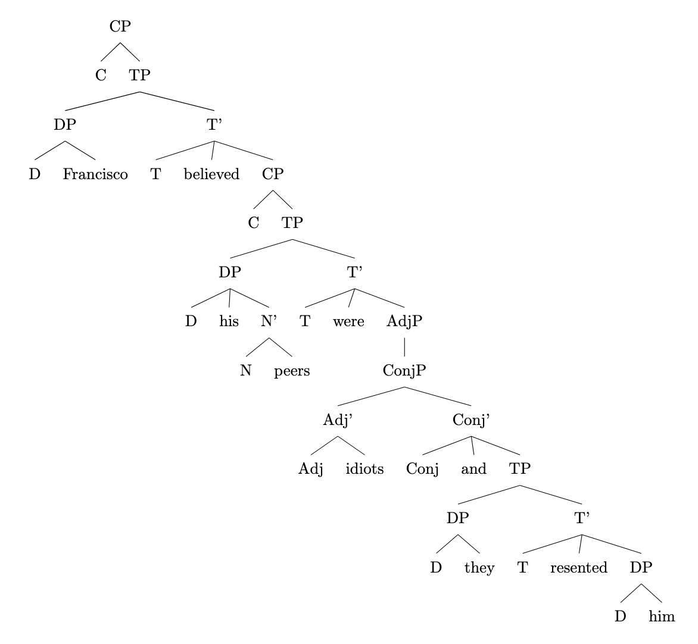
In Parse 1, Francisco believes both that his peers were idiots and that they resented him. In Parse 2, Francisco only believes that his peers were idiots, and they resent him because of that belief.

Messages generated with 12650 tokens

meta.llama3-1-405b-instruct-v1

amb_01.txt arn:aws:bedrock:us-west-2::foundation-model/meta.llama3-1-405b-instruct-v1:0 temperature=0.5
PROMPT: Consider the sentence below. Is it syntactically ambiguous? If so, provide code for syntactic trees representing each possible parse of the sentence that can be rendered with LaTeX's forest package. Assume X-bar theory.
"A passer-by has heard her pump."
REPLY: Yes, the sentence is syntactically ambiguous. Here are the two possible parses:

1. "A passer-by has heard her pump" (where "her pump" is a noun phrase referring to a pump belonging to her)

```latex
\begin{forest}
[S
[NP [Det [a]]
[N [passer-by]]]
[VP [V [has]]
[VP [V [heard]]
[NP [Det [her]]
[N [pump]]]]]
]
\end{forest}
```
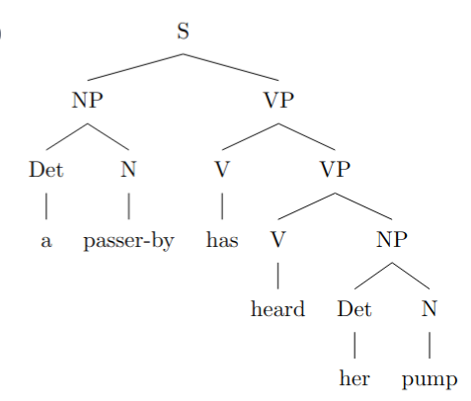
2. "A passer-by has heard her pump" (where "her pump" is a verb phrase meaning to pump something for her)

```latex
\begin{forest}
[S
[NP [Det [a]]
[N [passer-by]]]
[VP [V [has]]
[VP [V [heard]]
[VP [V [her]]
[V [pump]]]]]
]
\end{forest}
```
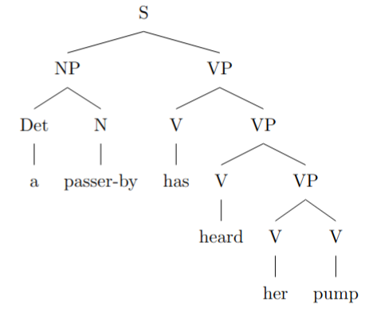

However, this second parse is unlikely, as "her" is not typically used as a verb. A more likely second parse would be:

2. "A passer-by has heard her pump" (where "pump" is a verb and "her" is the object being pumped)

```latex
\begin{forest}
[S
[NP [Det [a]]
[N [passer-by]]]
[VP [V [has]]
[VP [V [heard]]
[VP [NP [Det [her]]]
[V [pump]]]]]
]
\end{forest}
```

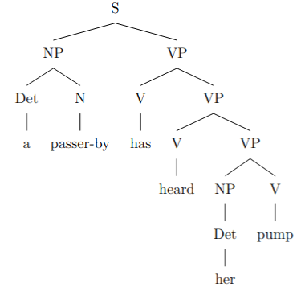
Note that the actual parse may depend on the context in which the sentence is used.

amb_02.txt arn:aws:bedrock:us-west-2::foundation-model/meta.llama3-1-405b-instruct-v1:0 temperature=0.5
PROMPT: Consider the sentence below. Is it syntactically ambiguous? If so, provide code for syntactic trees representing each possible parse of the sentence that can be rendered with LaTeX's forest package. Assume X-bar theory.
"The opposite team had her duck."
REPLY: Yes, the sentence is syntactically ambiguous. Here are the two possible parses:

**Parse 1: "her" is a possessive pronoun modifying "duck"**

```latex
\documentclass{article}
\usepackage[linguistics]{forest}

\begin{document}

\begin{forest}
[TP
[DP [The opposite team]]
[T' [T [had]]
[VP
[DP [her duck]]
]
]
]
\end{forest}

\end{document}
```
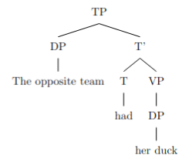
**Parse 2: "her" is an object pronoun and "duck" is a verb**

```latex
\documentclass{article}
\usepackage[linguistics]{forest}

\begin{document}

\begin{forest}
[TP
[DP [The opposite team]]
[T' [T [had]]
[VP
[DP [her]]
[V' [V [duck]]
]
]
]
]
\end{forest}

\end{document}
```

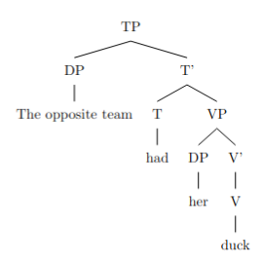

In the first parse, "her" is a possessive pronoun modifying the noun "duck", indicating that the duck belongs to her. In the second parse, "her" is an object pronoun and "duck" is a verb, indicating that the opposite team had her (as an object) duck (as a verb, meaning to lower or avoid something).

amb_03.txt arn:aws:bedrock:us-west-2::foundation-model/meta.llama3-1-405b-instruct-v1:0 temperature=0.5
PROMPT: Consider the sentence below. Is it syntactically ambiguous? If so, provide code for syntactic trees representing each possible parse of the sentence that can be rendered with LaTeX's forest package. Assume X-bar theory.
"Eliza wanted her cast out."
REPLY: Yes, the sentence is syntactically ambiguous. Here are the two possible parses:

**Parse 1: Eliza wanted [her cast out]**

In this parse, "her cast out" is a constituent, with "her" as the object of the verb "cast out".

```latex
\documentclass{article}
\usepackage[linguistics]{forest}

\begin{document}

\begin{forest}
[VP
[V
[Eliza]
[wanted]
]
[VP
[V
[cast]
[out]
]
[DP
[her]
]
]
]
\end{forest}

\end{document}
```
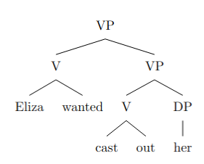
**Parse 2: Eliza wanted [her] [cast out]**

In this parse, "her" is the object of the verb "wanted", and "cast out" is a separate constituent.

```latex
\documentclass{article}
\usepackage[linguistics]{forest}

\begin{document}

\begin{forest}
[VP
[V
[Eliza]
[wanted]
]
[DP
[her]
]
[VP
[V
[cast]
[out]
]
]
]
\end{forest}

\end{document}
```

Note that the first parse implies that Eliza wanted someone to cast her out, while the second parse implies that Eliza wanted someone (her) to be cast out. The two parses have different semantic interpretations.
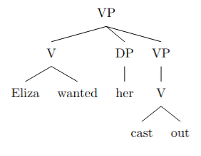

amb_04.txt arn:aws:bedrock:us-west-2::foundation-model/meta.llama3-1-405b-instruct-v1:0 temperature=0.5
PROMPT: Consider the sentence below. Is it syntactically ambiguous? If so, provide code for syntactic trees representing each possible parse of the sentence that can be rendered with LaTeX's forest package. Assume X-bar theory.
"Tobias kept her wound up."
REPLY: Yes, the sentence is syntactically ambiguous. The ambiguity arises from the possible attachment of the prepositional phrase "up". Here are two possible parses:

1. Tobias kept her wound (up) - In this parse, "up" is an adjunct modifying the verb "kept".

```latex
\documentclass{article}
\usepackage{forest}

\begin{document}

\begin{forest}
[VP
[V
[V [Tobias]]
[V [kept]]
]
[DP [her]]
[NP
[N [wound]]
[P [up]]
]
]
\end{forest}

\end{document}
```
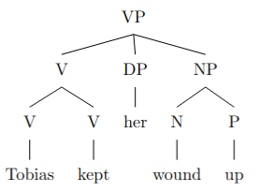
However, this representation is not entirely accurate under X-bar theory. A more accurate representation would be:

```latex
\documentclass{article}
\usepackage{forest}

\begin{document}

\begin{forest}
[VP
[V'
[V [kept]]
[DP [her]]
]
[NP'
[N [wound]]
[P [up]]
]
]
\end{forest}

\end{document}
```
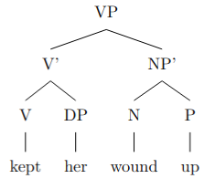
2. Tobias kept her (wound up) - In this parse, "wound up" is a phrasal verb.

```latex
\documentclass{article}
\usepackage{forest}

\begin{document}

\begin{forest}
[VP
[V'
[V [kept]]
[DP [her]]
]
[VP
[V'
[V [wound]]
[P [up]]
]
]
]
\end{forest}

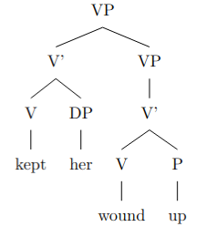

\end{document}
```

However, this representation still doesn't capture the phrasal verb "wound up" correctly. A more accurate representation would be:

```latex
\documentclass{article}
\usepackage{forest}

\begin{document}

\begin{forest}
[VP
[V'
[V [kept]]
[DP [her]]
]
[VP
[V' [wound up]]
]
]
\end{forest}

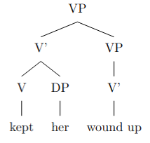

\end{document}
```

Or, following X-bar theory more strictly:

```latex
\documentclass{article}
\usepackage{forest}

\begin{document}

\begin{forest}
[VP
[V'
[V [kept]]
[DP [her]]
]
[VP
[V'
[V [wound up]]
]
]
]
\end{forest}

\end{document}
```
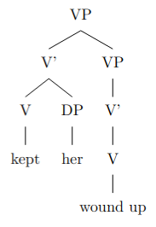

amb_05.txt arn:aws:bedrock:us-west-2::foundation-model/meta.llama3-1-405b-instruct-v1:0 temperature=0.5
PROMPT: Consider the sentence below. Is it syntactically ambiguous? If so, provide code for syntactic trees representing each possible parse of the sentence that can be rendered with LaTeX's forest package. Assume X-bar theory.
"The new director has had her set."
REPLY: A great sentence!

Yes, the sentence is syntactically ambiguous. The ambiguity arises from the attachment of the possessive pronoun "her". It can either be attached to the noun "set" as a possessive modifier or be part of the verb phrase "has had her" as an object.

Here are the two possible syntactic trees in LaTeX's forest package:

**Tree 1: "her" as a possessive modifier**

```latex
\documentclass{article}
\usepackage[linguistics]{forest}

\begin{document}

\begin{forest}
[TP
[DP [The] [new] [director]]
[T' [T [has]]
[VP [V' [V [had]]
[DP [her] [set]]]]]]
\end{forest}

\end{document}
```
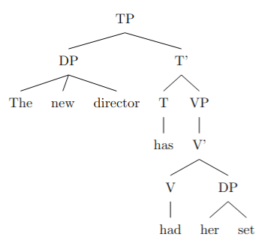
**Tree 2: "her" as an object**

```latex
\documentclass{article}
\usepackage[linguistics]{forest}

\begin{document}

\begin{forest}
[TP
[DP [The] [new] [director]]
[T' [T [has]]
[VP [V' [V [had]]
[DP [her]]
[DP [set]]]]]]
\end{forest}

\end{document}
```
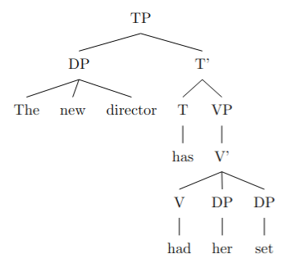
In Tree 1, "her" is attached to "set" as a possessive modifier, while in Tree 2, "her" is an object of the verb "had". Note that these trees assume a simplified X-bar structure, with some details omitted for clarity.

amb_06.txt arn:aws:bedrock:us-west-2::foundation-model/meta.llama3-1-405b-instruct-v1:0 temperature=0.5
PROMPT: Consider the sentence below. Is it syntactically ambiguous? If so, provide code for syntactic trees representing each possible parse of the sentence that can be rendered with LaTeX's forest package. Assume X-bar theory.
"Without her calling, they will fail."
REPLY: Yes, the sentence is syntactically ambiguous. The prepositional phrase "Without her calling" can be interpreted as either a modifier of the main clause or as a complement of the main verb.

Here are the two possible syntactic trees in LaTeX's forest package:

**Tree 1: PP as modifier**

```latex
\documentclass{article}
\usepackage[linguistics]{forest}

\begin{document}

\begin{forest}
[TP
[PP [P [Without]]
[NP [PRON [her]]
[VP [V [calling]]]]
]
[T' [T [will]]
[VP [V [fail]]
[NP [PRON [they]]]
]
]
]
\end{forest}

\end{document}
```
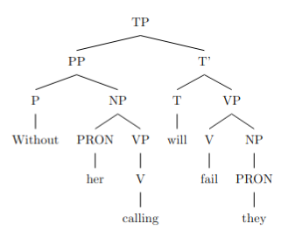
**Tree 2: PP as complement**

```latex
\documentclass{article}
\usepackage[linguistics]{forest}

\begin{document}

\begin{forest}
[TP
[T' [T [will]]
[VP [V [fail]]
[PP [P [Without]]
[NP [PRON [her]]
[VP [V [calling]]]]
]
[NP [PRON [they]]]
]
]
]
\end{forest}

\end{document}
```

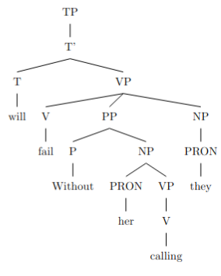

In Tree 1, the PP "Without her calling" is a modifier of the main clause, while in Tree 2, it is a complement of the main verb "fail". Note that the trees are simplified and do not show all the possible functional projections.

amb_07.txt arn:aws:bedrock:us-west-2::foundation-model/meta.llama3-1-405b-instruct-v1:0 temperature=0.5
PROMPT: Consider the sentence below. Is it syntactically ambiguous? If so, provide code for syntactic trees representing each possible parse of the sentence that can be rendered with LaTeX's forest package. Assume X-bar theory.
"Her mom was really upset by her whining."
REPLY: Yes, the sentence is syntactically ambiguous. The ambiguity arises from the attachment of the prepositional phrase "by her whining". It can either attach to the verb phrase "was really upset" or to the noun phrase "her mom".

Here is the code for the two possible syntactic trees using the forest package in LaTeX:

**Tree 1: PP attaches to VP**

```latex
\documentclass{article}
\usepackage[linguistics]{forest}

\begin{document}

\begin{forest}
[TP
[DP [D [Her] ] [NP [N [mom] ] ] ]
[T' [T [was] ]
[VP [V' [V [upset] ]
[AdvP [Adv [really] ] ]
[PP [P [by] ]
[DP [D [her] ] [NP [N [whining] ] ] ] ] ] ] ]
\end{forest}

\end{document}
```

DID NOT COMPILE; ADDED BRACKET (AM)
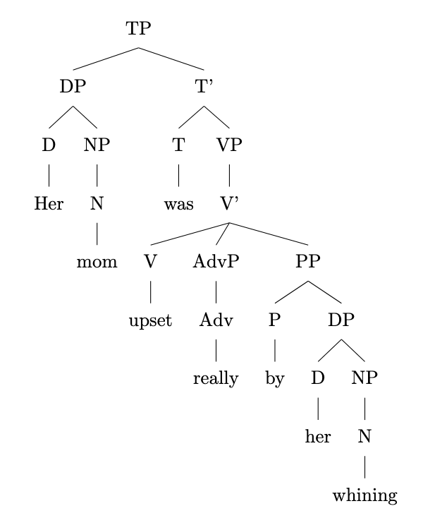
**Tree 2: PP attaches to NP**

```latex
\documentclass{article}
\usepackage[linguistics]{forest}

\begin{document}

\begin{forest}
[TP
[DP [D [Her] ] [NP [N [mom] ]
[PP [P [by] ]
[DP [D [her] ] [NP [N [whining] ] ] ] ] ]
[T' [T [was] ]
[VP [V' [V [upset] ]
[AdvP [Adv [really] ] ] ] ] ]
\end{forest}

\end{document}
```

DID NOT COMPILE; ADDED BRACKETs (AM)

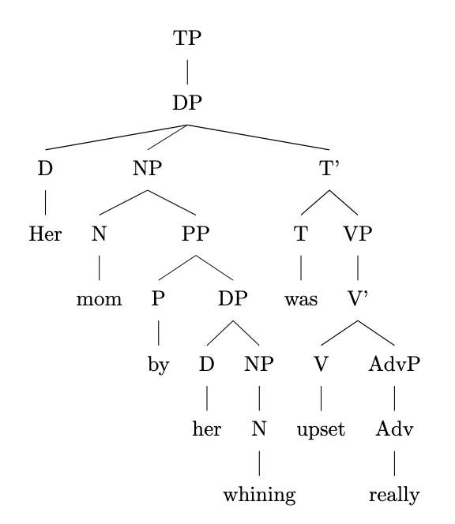

Note that in Tree 1, the PP "by her whining" attaches to the VP "was really upset", indicating that her mom was upset by her whining. In Tree 2, the PP attaches to the NP "her mom", indicating that her mom, who was upset, was characterized by her whining.

amb_08.txt arn:aws:bedrock:us-west-2::foundation-model/meta.llama3-1-405b-instruct-v1:0 temperature=0.5
PROMPT: Consider the sentence below. Is it syntactically ambiguous? If so, provide code for syntactic trees representing each possible parse of the sentence that can be rendered with LaTeX's forest package. Assume X-bar theory.
"We'll meet at the Old Stone Hotel."
REPLY: Yes, the sentence is syntactically ambiguous. The phrase "Old Stone Hotel" can be parsed in two different ways:

1. As a single noun phrase with "Old" and "Stone" as modifiers of the noun "Hotel".
2. As a noun phrase with "Old Stone" as a modifier of the noun "Hotel", where "Old Stone" is a compound adjective.

Here is the LaTeX code for the two possible syntactic trees using the forest package:

```latex
\documentclass{article}
\usepackage[linguistics]{forest}

\begin{document}

\begin{forest}
[TP
[NP [We]]
[T' [T [will]]
[VP [V [meet]]
[PP [P [at]]
[NP [the] [Old] [Stone] [Hotel]]]]]]
\end{forest}
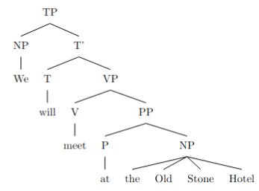
\begin{forest}
[TP
[NP [We]]
[T' [T [will]]
[VP [V [meet]]
[PP [P [at]]
[NP [the] [AP [Old] [Stone]] [Hotel]]]]]]
\end{forest}

\end{document}
```

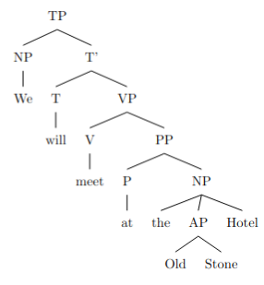

In the first tree, "Old" and "Stone" are separate modifiers of the noun "Hotel". In the second tree, "Old Stone" is a compound adjective modifying the noun "Hotel".

amb_09.txt arn:aws:bedrock:us-west-2::foundation-model/meta.llama3-1-405b-instruct-v1:0 temperature=0.5
PROMPT: Consider the sentence below. Is it syntactically ambiguous? If so, provide code for syntactic trees representing each possible parse of the sentence that can be rendered with LaTeX's forest package. Assume X-bar theory.
"The wet rodent lab has had a leak."
REPLY: Yes, the sentence is syntactically ambiguous. The ambiguity arises from the fact that "wet rodent lab" can be parsed as either a single noun phrase or as a noun phrase "wet rodent" modified by the noun "lab".

Here is the code for the two possible syntactic trees using LaTeX's forest package:

**Tree 1: "wet rodent lab" as a single noun phrase**
```latex
\documentclass{article}
\usepackage[linguistics]{forest}

\begin{document}

\begin{forest}
[TP
[DP [The] [NP [wet] [rodent] [lab]]]
[T' [T [has]]
[VP [V [had]]
[DP [a] [NP [leak]]]]]]
\end{forest}

\end{document}
```
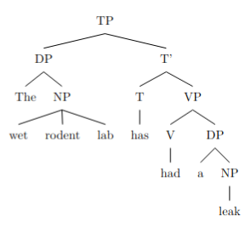
**Tree 2: "wet rodent" modified by "lab"**
```latex
\documentclass{article}
\usepackage[linguistics]{forest}

\begin{document}

\begin{forest}
[TP
[DP [The] [NP [wet] [rodent]]]
[T' [T [has]]
[VP [V [had]]
[PP [P [lab]]
[DP [a] [NP [leak]]]]]]]
\end{forest}

\end{document}
```

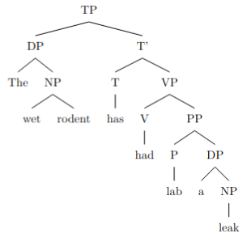

Note that in Tree 2, I've assumed that "lab" is a preposition, which might not be the most obvious choice. Alternatively, one could argue that "lab" is a noun adjunct, in which case the tree would look slightly different.

Also, keep in mind that these trees are simplified and don't show all the possible details of a full X-bar theoretic analysis.

amb_10.txt arn:aws:bedrock:us-west-2::foundation-model/meta.llama3-1-405b-instruct-v1:0 temperature=0.5
PROMPT: Consider the sentence below. Is it syntactically ambiguous? If so, provide code for syntactic trees representing each possible parse of the sentence that can be rendered with LaTeX's forest package. Assume X-bar theory.
"The new energy theorem confuses me."
REPLY: Yes, the sentence is syntactically ambiguous. The ambiguity arises from the fact that "new" can modify either "energy" or "energy theorem". Here are the two possible parses:

**Parse 1: "new" modifies "energy"**

```latex
\documentclass{article}
\usepackage[linguistics]{forest}

\begin{document}

\begin{forest}
[TP
[DP [The] ]
[T'
[T [confuses] ]
[VP
[DP [me] ]
[V'
[V [\emptyset] ]
[DP
[D [\emptyset] ]
[NP
[AdjP [new] ]
[N' [energy] [theorem] ]
]
]
]
]
]
]
\end{forest}

\end{document}
```
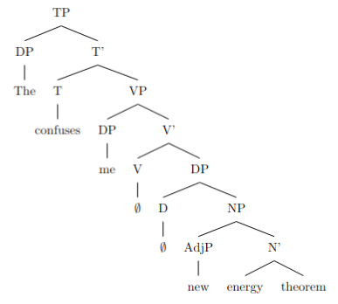
**Parse 2: "new" modifies "energy theorem"**

```latex
\documentclass{article}
\usepackage[linguistics]{forest}

\begin{document}

\begin{forest}
[TP
[DP [The] ]
[T'
[T [confuses] ]
[VP
[DP [me] ]
[V'
[V [\emptyset] ]
[DP
[D [\emptyset] ]
[NP
[AdjP [new] ]
[N'
[N [energy] ]
[N [theorem] ]
]
]
]
]
]
]
]
\end{forest}

\end{document}
```
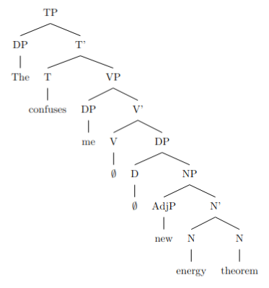
In the first parse, "new" is an adjunct to the noun "energy", while in the second parse, "new" is an adjunct to the noun phrase "energy theorem". The two parses differ in the attachment site of the adjective "new".

Note: The LaTeX code uses the `forest` package to draw the syntactic trees. The trees are represented in the X-bar theory format, with the phrasal categories (e.g. TP, DP, VP) represented as nodes, and the lexical categories (e.g. T, V, N) represented as leaves. The empty nodes (`\emptyset`) represent the phonologically null heads of the phrases.

amb_11.txt arn:aws:bedrock:us-west-2::foundation-model/meta.llama3-1-405b-instruct-v1:0 temperature=0.5
PROMPT: Consider the sentence below. Is it syntactically ambiguous? If so, provide code for syntactic trees representing each possible parse of the sentence that can be rendered with LaTeX's forest package. Assume X-bar theory.
"Less colorful clothing is acceptable at this party."
REPLY: Yes, the sentence is syntactically ambiguous. The ambiguity arises from the attachment of the adjective "less colorful". It can either modify the noun "clothing" or the noun phrase "clothing is acceptable at this party" as a whole. Here are the two possible syntactic trees:

Tree 1: "Less colorful" modifies "clothing"

```latex
\documentclass{article}
\usepackage[linguistics]{forest}

\begin{document}

\begin{forest}
[IP
[NP [Det [Less colorful] ] [N [clothing] ] ]
[I' [I [is] ]
[AP [acceptable] ]
[PP [at] [NP [this party] ] ]
]
]
\end{forest}

\end{document}
```
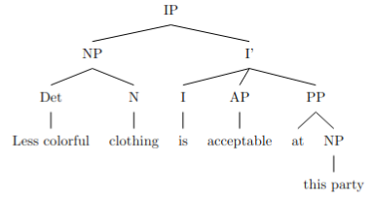
Tree 2: "Less colorful" modifies the sentence as a whole

```latex
\documentclass{article}
\usepackage[linguistics]{forest}

\begin{document}

\begin{forest}
[IP
[AP [Less colorful] ]
[IP
[NP [clothing] ]
[I' [I [is] ]
[AP [acceptable] ]
[PP [at] [NP [this party] ] ]
]
]
]
\end{forest}

\end{document}
```
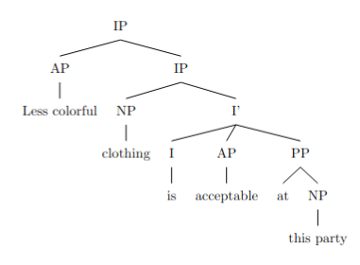

However, note that the second parse is less plausible semantically, as "less colorful" is more likely to describe the type of clothing rather than the degree of acceptability of clothing at the party.

amb_12.txt arn:aws:bedrock:us-west-2::foundation-model/meta.llama3-1-405b-instruct-v1:0 temperature=0.5
PROMPT: Consider the sentence below. Is it syntactically ambiguous? If so, provide code for syntactic trees representing each possible parse of the sentence that can be rendered with LaTeX's forest package. Assume X-bar theory.
"There are more comfortable seats in the lobby."
REPLY: Yes, the sentence is syntactically ambiguous. The ambiguity arises from the attachment of the prepositional phrase "in the lobby". It can either modify the noun "seats" or the verb "are".

Here is the code for the two possible syntactic trees using LaTeX's forest package:

**Tree 1: PP attaches to NP**

```latex
\documentclass{article}
\usepackage[linguistics]{forest}

\begin{document}

\begin{forest}
[TP
[T'
[T [are]]
[VP
[V' [are]]
[NP
[Det [more]]
[Adj [comfortable]]
[N' [seats]
[PP [in] [NP [the] [lobby]]]
]
]
]
]
]
\end{forest}

\end{document}
```

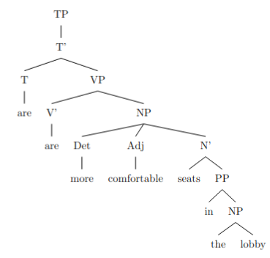
**Tree 2: PP attaches to VP**

```latex
\documentclass{article}
\usepackage[linguistics]{forest}

\begin{document}

\begin{forest}
[TP
[T'
[T [are]]
[VP
[V'
[V [are]]
[PP [in] [NP [the] [lobby]]]
]
[NP
[Det [more]]
[Adj [comfortable]]
[N [seats]]
]
]
]
]
\end{forest}

\end{document}
```

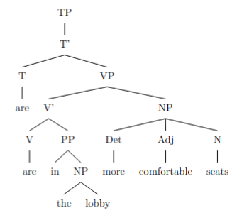

In Tree 1, the PP "in the lobby" attaches to the NP "seats", indicating that the comfortable seats are located in the lobby. In Tree 2, the PP attaches to the VP, indicating that the state of being more comfortable is located in the lobby. The actual interpretation depends on the context in which the sentence is used.

amb_13.txt arn:aws:bedrock:us-west-2::foundation-model/meta.llama3-1-405b-instruct-v1:0 temperature=0.5
PROMPT: Consider the sentence below. Is it syntactically ambiguous? If so, provide code for syntactic trees representing each possible parse of the sentence that can be rendered with LaTeX's forest package. Assume X-bar theory.
"Eric sent his employee agreements."
REPLY: Yes, the sentence "Eric sent his employee agreements" is syntactically ambiguous. The ambiguity lies in the phrase "his employee agreements", which can be parsed as either a possessive noun phrase (NP) or a noun phrase with a post-nominal modifier.

Here are two possible syntactic trees, one for each parse:

**Parse 1: Possessive NP**

```latex
\documentclass{article}
\usepackage[linguistics]{forest}

\begin{document}
\begin{forest}
[S
[NP [Eric]]
[VP
[V [sent]]
[NP
[Det [his]]
[N [employee agreements]]
]
]
]
\end{forest}
\end{document}
```
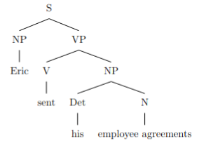
**Parse 2: NP with post-nominal modifier**

```latex
\documentclass{article}
\usepackage[linguistics]{forest}

\begin{document}
\begin{forest}
[S
[NP [Eric]]
[VP
[V [sent]]
[NP
[N [agreements]]
[PP
[P [\emptyset]]
[NP
[Det [his]]
[N [employee]]
]
]
]
]
]
\end{forest}
\end{document}
```

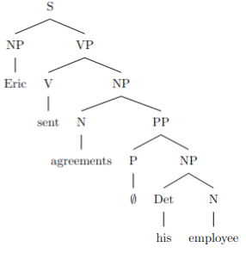

Note that in the second parse, I've represented the post-nominal modifier as a prepositional phrase (PP) with an empty preposition (\emptyset), as is common in X-bar theory. The NP "his employee" functions as a modifier of the noun "agreements".

Please compile the LaTeX code to visualize the trees.

Keep in mind that this is just one possible way to represent the syntactic structure of the sentence, and there may be other analyses depending on the theoretical framework and linguistic interpretation.

amb_14.txt arn:aws:bedrock:us-west-2::foundation-model/meta.llama3-1-405b-instruct-v1:0 temperature=0.5
PROMPT: Consider the sentence below. Is it syntactically ambiguous? If so, provide code for syntactic trees representing each possible parse of the sentence that can be rendered with LaTeX's forest package. Assume X-bar theory.
"Mary Brown read the monster tales."
REPLY: A delightful sentence!

Yes, the sentence is syntactically ambiguous. The ambiguity arises from the fact that "Mary Brown" can be either a single noun phrase (a person's name) or two separate noun phrases (a person's name and a surname).

Here are the two possible parses, represented as syntactic trees using LaTeX's forest package:

**Parse 1: "Mary Brown" as a single noun phrase**

```latex
\documentclass{article}
\usepackage[linguistics]{forest}

\begin{document}

\begin{forest}
[S
[NP [Mary Brown]]
[VP
[V [read]]
[NP
[Det [the]]
[N [monster tales]]
]
]
]
\end{forest}

\end{document}
```

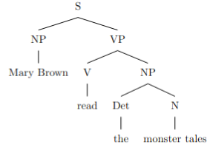
**Parse 2: "Mary" and "Brown" as separate noun phrases**

```latex
\documentclass{article}
\usepackage[linguistics]{forest}

\begin{document}

\begin{forest}
[S
[NP [Mary]]
[NP [Brown]]
[VP
[V [read]]
[NP
[Det [the]]
[N [monster tales]]
]
]
]
\end{forest}

\end{document}
```
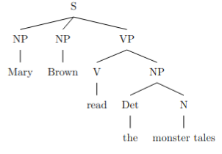
In the first parse, "Mary Brown" is a single noun phrase, functioning as the subject of the sentence. In the second parse, "Mary" and "Brown" are separate noun phrases, with "Mary" functioning as the subject and "Brown" potentially functioning as an appositive or a separate entity (although this parse is less likely semantically).

Note that these trees assume a simplified X-bar theory, with S representing the sentence, NP representing noun phrases, VP representing verb phrases, V representing verbs, Det representing determiners, and N representing nouns.

amb_15.txt arn:aws:bedrock:us-west-2::foundation-model/meta.llama3-1-405b-instruct-v1:0 temperature=0.5
PROMPT: Consider the sentence below. Is it syntactically ambiguous? If so, provide code for syntactic trees representing each possible parse of the sentence that can be rendered with LaTeX's forest package. Assume X-bar theory.
"Rowan fed his pet chicken."
REPLY: Yes, the sentence is syntactically ambiguous. The ambiguity arises from the fact that "his pet chicken" can be interpreted as either an NP with "his" as a possessive pronoun modifying the noun phrase "pet chicken", or as an NP with "his" as a possessive pronoun modifying the noun "pet" which in turn is modified by the noun "chicken".

Here are the two possible syntactic trees in LaTeX's forest package:

\begin{forest}
[IP
[NP [Rowan]]
[I'
[I [fed]]
[VP
[NP [his] [pet chicken]]
]
]
]
\end{forest}
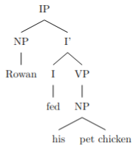
\begin{forest}
[IP
[NP [Rowan]]
[I'
[I [fed]]
[VP
[NP
[NP [his] [pet]]
[NP [chicken]]
]
]
]
]
\end{forest}
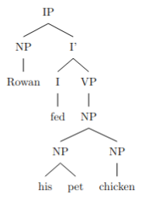
Note: In the first tree, "his pet chicken" is a single NP with "his" modifying the noun phrase "pet chicken". In the second tree, "his pet" is an NP with "his" modifying the noun "pet", and "chicken" is a separate NP.

amb_16.txt arn:aws:bedrock:us-west-2::foundation-model/meta.llama3-1-405b-instruct-v1:0 temperature=0.5
PROMPT: Consider the sentence below. Is it syntactically ambiguous? If so, provide code for syntactic trees representing each possible parse of the sentence that can be rendered with LaTeX's forest package. Assume X-bar theory.
"Susanna called her friend at the hospital."
REPLY: A great example of a syntactically ambiguous sentence!

Yes, the sentence "Susanna called her friend at the hospital" is syntactically ambiguous. The prepositional phrase "at the hospital" can be attached to either the verb "called" or the noun "friend". Here are the two possible parses, represented as syntactic trees using LaTeX's forest package:

**Parse 1: "at the hospital" modifies the verb "called"**

```latex
\documentclass{article}
\usepackage[linguistics]{forest}

\begin{document}

\begin{forest}
[S
[NP [Susanna]]
[VP
[V [called]]
[PP [at the hospital]]
[NP [her friend]]
]
]
\end{forest}

\end{document}
```
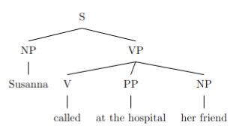
**Parse 2: "at the hospital" modifies the noun "friend"**

```latex
\documentclass{article}
\usepackage[linguistics]{forest}

\begin{document}

\begin{forest}
[S
[NP [Susanna]]
[VP
[V [called]]
[NP
[NP [her friend]]
[PP [at the hospital]]
]
]
]
\end{forest}

\end{document}
```
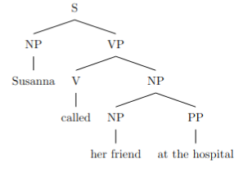
In the first parse, the prepositional phrase "at the hospital" is a sister of the verb "called", indicating that the calling action took place at the hospital. In the second parse, the prepositional phrase "at the hospital" is a sister of the noun "friend", indicating that the friend is located at the hospital. Both parses are grammatically valid, but they convey different meanings.

amb_17.txt arn:aws:bedrock:us-west-2::foundation-model/meta.llama3-1-405b-instruct-v1:0 temperature=0.5
PROMPT: Consider the sentence below. Is it syntactically ambiguous? If so, provide code for syntactic trees representing each possible parse of the sentence that can be rendered with LaTeX's forest package. Assume X-bar theory.
"They visited a household with a child."
REPLY: Yes, the sentence is syntactically ambiguous. The prepositional phrase "with a child" can modify either the noun phrase "a household" or the verb phrase "visited a household". Here are the two possible parses in LaTeX's forest package:

```
\documentclass{article}
\usepackage[linguistics]{forest}

\begin{document}

\begin{forest}
[VP
[V [They visited]]
[NP
[Det [a]]
[N [household]]
[PP
[P [with]]
[NP
[Det [a]]
[N [child]]
]
]
]
]
\end{forest}

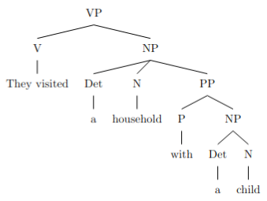
\begin{forest}
[VP
[V [They visited]]
[NP
[Det [a]]
[N [household]]
]
[PP
[P [with]]
[NP
[Det [a]]
[N [child]]
]
]
]
\end{forest}

\end{document}
```

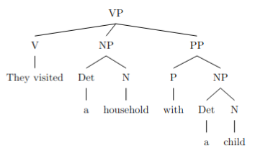

In the first tree, the PP "with a child" is a modifier of the NP "a household", indicating that the household has a child. In the second tree, the PP "with a child" is a modifier of the VP "visited a household", indicating that the visiting was done with a child.

amb_18.txt arn:aws:bedrock:us-west-2::foundation-model/meta.llama3-1-405b-instruct-v1:0 temperature=0.5
PROMPT: Consider the sentence below. Is it syntactically ambiguous? If so, provide code for syntactic trees representing each possible parse of the sentence that can be rendered with LaTeX's forest package. Assume X-bar theory.
"Julius hid the presents for the children."
REPLY: Yes, the sentence is syntactically ambiguous. The prepositional phrase "for the children" can be attached to either the verb "hid" or the noun "presents". Here are the two possible syntactic trees in LaTeX's forest package:

**Tree 1: PP attached to V**

```latex
\documentclass{article}
\usepackage[linguistics]{forest}

\begin{document}

\begin{forest}
[VP
[V\textsubscript{P} [V [hid]]]
[DP [Det [the]] [NP [N [presents]]]]
[PP [P [for]] [DP [Det [the]] [NP [N [children]]]]]
]
\end{forest}

\end{document}
```
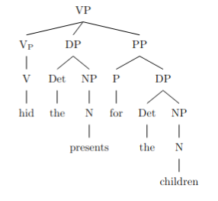
**Tree 2: PP attached to N**

```latex
\documentclass{article}
\usepackage[linguistics]{forest}

\begin{document}

\begin{forest}
[VP
[V\textsubscript{P} [V [hid]]]
[DP [Det [the]] [NP [N [presents]] [PP [P [for]] [DP [Det [the]] [NP [N [children]]]]]]]
]
\end{forest}

\end{document}
```

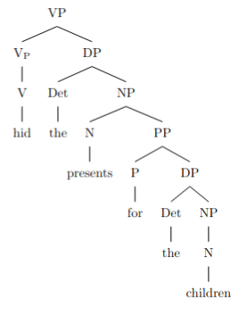
In Tree 1, the PP "for the children" is attached to the VP, indicating that Julius hid the presents for the benefit of the children. In Tree 2, the PP is attached to the NP "presents", indicating that the presents are for the children.

amb_19.txt arn:aws:bedrock:us-west-2::foundation-model/meta.llama3-1-405b-instruct-v1:0 temperature=0.5
PROMPT: Consider the sentence below. Is it syntactically ambiguous? If so, provide code for syntactic trees representing each possible parse of the sentence that can be rendered with LaTeX's forest package. Assume X-bar theory.
"You shot a pigeon sitting by the roadside."
REPLY: Yes, the sentence is syntactically ambiguous. The ambiguity arises from the phrase "sitting by the roadside", which can either modify the noun "pigeon" or the verb "shot". Here are the two possible parses in the form of LaTeX code using the forest package:

**Parse 1: "sitting by the roadside" modifies "pigeon"**
```latex
\documentclass{article}
\usepackage[linguistics]{forest}

\begin{document}

\begin{forest}
[TP
[DP [You]]
[T' [T [did]]
[VP [V [shot]]
[DP [a [pigeon]]
[PP [sitting]
[PP [by]
[DP [the [roadside]]]]]]]]
\end{forest}

\end{document}
```
DID NOT COMPILE; ADDED BRACKET (AM)

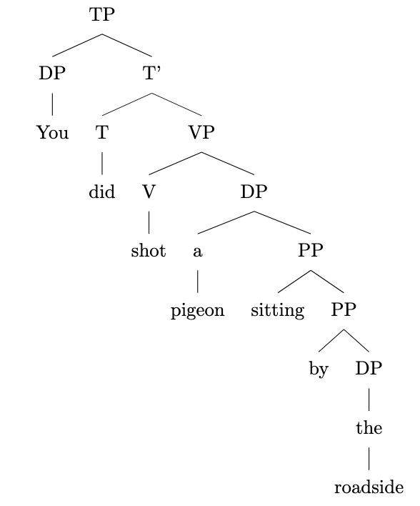
**Parse 2: "sitting by the roadside" modifies "shot"**
```latex
\documentclass{article}
\usepackage[linguistics]{forest}

\begin{document}

\begin{forest}
[TP
[DP [You]]
[T' [T [did]]
[VP [V [shot]]
[PP [sitting]
[PP [by]
[DP [the [roadside]]]]
[DP [a [pigeon]]]]]]
\end{forest}

\end{document}
```

DID NOT COMPILE; ADDED BRACKET (AM)

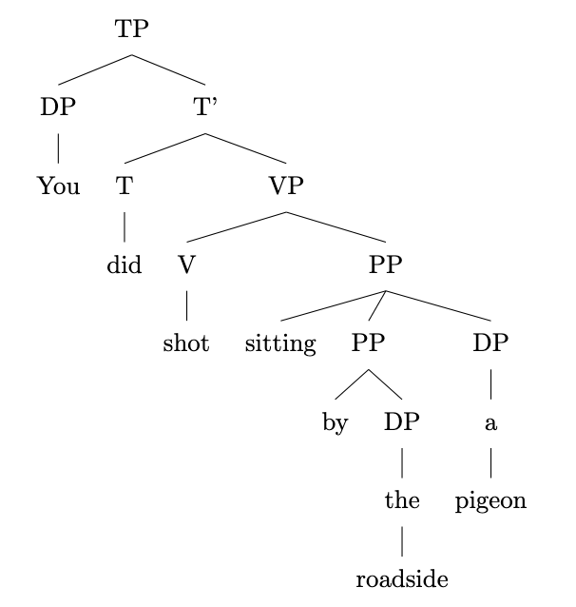
In the first parse, "sitting by the roadside" is a prepositional phrase modifying the noun "pigeon", indicating that the pigeon was sitting by the roadside when it was shot. In the second parse, "sitting by the roadside" is a prepositional phrase modifying the verb "shot", indicating that the action of shooting took place while the subject (you) was sitting by the roadside.

amb_20.txt arn:aws:bedrock:us-west-2::foundation-model/meta.llama3-1-405b-instruct-v1:0 temperature=0.5
PROMPT: Consider the sentence below. Is it syntactically ambiguous? If so, provide code for syntactic trees representing each possible parse of the sentence that can be rendered with LaTeX's forest package. Assume X-bar theory.
"He glanced at a badger basking in the sunlight."
REPLY: Yes, the sentence is syntactically ambiguous. The ambiguity arises from the attachment of the prepositional phrase "in the sunlight". It can either modify the verb "basking" or the verb "glanced".

Here is the code for the two possible syntactic trees using LaTeX's forest package:

**Tree 1: PP attaches to "basking"**

```latex
\documentclass{article}
\usepackage[linguistics]{forest}

\begin{document}

\begin{forest}
[TP
[DP [He]]
[T' [T [did]]
[VP [V [glanced]]
[PP [at]
[DP [a badger]
[VP [V [basking]]
[PP [in]
[DP [the sunlight]]]]]]]]]
\end{forest}

\end{document}
```
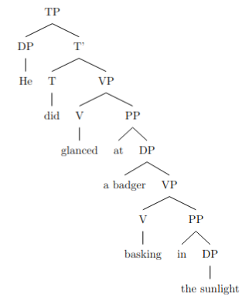
**Tree 2: PP attaches to "glanced"**

```latex
\documentclass{article}
\usepackage[linguistics]{forest}

\begin{document}

\begin{forest}
[TP
[DP [He]]
[T' [T [did]]
[VP [V [glanced]]
[PP [at]
[DP [a badger]
[VP [V [basking]]]]]
[PP [in]
[DP [the sunlight]]]]]]
\end{forest}

\end{document}
```

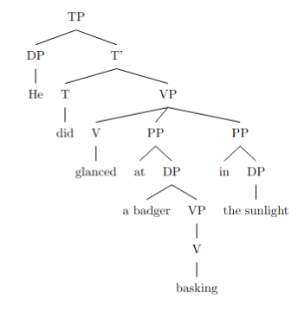

Note that in Tree 1, the PP "in the sunlight" is a sister to the VP "basking", indicating that it modifies the verb "basking". In Tree 2, the PP "in the sunlight" is a sister to the VP "glanced", indicating that it modifies the verb "glanced".

amb_21.txt arn:aws:bedrock:us-west-2::foundation-model/meta.llama3-1-405b-instruct-v1:0 temperature=0.5
PROMPT: Consider the sentence below. Is it syntactically ambiguous? If so, provide code for syntactic trees representing each possible parse of the sentence that can be rendered with LaTeX's forest package. Assume X-bar theory.
"The envoy to the duke who offended the emperor was executed."
REPLY: Yes, the sentence is syntactically ambiguous. The ambiguity arises from the attachment of the relative clause "who offended the emperor." It can either attach to "the duke" or "the envoy to the duke." Here are the two possible syntactic trees in LaTeX's forest package:

```latex
\documentclass{article}
\usepackage[linguistics]{forest}

\begin{document}

\begin{forest}
[TP
[DP [D [the]]
[NP [envoy]
[PP [to]
[DP [D [the]]
[NP [duke]
[CP [who]
[VP [offended]
[DP [D [the]]
[NP [emperor]]]]]]]]
[VP [was]
[VP [executed]]]]
\end{forest}

DID NOT COMPILE; ADDED BRACKETS (AM)
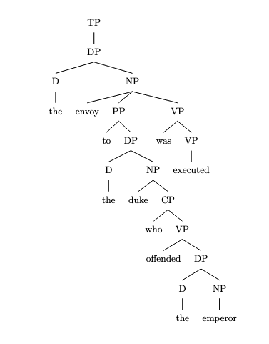
\begin{forest}
[TP
[DP [D [the]]
[NP [envoy]
[PP [to]
[DP [D [the]]
[NP [duke]]]]
[CP [who]
[VP [offended]
[DP [D [the]]
[NP [emperor]]]]]
[VP [was]
[VP [executed]]]]
\end{forest}

\end{document}
```

DID NOT COMPILE; ADDED BRACKETS (AM)
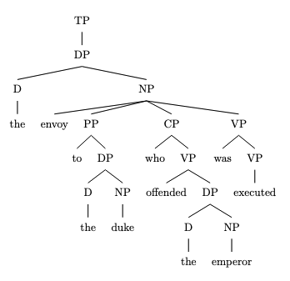
The first tree represents the parse where the relative clause attaches to "the duke," and the second tree represents the parse where it attaches to "the envoy to the duke." Note that these trees follow X-bar theory, with the phrasal categories (DP, NP, PP, CP, VP, TP) being the maximal projections of their respective heads.

amb_22.txt arn:aws:bedrock:us-west-2::foundation-model/meta.llama3-1-405b-instruct-v1:0 temperature=0.5
PROMPT: Consider the sentence below. Is it syntactically ambiguous? If so, provide code for syntactic trees representing each possible parse of the sentence that can be rendered with LaTeX's forest package. Assume X-bar theory.
"The critics of the activists who had become controversial were baffled."
REPLY: Yes, the sentence is syntactically ambiguous. The ambiguity arises from the attachment of the relative clause "who had become controversial". It can either modify "the activists" or "the critics of the activists".

Here is the code for the two possible syntactic trees using LaTeX's forest package:

**Tree 1: Relative clause modifies "the activists"**
```latex
\documentclass{article}
\usepackage[linguistics]{forest}

\begin{document}

\begin{forest}
[TP
[DP [The [critics [of [the [activists [CP [who [had [become [controversial]]]]]]]]]]
[VP [were [baffled]]]
]
\end{forest}

\end{document}
```

DID NOT COMPILE; ADDED BRACKETS (AM)
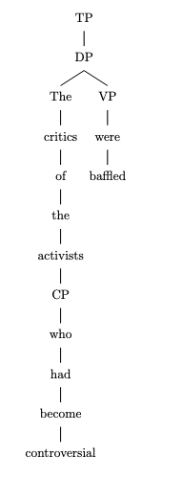

**Tree 2: Relative clause modifies "the critics of the activists"**
```latex
\documentclass{article}
\usepackage[linguistics]{forest}

\begin{document}

\begin{forest}
[TP
[DP [The [critics [of [the [activists]]] [CP [who [had [become [controversial]]]]]]]
[VP [were [baffled]]]
]
\end{forest}

\end{document}
```
DID NOT COMPILE; ADDED BRACKETS (AM)

In Tree 1, the relative clause "who had become controversial" is attached to the NP "the activists", while in Tree 2, it is attached to the DP "the critics of the activists". Note that the trees are simplified and do not show all the possible intermediate projections (e.g., NP, DP, CP) for the sake of clarity.

amb_23.txt arn:aws:bedrock:us-west-2::foundation-model/meta.llama3-1-405b-instruct-v1:0 temperature=0.5
PROMPT: Consider the sentence below. Is it syntactically ambiguous? If so, provide code for syntactic trees representing each possible parse of the sentence that can be rendered with LaTeX's forest package. Assume X-bar theory.
"The girl who was weeping quietly left."
REPLY: Yes, the sentence is syntactically ambiguous. The ambiguity arises from the attachment of the adverb "quietly". It can either modify the verb "weeping" or the verb "left". Here are the two possible syntactic trees in LaTeX's forest package:

**Tree 1: "quietly" modifies "weeping"**

```latex
\documentclass{article}
\usepackage[linguistics]{forest}

\begin{document}

\begin{forest}
[TP
[DP [The] [girl]]
[T'
[T [was]]
[VP
[V [weeping]]
[AdvP [quietly]]
[CP
[C [who]]
[TP
[T [t]]
[VP
[V [left]]
]
]
]
]
]
]
\end{forest}

\end{document}
```
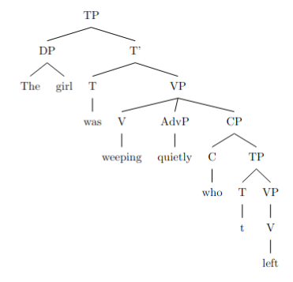
**Tree 2: "quietly" modifies "left"**

```latex
\documentclass{article}
\usepackage[linguistics]{forest}

\begin{document}

\begin{forest}
[TP
[DP [The] [girl]]
[T'
[T [was]]
[VP
[V [weeping]]
[CP
[C [who]]
[TP
[T [t]]
[VP
[AdvP [quietly]]
[V [left]]
]
]
]
]
]
]
\end{forest}

\end{document}
```

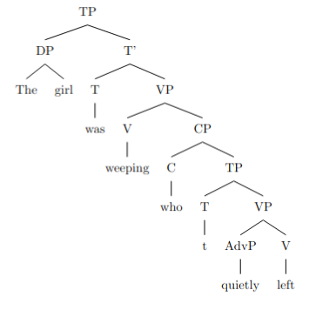

In Tree 1, "quietly" is an adverbial phrase (AdvP) modifying the verb "weeping", while in Tree 2, it modifies the verb "left". The two trees represent the two possible parses of the sentence.

amb_24.txt arn:aws:bedrock:us-west-2::foundation-model/meta.llama3-1-405b-instruct-v1:0 temperature=0.5
PROMPT: Consider the sentence below. Is it syntactically ambiguous? If so, provide code for syntactic trees representing each possible parse of the sentence that can be rendered with LaTeX's forest package. Assume X-bar theory.
"The Tesla that was about to explode spontaneously swerved."
REPLY: Yes, the sentence is syntactically ambiguous. The ambiguity arises from the attachment of the relative clause "that was about to explode spontaneously". It can either modify "The Tesla" or "swerved".

Here are the two possible syntactic trees in LaTeX's forest package:

**Tree 1: Relative clause modifies "The Tesla"**
```latex
\documentclass{article}
\usepackage[linguistics]{forest}

\begin{document}

\begin{forest}
[TP
[DP [The] [Tesla]]
[CP [that]
[TP
[T [was]]
[VP
[V [about]]
[PP [to]
[VP
[V [explode]]
[AdvP [spontaneously]]
]
]
]
]
]
[VP
[V [swerved]]
]
]
\end{forest}

\end{document}
```
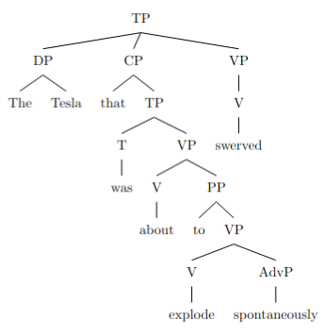
**Tree 2: Relative clause modifies "swerved" (implausible but technically possible)**
```latex
\documentclass{article}
\usepackage[linguistics]{forest}

\begin{document}

\begin{forest}
[TP
[DP [The] [Tesla]]
[VP
[V [swerved]]
[CP [that]
[TP
[T [was]]
[VP
[V [about]]
[PP [to]
[VP
[V [explode]]
[AdvP [spontaneously]]
]
]
]
]
]
]
]
\end{forest}

\end{document}
```

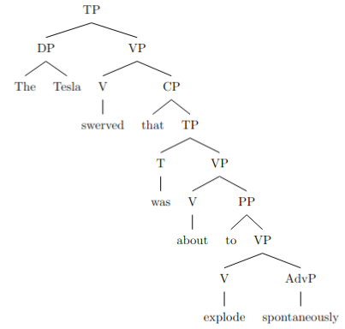

Note that the second tree is less plausible, as the relative clause would be describing the manner in which the Tesla swerved, rather than providing additional information about the Tesla itself. However, it is still a technically possible parse of the sentence.

amb_25.txt arn:aws:bedrock:us-west-2::foundation-model/meta.llama3-1-405b-instruct-v1:0 temperature=0.5
PROMPT: Consider the sentence below. Is it syntactically ambiguous? If so, provide code for syntactic trees representing each possible parse of the sentence that can be rendered with LaTeX's forest package. Assume X-bar theory.
"Lara Croft decided in May she would raid more tombs."
REPLY: Yes, the sentence is syntactically ambiguous. The prepositional phrase "in May" can be interpreted as modifying either the verb "decided" or the clause "she would raid more tombs". Here are the two possible syntactic trees in LaTeX's forest package:

**Tree 1: "in May" modifies "decided"**
```latex
\documentclass{article}
\usepackage[linguistics]{forest}

\begin{document}

\begin{forest}
[TP
[DP [Lara Croft]]
[T'
[T [decided]]
[VP
[PP [in May]]
[VP
[CP
[C [that]]
[TP
[DP [she]]
[T'
[T [would]]
[VP
[V [raid]]
[DP [more tombs]]
]
]
]
]
]
]
]
]
\end{forest}

\end{document}
```
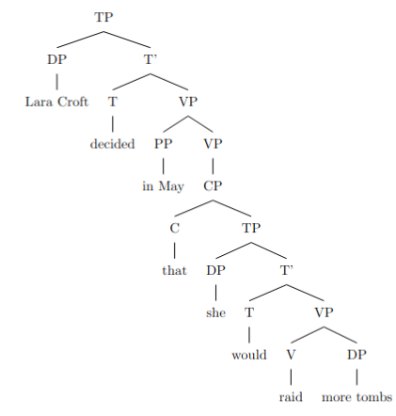
**Tree 2: "in May" modifies "she would raid more tombs"**
```latex
\documentclass{article}
\usepackage[linguistics]{forest}

\begin{document}

\begin{forest}
[TP
[DP [Lara Croft]]
[T'
[T [decided]]
[CP
[C [that]]
[TP
[DP [she]]
[T'
[T [would]]
[VP
[PP [in May]]
[VP
[V [raid]]
[DP [more tombs]]
]
]
]
]
]
]
]
\end{forest}

\end{document}
```
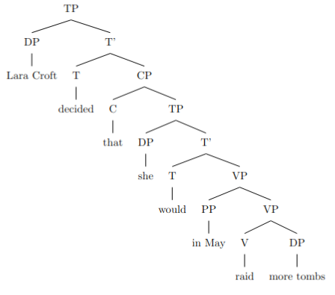

In the first tree, the PP "in May" is a sister of the VP "she would raid more tombs", indicating that it modifies the verb "decided". In the second tree, the PP "in May" is a sister of the VP "raid more tombs", indicating that it modifies the clause "she would raid more tombs".

amb_26.txt arn:aws:bedrock:us-west-2::foundation-model/meta.llama3-1-405b-instruct-v1:0 temperature=0.5
PROMPT: Consider the sentence below. Is it syntactically ambiguous? If so, provide code for syntactic trees representing each possible parse of the sentence that can be rendered with LaTeX's forest package. Assume X-bar theory.
"Alex swore on Saturday he would visit his grandfather."
REPLY: Yes, the sentence is syntactically ambiguous. The ambiguity arises from the attachment of the prepositional phrase "on Saturday". It can either modify the verb "swore" or the clause "he would visit his grandfather".

Here is the code for the two possible syntactic trees using LaTeX's forest package:

**Tree 1: "on Saturday" modifies "swore"**
```latex
\documentclass{article}
\usepackage[linguistics]{forest}

\begin{document}

\begin{forest}
[TP
[DP [Alex]]
[T' [T [swore]]
[PP [on] [DP [Saturday]]]
[CP [he] [would] [VP [visit] [DP [his] [grandfather]]]]
]
]
\end{forest}
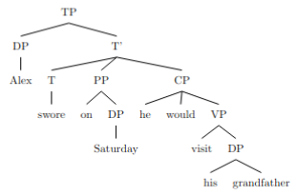
\end{document}
```

**Tree 2: "on Saturday" modifies the clause "he would visit his grandfather"**
```latex
\documentclass{article}
\usepackage[linguistics]{forest}

\begin{document}

\begin{forest}
[TP
[DP [Alex]]
[T' [T [swore]]
[CP
[PP [on] [DP [Saturday]]]
[CP [he] [would] [VP [visit] [DP [his] [grandfather]]]]
]
]
]
\end{forest}

\end{document}
```

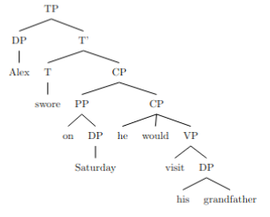
In Tree 1, the PP "on Saturday" is a sister to the verb "swore", indicating that it modifies the verb. In Tree 2, the PP "on Saturday" is a sister to the clause "he would visit his grandfather", indicating that it modifies the clause.

amb_27.txt arn:aws:bedrock:us-west-2::foundation-model/meta.llama3-1-405b-instruct-v1:0 temperature=0.5
PROMPT: Consider the sentence below. Is it syntactically ambiguous? If so, provide code for syntactic trees representing each possible parse of the sentence that can be rendered with LaTeX's forest package. Assume X-bar theory.
"He told me he ate the leftovers yesterday."
REPLY: Yes, the sentence is syntactically ambiguous. The ambiguity arises from the attachment of the adverb "yesterday". It can either modify the verb "ate" or the verb "told". Here are the two possible syntactic trees in LaTeX's forest package:

```latex
\documentclass{article}
\usepackage[linguistics]{forest}

\begin{document}

\begin{forest}
[CP
[C [he]]
[TP
[T [told]]
[VP
[V [me]]
[CP
[C [he]]
[TP
[T [ate]]
[VP
[V [the leftovers]]
[AdvP [yesterday]]
]
]
]
]
]
]
\end{forest}
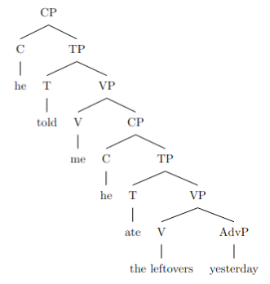
\begin{forest}
[CP
[C [he]]
[TP
[T [told]]
[VP
[V [me]]
[CP
[C [he]]
[TP
[T [ate]]
[VP
[V [the leftovers]]
]
]
]
[AdvP [yesterday]]
]
]
]
\end{forest}

\end{document}
```

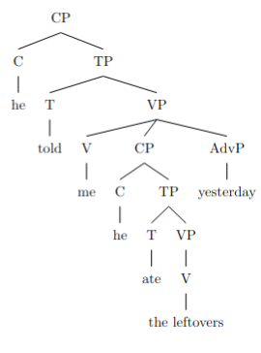
In the first tree, "yesterday" modifies "ate", indicating that the eating of the leftovers happened yesterday. In the second tree, "yesterday" modifies "told", indicating that the telling happened yesterday.

amb_28.txt arn:aws:bedrock:us-west-2::foundation-model/meta.llama3-1-405b-instruct-v1:0 temperature=0.5
PROMPT: Consider the sentence below. Is it syntactically ambiguous? If so, provide code for syntactic trees representing each possible parse of the sentence that can be rendered with LaTeX's forest package. Assume X-bar theory.
"He dreamed that he'd shown up to school late the day of a test."
REPLY: Yes, the sentence is syntactically ambiguous. The ambiguity arises from the attachment of the phrase "the day of a test". It can either modify the verb "shown up" or the noun "school". Here are the two possible syntactic trees in LaTeX's forest package:

**Tree 1: "the day of a test" modifies "shown up"**

```latex
\documentclass{article}
\usepackage[linguistics]{forest}

\begin{document}

\begin{forest}
[CP
[C'
[C [that]]
[TP
[T' [T [did]]
[VP
[V' [V [dream]]
[CP
[C' [C [that]]
[TP
[T' [T [had]]
[VP
[V' [V [show]]
[PP
[P' [P [up]]
[PP
[P' [P [to]]
[NP
[N' [N [school]]
[AdvP
[Adv' [Adv [late]]
[PP
[P' [P [the day of]]
[NP [N' [N [a test]]]
]
]
]
]
]
]
]
]
]
]
]
]
\end{forest}

\end{document}
```
DOES NOT COMPILE

**Tree 2: "the day of a test" modifies "school"**

```latex
\documentclass{article}
\usepackage[linguistics]{forest}

\begin{document}

\begin{forest}
[CP
[C'
[C [that]]
[TP
[T' [T [did]]
[VP
[V' [V [dream]]
[CP
[C' [C [that]]
[TP
[T' [T [had]]
[VP
[V' [V [show]]
[PP
[P' [P [up]]
[PP
[P' [P [to]]
[NP
[N' [N [school]]
[PP
[P' [P [the day of]]
[NP [N' [N [a test]]]
]
]
[AdvP
[Adv' [Adv [late]]
]
]
]
]
]
]
]
]
]
]
\end{forest}

\end{document}
```

DOES NOT COMPILE

Note that these trees assume a simplified X-bar structure, and some details may vary depending on the specific theoretical framework adopted.

amb_29.txt arn:aws:bedrock:us-west-2::foundation-model/meta.llama3-1-405b-instruct-v1:0 temperature=0.5
PROMPT: Consider the sentence below. Is it syntactically ambiguous? If so, provide code for syntactic trees representing each possible parse of the sentence that can be rendered with LaTeX's forest package. Assume X-bar theory.
"I knew I wanted to speak to my lawyer but she was away from the phone."
REPLY: The sentence is indeed syntactically ambiguous. The ambiguity arises from the attachment of the clause "but she was away from the phone." It can be attached either to the main clause "I knew I wanted to speak to my lawyer" or to the embedded clause "I wanted to speak to my lawyer."

Here is the code for the two possible syntactic trees using LaTeX's forest package:

**Tree 1: High attachment**

```latex
\documentclass{article}
\usepackage[linguistics]{forest}

\begin{document}

\begin{forest}
[CP
[C [I]]
[TP
[T [knew]]
[VP
[V [wanted]]
[TP
[T [to]]
[VP
[V [speak]]
[PP
[P [to]]
[DP [my] [lawyer]]
]
]
]
[CP
[C [but]]
[TP
[T [was]]
[VP
[V [away]]
[PP
[P [from]]
[DP [the] [phone]]
]
]
]
]
]
]
]
\end{forest}

\end{document}
```
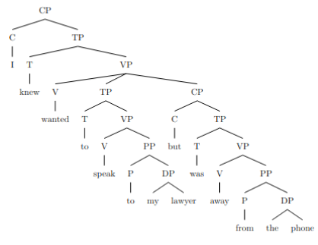
**Tree 2: Low attachment**

```latex
\documentclass{article}
\usepackage[linguistics]{forest}

\begin{document}

\begin{forest}
[CP
[C [I]]
[TP
[T [knew]]
[VP
[V [wanted]]
[TP
[T [to]]
[VP
[V [speak]]
[PP
[P [to]]
[DP [my] [lawyer]]
]
[CP
[C [but]]
[TP
[T [was]]
[VP
[V [away]]
[PP
[P [from]]
[DP [the] [phone]]
]
]
]
]
]
]
]
]
]
\end{forest}

\end{document}
```
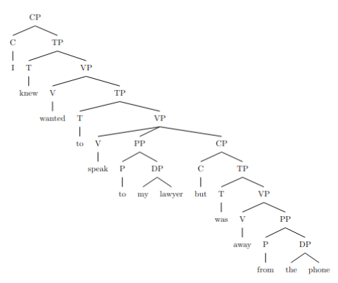

In Tree 1, the clause "but she was away from the phone" is attached to the main clause "I knew I wanted to speak to my lawyer", whereas in Tree 2, it is attached to the embedded clause "I wanted to speak to my lawyer".

amb_30.txt arn:aws:bedrock:us-west-2::foundation-model/meta.llama3-1-405b-instruct-v1:0 temperature=0.5
PROMPT: Consider the sentence below. Is it syntactically ambiguous? If so, provide code for syntactic trees representing each possible parse of the sentence that can be rendered with LaTeX's forest package. Assume X-bar theory.
"Francisco believed his peers were idiots and they resented him."
REPLY: Yes, the sentence is syntactically ambiguous. The ambiguity arises from the coordination of the two clauses "his peers were idiots" and "they resented him". The sentence can be parsed in two ways:

1. Francisco believed [his peers were idiots and they resented him].
2. Francisco believed [his peers were idiots] and [they resented him].

Here is the LaTeX code for the two possible syntactic trees using the forest package:

**Tree 1:**
```latex
\documentclass{article}
\usepackage[linguistics]{forest}

\begin{document}

\begin{forest}
[TP
[DP [Francisco]]
[T' [T [believed]]
[CP [C [\emptyset]]
[TP
[DP [his peers]]
[T' [T [were]]
[AP [idiots]]
]
[conjP [and]
[TP
[DP [they]]
[T' [T [resented]]
[DP [him]]
]
]
]
]
]
]
]
\end{forest}

\end{document}
```
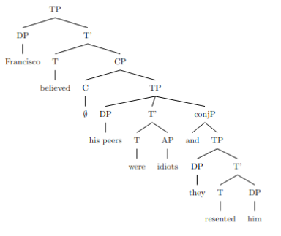
**Tree 2:**
```latex
\documentclass{article}
\usepackage[linguistics]{forest}

\begin{document}

\begin{forest}
[TP
[DP [Francisco]]
[T' [T [believed]]
[CP [C [\emptyset]]
[TP
[DP [his peers]]
[T' [T [were]]
[AP [idiots]]
]
]
]
]
[conjP [and]
[TP
[DP [they]]
[T' [T [resented]]
[DP [him]]
]
]
]
]
\end{forest}

\end{document}
```

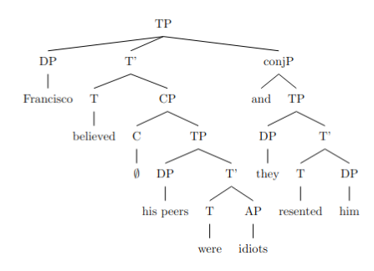

In Tree 1, the coordination is between the two clauses "his peers were idiots" and "they resented him", which are both dominated by the CP node. In Tree 2, the coordination is between the two TPs "Francisco believed his peers were idiots" and "they resented him", which are both dominated by the conjP node.

Messages generated with 11342 tokens

o1-preview-2024-09-12

amb_01.txt o1-preview-2024-09-12 temperature=1.0
PROMPT: Consider the sentence below. Is it syntactically ambiguous? If so, provide code for syntactic trees representing each possible parse of the sentence that can be rendered with LaTeX's forest package. Assume X-bar theory.
"A passer-by has heard her pump."
REPLY: Yes, the sentence "A passer-by has heard her pump." is syntactically ambiguous. The ambiguity arises from the different possible grammatical structures of the phrase "her pump" within the sentence. Specifically, "her pump" can be interpreted either as a noun phrase (NP) functioning as the direct object of "heard" or as a clause where "her" is the subject and "pump" is a verb, forming a complement clause to "heard". Below are the syntactic trees representing each possible parse, formatted for LaTeX's forest package under X-bar theory.

**First Parse (Her Pump as a Noun Phrase):**

In this parse, "her pump" is a noun phrase that serves as the direct object of the verb "heard". The passer-by has heard the pump that belongs to her.

```latex
\begin{forest}
[CP
[NP [Det [A]] [N$'$ [N [passer-by]]]]
[C$'$
[C [\phantom{C}]]
[TP
[T$'$ [T [has]]
[VP
[V$'$ [V [heard]]
[NP [Det [her]] [N$'$ [N [pump]]]]
]
]
]
]
]
\end{forest}
```

DID NOT COMPILE; ADDED BRACKETS (AM)
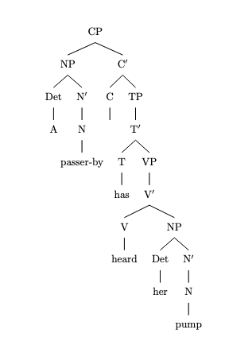
**Second Parse (Her Pump as a Clause with "Pump" as a Verb):**

In this parse, "her" functions as the subject of the verb "pump", forming a complement clause to "heard". The passer-by has heard that she pumps.

```latex
\begin{forest}
[CP
[NP [Det [A]] [N$'$ [N [passer-by]]]]
[C$'$
[C [\phantom{C}]]
[TP
[T$'$ [T [has]]
[VP
[V$'$ [V [heard]]
[CP
[NP [N [her]]]
[C$'$
[C [\phantom{C}]]
[TP
[T$'$ [T [\phantom{T}]]
[VP
[V$'$ [V [pump]]]
]
]
]
]
]
]
]
]
]
]
\end{forest}
```
DID NOT COMPILE; ADDED BRACKETS (AM)
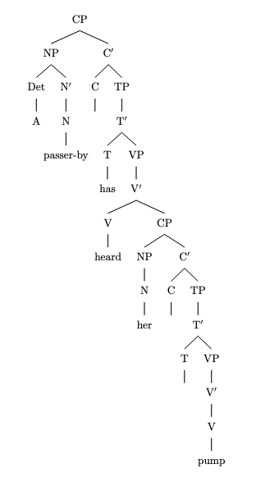
**Explanation of the Parses:**

- **First Parse:**
- **NP (Subject):** "A passer-by"
- Det: "A"
- N: "passer-by"
- **VP:**
- V: "has heard"
- **NP (Object):** "her pump"
- Det: "her"
- N: "pump"

- **Second Parse:**
- **NP (Subject):** "A passer-by"
- Det: "A"
- N: "passer-by"
- **VP:**
- V: "has heard"
- **CP (Complement Clause):**
- **NP (Subject of the embedded clause):** "her"
- **VP (Embedded clause):**
- V: "pump"

**Notes on the Trees:**

- The trees are constructed according to X-bar theory, where each phrase consists of a head (X) and may include specifiers and complements.
- Empty categories (represented by `\phantom{C}` or `\phantom{T}`) indicate positions that are syntactically relevant but not overtly filled.
- The forest package in LaTeX allows for the creation of tree diagrams, where each node corresponds to a syntactic category in the parse.

By providing these two parses, we illustrate the syntactic ambiguity present in the sentence.

amb_02.txt o1-preview-2024-09-12 temperature=1.0
PROMPT: Consider the sentence below. Is it syntactically ambiguous? If so, provide code for syntactic trees representing each possible parse of the sentence that can be rendered with LaTeX's forest package. Assume X-bar theory.
"The opposite team had her duck."
REPLY: Yes, the sentence "The opposite team had her duck." is syntactically ambiguous. It can be parsed in at least two ways:

1. **First Parse**: "her duck" is a noun phrase (NP) meaning the duck that belongs to her. In this interpretation, "had" is a simple past tense verb meaning "possessed" or "held".

2. **Second Parse**: "had her duck" involves a causative construction where "had" means "caused". Here, "her" is the object of "had", and "duck" is a bare infinitive verb meaning to lower quickly. The opposite team caused her to duck.

Below are the syntactic trees for each parse using LaTeX's forest package, assuming X-bar theory:

**First Parse (duck as a noun):**

```latex
\begin{forest}
[TP
[DP
[D [The]]
[NP
[AdjP [opposite]]
[N [team]]
]
]
[T$'$
[T [had]]
[VP
[V [had]]
[DP
[D [her]]
[NP [N [duck]]]
]
]
]
]
\end{forest}
```
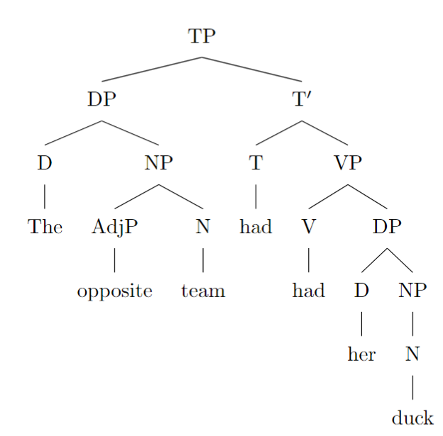
**Second Parse (duck as a verb):**

```latex
\begin{forest}
[TP
[DP
[D [The]]
[NP
[AdjP [opposite]]
[N [team]]
]
]
[T$'$
[T [had]]
[VP
[V [had]]
[DP [her]]
[VP
[V [duck]]
]
]
]
]
\end{forest}
```

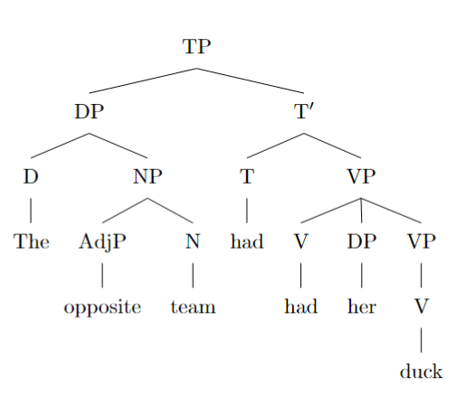

**Explanation:**

- In the **first parse**, the verb phrase (VP) consists of the verb "had" and its direct object "her duck", which is a noun phrase (NP). The possessive determiner "her" modifies the noun "duck".

- In the **second parse**, the VP starts with the verb "had", followed by the NP "her" as the object, and then a VP "duck" as the complement. Here, "duck" is a verb, and "her" is the person who is caused to perform the action of ducking.

These trees illustrate the two different syntactic structures associated with the two interpretations of the sentence.

amb_03.txt o1-preview-2024-09-12 temperature=1.0
PROMPT: Consider the sentence below. Is it syntactically ambiguous? If so, provide code for syntactic trees representing each possible parse of the sentence that can be rendered with LaTeX's forest package. Assume X-bar theory.
"Eliza wanted her cast out."
REPLY: Yes, the sentence "Eliza wanted her cast out." is syntactically ambiguous. The ambiguity lies in whether "her cast" functions as a single noun phrase (e.g., a medical cast that belongs to her) with "out" as a predicate adjective, or whether "her" is a pronoun object of "wanted," and "cast out" is a verb phrase (e.g., meaning to expel her).

Below are the syntactic trees for each possible parse using LaTeX's `forest` package, assuming X-bar theory.

**First Parse** (Where "her cast" is a noun phrase and "out" is a predicate adjective):

```latex
\documentclass{article}
\usepackage[edges]{forest}
\begin{document}

\begin{forest}
for tree={align=center, s sep=1cm, l=1cm}
[IP
[NP [N Eliza]]
[I'
[I\phantom{I}]
[VP
[V [wanted]]
[SC
[NP
[Det [her]]
[N [cast]]
]
[AP [A [out]]]
]
]
]
]
\end{forest}

\end{document}
```

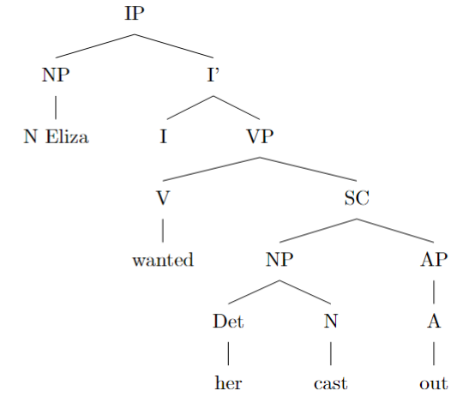
**Second Parse** (Where "her" is the object, and "cast out" is a verb phrase):

```latex
\documentclass{article}
\usepackage[edges]{forest}
\begin{document}

\begin{forest}
for tree={align=center, s sep=1cm, l=1cm}
[IP
[NP [N Eliza]]
[I'
[I\phantom{I}]
[VP
[V [wanted]]
[SC
[NP [N [her]]]
[VP
[V [cast out]]
]
]
]
]
]
\end{forest}

\end{document}
```

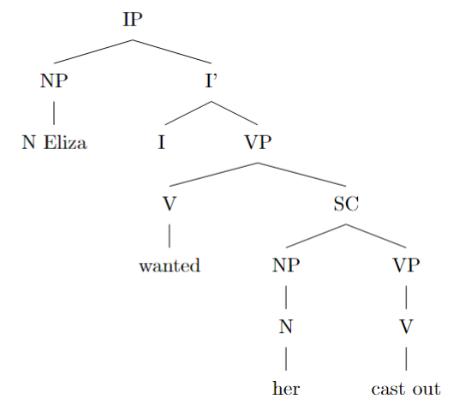

In these trees, `IP` represents the inflectional phrase (sentence), `NP` is a noun phrase, `I'` is the I-bar, `I` is the inflection (empty in this case), `VP` is a verb phrase, `V` is the verb, `SC` is a small clause, `AP` is an adjective phrase, and `Det` is a determiner.

**Explanation of the Parses:**

- **First Parse:** "Eliza wanted [her cast] [out]." Here, "her cast" is a noun phrase functioning as the subject of the small clause, and "out" is a predicate adjective. This structure implies that Eliza desired for her own cast (e.g., a medical cast) to be out (removed).

- **Second Parse:** "Eliza wanted [her] [cast out]." In this parse, "her" is the object of "wanted," and "cast out" is a verb phrase serving as the predicate of the small clause. This suggests that Eliza wanted someone else (her) to be cast out (expelled).

By providing these parses, we illustrate the syntactic ambiguity inherent in the sentence due to different possible structures under X-bar theory.

amb_04.txt o1-preview-2024-09-12 temperature=1.0
PROMPT: Consider the sentence below. Is it syntactically ambiguous? If so, provide code for syntactic trees representing each possible parse of the sentence that can be rendered with LaTeX's forest package. Assume X-bar theory.
"Tobias kept her wound up."
REPLY: The sentence "Tobias kept her wound up." is not syntactically ambiguous under X-bar theory. While it may seem ambiguous due to the different interpretations of "wound up" (either as an adjective describing her state or as a past participle indicating an action performed on her), this ambiguity arises at the semantic and lexical levels rather than the syntactic level.

In both interpretations, the syntactic structure of the sentence remains the same. The verb "kept" takes a small clause complement where "her" is the subject of the predicate "wound up". The structure can be represented as follows:

```
[CP
[TP
[NP Tobias ]
[T'
[T ]
[VP
[V kept ]
[SC
[NP her ]
[AP wound up ]
]
]
]
]
]
```
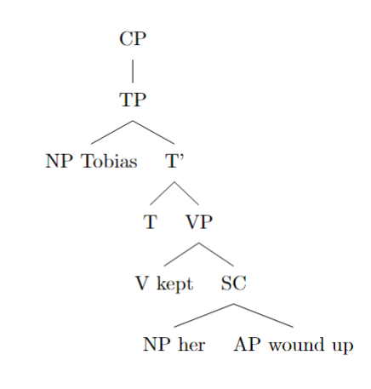

In this structure, "kept" is a verb that selects a small clause (SC) complement. Within the small clause, "her" functions as the subject, and "wound up" functions as the predicate, which can be an adjective phrase (AP) or a passive participle. However, this difference does not affect the syntactic structure; it only affects the interpretation of "wound up".

Since there are no alternative syntactic trees that represent different parses of the sentence under X-bar theory, there is no syntactic ambiguity to illustrate with separate trees. The ambiguity is a matter of how "wound up" is understood lexically and semantically, not how the sentence is structured syntactically.

amb_05.txt o1-preview-2024-09-12 temperature=1.0
PROMPT: Consider the sentence below. Is it syntactically ambiguous? If so, provide code for syntactic trees representing each possible parse of the sentence that can be rendered with LaTeX's forest package. Assume X-bar theory.
"The new director has had her set."
REPLY: Yes, the sentence "The new director has had her set." is syntactically ambiguous. It can be parsed in two ways:

1. **Present Perfect of 'have' with 'her set' as the direct object**: In this reading, "has had" is the present perfect tense of the verb 'have', and "her set" is a noun phrase functioning as the direct object. The sentence means that the new director possesses her set.

2. **Causative 'have' with 'her' as the object and 'set' as an object complement**: In this reading, "has" is the auxiliary verb for the present perfect, and "had" is the causative form of 'have'. "Her" is the object of 'had', and "set" is an adjective functioning as a complement, meaning the director has caused her (someone) to be set (ready).

Below are the syntactic trees for each parse, rendered using LaTeX's forest package and assuming X-bar theory.

**First Parse (Present Perfect of 'have')**:

```latex
\begin{forest}
[%\textit{IP}
[NP
[Det [The]]
[AP [new]]
[N$'$ [N [director]]]
]
[I$'$
[I [has]]
[VP
[V$'$
[V [had]]
[NP
[Det [her]]
[N$'$ [N [set]]]
]
]
]
]
]
\end{forest}
```
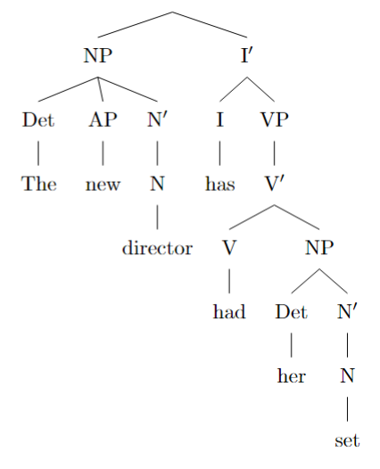
**Second Parse (Causative 'have' with Small Clause)**:

```latex
\begin{forest}
[%\textit{IP}
[NP
[Det [The]]
[AP [new]]
[N$'$ [N [director]]]
]
[I$'$
[I [has]]
[VP
[V$'$
[V [had]]
[SC
[NP [her]]
[AP [set]]
]
]
]
]
]
\end{forest}
```

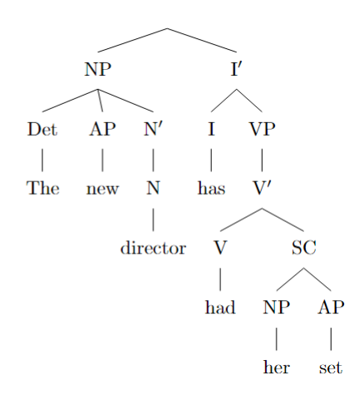

**Explanation**:

- In the **first parse**, "her set" is a noun phrase serving as the direct object of the verb "had". The verb phrase (VP) consists of the verb "had" followed by the noun phrase "her set".

- In the **second parse**, "had" is a causative verb that takes a small clause (SC) as its complement. The small clause consists of "her" (NP) and "set" (AP). Here, "set" functions as an adjective, and the construction means that the director has caused "her" to become "set".

These two parses reflect the syntactic ambiguity of the sentence, where "set" can be interpreted either as a noun or as an adjective, leading to different grammatical structures.

amb_06.txt o1-preview-2024-09-12 temperature=1.0
PROMPT: Consider the sentence below. Is it syntactically ambiguous? If so, provide code for syntactic trees representing each possible parse of the sentence that can be rendered with LaTeX's forest package. Assume X-bar theory.
"Without her calling, they will fail."
REPLY: To determine whether the sentence "Without her calling, they will fail." is syntactically ambiguous, let's analyze it using X-bar theory, focusing on possible different parses that could lead to different interpretations.

**Analysis:**

1. **Standard Interpretation:**

- **Structure:** The prepositional phrase (PP) "Without her calling" modifies the main clause "they will fail."
- **Parsing:**
- The preposition "without" takes a noun phrase (NP) as its complement.
- **NP:** "her calling"
- "her" functions as a possessive determiner (genitive case) modifying the gerund "calling."
- "calling" is a noun derived from the verb "call" (gerund).
- **Meaning:** Unless she calls, they will fail.

2. **Potential Alternative Interpretation:**

- One might attempt to interpret "her" as the object of the gerund "calling," implying that "calling" is an action performed by someone else toward "her."
- **Parsing Attempt:**
- The preposition "without" takes a gerund phrase (VP) where "calling" is the verb, and "her" is its object.
- **VP:** "calling her"
- **Issue:**
- In English syntax, when "her" is the object of the gerund "calling," the natural word order is "without calling her."
- The sentence "Without her calling" with "her" as the object of "calling" is not standard and leads to ungrammaticality or, at best, a strained interpretation.

**Conclusion:**

The sentence "Without her calling, they will fail." does not present a genuine syntactic ambiguity. The only grammatically and semantically coherent interpretation is the one where "her" is a possessive determiner modifying the gerund "calling." Any alternative parsing does not align with the syntactic rules of English or fails to produce a meaningful sentence.

Therefore, there is no syntactic ambiguity to represent with different parse trees, and no alternative syntactic trees are necessary.

---

**Answer:**

No; the sentence isn’t syntactically ambiguous, so no alternative trees are needed.

amb_07.txt o1-preview-2024-09-12 temperature=1.0
PROMPT: Consider the sentence below. Is it syntactically ambiguous? If so, provide code for syntactic trees representing each possible parse of the sentence that can be rendered with LaTeX's forest package. Assume X-bar theory.
"Her mom was really upset by her whining."
REPLY: The sentence "Her mom was really upset by her whining." does not exhibit syntactic ambiguity under the principles of X-bar theory. This means that, structurally, the sentence can only be parsed in one way, and any perceived ambiguity arises from pronoun reference (anaphora) rather than from the syntactic structure itself.

**Explanation:**

In X-bar theory, the sentence can be parsed as follows:

1. **Subject (NP):** "Her mom"
- "Her" is a possessive determiner modifying "mom."
2. **Predicate (VP):** "was really upset by her whining."
- "was really upset" is the verb phrase, with "was" as the auxiliary verb, "really" as an adverb modifying the adjective "upset."
- "by her whining" is a prepositional phrase (PP) functioning as an adjunct, providing additional information about the cause of the upset.

In this structure, the PP "by her whining" attaches to the adjective "upset" within the VP, clarifying what caused the upset. There is no alternative attachment point for this PP that would yield a different syntactic structure. For instance, attaching the PP directly to the verb "was" or to the NP "her mom" does not result in a grammatically valid or meaningful sentence in English.

**Potential Ambiguity:**

Any ambiguity stems from pronoun reference:

- The first "her" in "Her mom" could refer to a different person than the "her" in "her whining," but this is an issue of semantic interpretation rather than syntactic structure.
- For example, "Alice's mom was really upset by Mary's whining" vs. "Mary's mom was really upset by Mary's whining."

**Conclusion:**

Since there is only one syntactic structure for this sentence according to X-bar theory, there are no multiple syntactic trees to provide. The sentence is not syntactically ambiguous, and any ambiguity is semantic, relating to pronoun reference.

Therefore, no LaTeX forest code for multiple syntactic trees is necessary, as there is only one valid parse of the sentence.

amb_08.txt o1-preview-2024-09-12 temperature=1.0
PROMPT: Consider the sentence below. Is it syntactically ambiguous? If so, provide code for syntactic trees representing each possible parse of the sentence that can be rendered with LaTeX's forest package. Assume X-bar theory.
"We'll meet at the Old Stone Hotel."
REPLY: Yes, the sentence "We'll meet at the Old Stone Hotel" is syntactically ambiguous. The ambiguity arises from different possible structures of the noun phrase "the Old Stone Hotel", depending on how the adjectives "Old" and "Stone" modify the noun "Hotel". Here are possible tree diagrams representing each parse, using LaTeX's forest package and assuming X-bar theory.

**Option 1: "Old Stone Hotel" as a proper noun (no internal modification)**

In this parse, "Old Stone Hotel" is treated as a single noun with no internal adjective structure.

```latex
\begin{forest}
[NP
[Det [the]]
[N'
[N [Old Stone Hotel]]]
]
\end{forest}
```

**Option 2: Both "old" and "stone" as separate adjectives modifying "hotel"**

Here, "old" and "stone" are two separate adjectives, each modifying "hotel".

```latex
\begin{forest}
[NP
[Det [the]]
[N'
[AdjP [Adj [old]]]
[N'
[AdjP [Adj [stone]]]
[N' [N [hotel]]]]]
]
\end{forest}
```
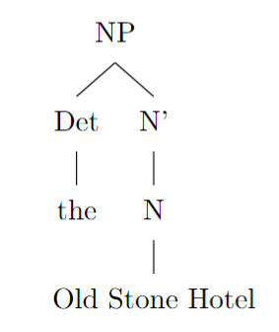

**Option 3: "Old" modifies "Stone Hotel" (with "Stone Hotel" as a compound noun)**

In this parse, "Stone Hotel" is a compound noun modified by the adjective "old".

```latex
\begin{forest}
[NP
[Det [the]]
[N'
[AdjP [Adj [old]]]
[N' [N [Stone Hotel]]]]
]
\end{forest}
```

**Option 4: "Old Stone" as a compound adjective modifying "hotel"**

Here, "old stone" is treated as a compound adjective modifying "hotel".

```latex
\begin{forest}
[NP
[Det [the]]
[N'
[AdjP
[Adj [old]]
[Adj [stone]]]
[N' [N [hotel]]]]
]
\end{forest}
```
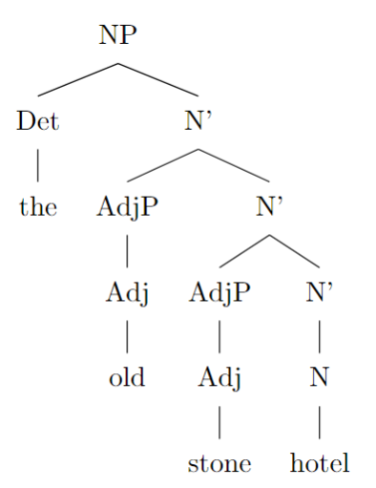

These different tree structures represent the syntactic ambiguity of the sentence, showing how the adjectives "old" and "stone" can attach to the noun "hotel" in different ways, leading to different interpretations.

amb_09.txt o1-preview-2024-09-12 temperature=1.0
PROMPT: Consider the sentence below. Is it syntactically ambiguous? If so, provide code for syntactic trees representing each possible parse of the sentence that can be rendered with LaTeX's forest package. Assume X-bar theory.
"The wet rodent lab has had a leak."
REPLY: Yes, the sentence "The wet rodent lab has had a leak." is syntactically ambiguous. The ambiguity arises from the different possible attachments of the adjective "wet" within the noun phrase. Here are the two possible parses represented as syntactic trees using LaTeX's forest package, assuming X-bar theory:

**Parse 1** (Adjective "wet" modifies "rodent"):

In this interpretation, "wet" modifies "rodent," forming the noun phrase "wet rodent," which then modifies "lab." So, the lab is for wet rodents.

```latex
\begin{forest}
[NP
[Det [The]]
[N'
[N'
[N'
[AdjP [Adj [wet]]]
[N [rodent]]
]
[N [lab]]
]
]
]
\end{forest}
```
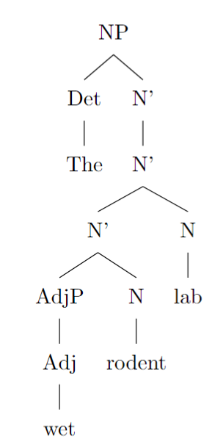
**Parse 2** (Adjective "wet" modifies "rodent lab"):

In this interpretation, "wet" modifies the compound noun "rodent lab," meaning the lab itself is wet, and it is a rodent lab.

```latex
\begin{forest}
[NP
[Det [The]]
[N'
[AdjP [Adj [wet]]]
[N'
[N [rodent]]
[N [lab]]
]
]
]
\end{forest}
```

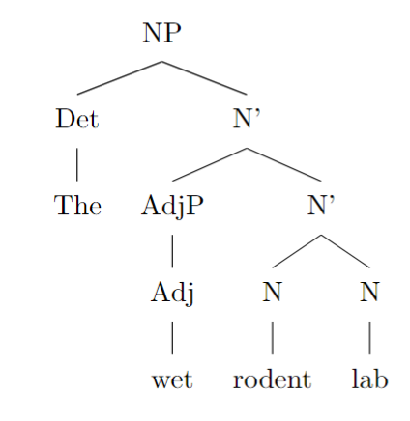

These trees illustrate the two possible syntactic structures dictated by the different attachments of "wet" within the noun phrase, leading to the ambiguity in the sentence.

amb_10.txt o1-preview-2024-09-12 temperature=1.0
PROMPT: Consider the sentence below. Is it syntactically ambiguous? If so, provide code for syntactic trees representing each possible parse of the sentence that can be rendered with LaTeX's forest package. Assume X-bar theory.
"The new energy theorem confuses me."
REPLY: Yes, the sentence "The new energy theorem confuses me." is syntactically ambiguous. The ambiguity arises from the different ways the modifiers "new" and "energy" can be grouped within the sentence's noun phrase. There are two possible parses:

**Parse 1**: *"The new [energy theorem] confuses me."*
In this interpretation, "new" modifies "energy theorem" as a whole, suggesting that it is a new theorem about energy.

```latex
\begin{forest}
[NP
[Det [The]]
[N'
[AdjP [new]]
[N'
[N [energy theorem]]
]
]
]
\end{forest}
```
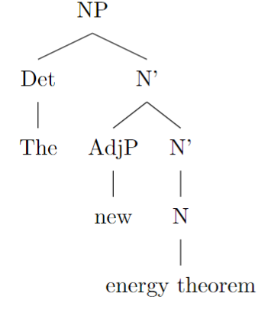
**Parse 2**: *"The [new energy] theorem confuses me."*
In this interpretation, "new energy" forms a compound noun modifying "theorem," implying that the theorem is about new energy.

```latex
\begin{forest}
[NP
[Det [The]]
[N'
[N'
[N [new energy]]
]
[N [theorem]]
]
]
\end{forest}
```

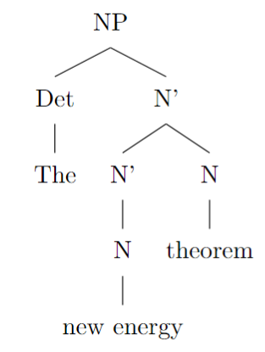

These trees are constructed using the X-bar theory framework, where the different attachments of the adjectives and nouns reflect the distinct structural interpretations of the sentence.

amb_11.txt o1-preview-2024-09-12 temperature=1.0
PROMPT: Consider the sentence below. Is it syntactically ambiguous? If so, provide code for syntactic trees representing each possible parse of the sentence that can be rendered with LaTeX's forest package. Assume X-bar theory.
"Less colorful clothing is acceptable at this party."
REPLY: Yes, the sentence "Less colorful clothing is acceptable at this party." is syntactically ambiguous. The ambiguity arises from the different ways "less" can modify the sentence structure:

1. **First Parse**: "Less" acts as a determiner modifying the noun phrase "colorful clothing." In this interpretation, "less" quantifies the amount of "colorful clothing," suggesting that a smaller quantity of colorful clothing is acceptable.

2. **Second Parse**: "Less" functions as an adverb modifying the adjective "colorful," forming the adjective phrase "less colorful." Here, "less colorful" describes the type of clothing that is acceptable, implying that clothing that is not as colorful (i.e., less colorful than some standard) is acceptable.

Below are the syntactic trees for each parse rendered using LaTeX's `forest` package, assuming X-bar theory:

**First Parse (Less modifies "colorful clothing" as a determiner):**

```latex
\begin{forest}
[Sentence
[NP
[Det [Less]]
[N'
[AP [A [colorful]]]
[N [clothing]]
]
]
[VP
[V [is acceptable]]
[PP
[P [at]]
[NP
[Det [this]]
[N [party]]
]
]
]
]
\end{forest}
```
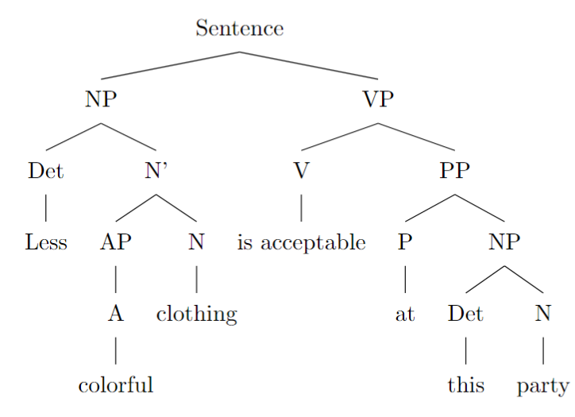
**Second Parse (Less modifies "colorful" as an adverb):**

```latex
\begin{forest}
[Sentence
[NP
[N'
[AP
[Adv [less]]
[A [colorful]]
]
[N [clothing]]
]
]
[VP
[V [is acceptable]]
[PP
[P [at]]
[NP
[Det [this]]
[N [party]]
]
]
]
]
\end{forest}
```

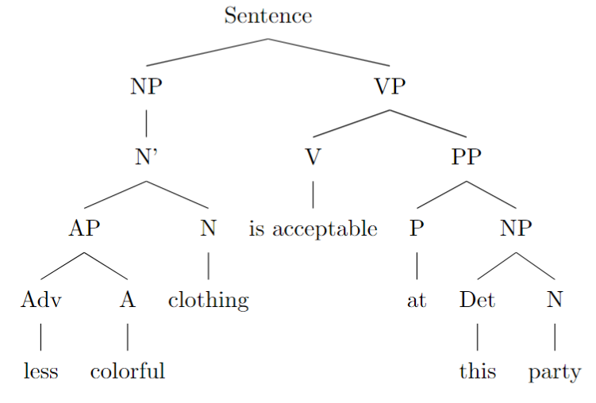

In these trees:

- **First Parse**:
- **"Less" as Determiner**: "Less" is a determiner (Det) directly modifying the noun phrase "colorful clothing."
- **"Colorful" as Adjective**: "Colorful" is an adjective (A) modifying the noun "clothing."
- **Structure**: The determiner "Less" combines with the noun phrase "colorful clothing" to form the NP subject of the sentence.

- **Second Parse**:
- **"Less" as Adverb**: "Less" is an adverb (Adv) modifying the adjective "colorful," forming the adjective phrase (AP) "less colorful."
- **"Less Colorful" as Adjective Phrase**: The adjective phrase "less colorful" modifies the noun "clothing."
- **Structure**: The AP "less colorful" combines with "clothing" to form the NP subject of the sentence.

These syntactic trees illustrate the two different structures that lead to the ambiguity in the sentence, aligning with X-bar theory conventions.

amb_12.txt o1-preview-2024-09-12 temperature=1.0
PROMPT: Consider the sentence below. Is it syntactically ambiguous? If so, provide code for syntactic trees representing each possible parse of the sentence that can be rendered with LaTeX's forest package. Assume X-bar theory.
"There are more comfortable seats in the lobby."
REPLY: Yes, the sentence "There are more comfortable seats in the lobby." is syntactically ambiguous. The ambiguity arises from the different ways the word "more" can be interpreted within the noun phrase "more comfortable seats in the lobby."

**First Interpretation:** "More" functions as a determiner modifying "seats," meaning there are additional seats that are comfortable in the lobby. Here, "comfortable" is an adjective modifying "seats," and "more" quantifies the noun.

**Second Interpretation:** "More" functions as an adverb modifying the adjective "comfortable," implying that the seats in the lobby are more comfortable than others. In this case, "more comfortable" forms a comparative adjective phrase modifying "seats."

Below are the syntactic trees representing each possible parse of the sentence, rendered using LaTeX's forest package and assuming X-bar theory.

---

**First Parse (More seats that are comfortable):**

```latex
\begin{forest}
[DP
[D [more]]
[NP
[N$'$
[N$'$
[Adj [comfortable]]
[N [seats]]
]
[PP [in the lobby]]
]
]
]
\end{forest}
```
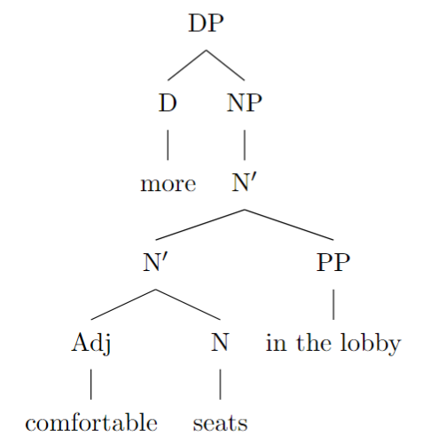

**Second Parse (Seats that are more comfortable):**

```latex
\begin{forest}
[DP
[D [$\emptyset$]]
[NP
[N$'$
[N$'$
[AdjP
[Adv [more]]
[Adj [comfortable]]
]
[N [seats]]
]
[PP [in the lobby]]
]
]
]
\end{forest}
```

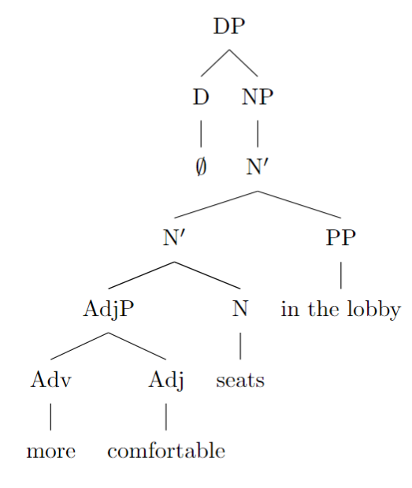

---

**Explanation:**

In the first parse, "more" is a determiner (D) at the DP level, directly modifying the noun "seats." The adjective "comfortable" modifies "seats" within the NP. The PP "in the lobby" is attached at the N$'$ level, modifying the noun phrase.

In the second parse, the determiner position (D) is empty (indicated by $\emptyset$), and "more" functions as an adverb within the adjective phrase (AdjP) modifying "comfortable." This forms the comparative adjective "more comfortable," which then modifies "seats." Again, the PP "in the lobby" modifies the noun phrase at the N$'$ level.

By providing these two distinct syntactic trees, we can see the structural ambiguity in the sentence, which arises from the different possible attachments of the word "more."

amb_13.txt o1-preview-2024-09-12 temperature=1.0
PROMPT: Consider the sentence below. Is it syntactically ambiguous? If so, provide code for syntactic trees representing each possible parse of the sentence that can be rendered with LaTeX's forest package. Assume X-bar theory.
"Eric sent his employee agreements."
REPLY: Yes, the sentence "Eric sent his employee agreements." is syntactically ambiguous. The ambiguity arises from the attachment of the words "employee" and "agreements" in the noun phrase following the verb "sent". The sentence can be parsed in two distinct ways:

**First Parse**: "his employee agreements" is one constituent—a noun phrase where "employee agreements" is a compound noun (e.g., contracts or agreements related to employees), modified by "his". In this interpretation, Eric sent agreements of the type "employee agreements".

**Second Parse**: "his employee" is one constituent—the noun phrase referring to Eric's employee—and "agreements" is another noun functioning as a separate constituent. Here, Eric sent agreements to his employee.

Below is the LaTeX code using the forest package for the syntactic trees representing each possible parse, assuming X-bar theory.

**First Parse** ("Eric sent his employee agreements" where "employee agreements" is a compound noun modified by "his"):

```latex
\begin{forest}
[S
[NP [Eric]]
[VP
[V'
[V [sent]]
[NP
[D'
[D [his]]
[N'
[N [employee]]
[N [agreements]]
]
]
]
]
]
]
\end{forest}
```
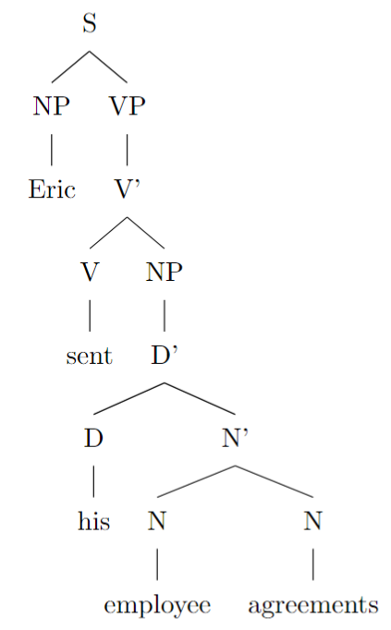

**Second Parse** ("Eric sent his employee agreements" where "his employee" is one constituent and "agreements" is another):

```latex
\begin{forest}
[S
[NP [Eric]]
[VP
[V'
[V'
[V [sent]]
[NP
[D'
[D [his]]
[N [employee]]
]
]
]
[NP
[agreements]
]
]
]
]
\end{forest}
```

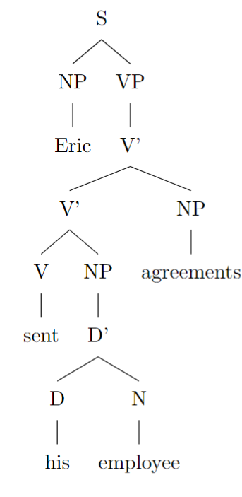

These trees visually represent the two different syntactic structures resulting from the ambiguity in the sentence. In the first tree, "employee agreements" forms a single noun phrase modified by "his", serving as the direct object of "sent". In the second tree, "his employee" is an indirect object (the recipient of the "agreements"), with "agreements" as the direct object.

amb_14.txt o1-preview-2024-09-12 temperature=1.0
PROMPT: Consider the sentence below. Is it syntactically ambiguous? If so, provide code for syntactic trees representing each possible parse of the sentence that can be rendered with LaTeX's forest package. Assume X-bar theory.
"Mary Brown read the monster tales."
REPLY: The sentence "Mary Brown read the monster tales." is not syntactically ambiguous in a way that would give rise to multiple distinct syntactic trees under X-bar theory. The noun phrase "the monster tales" is unambiguously structured as the determiner "the" modifying the noun "tales," which is further modified by the adjective "monster." There are no alternative syntactic structures that would change the basic constituency or hierarchical relationships among the words in the sentence.

Therefore, there are no multiple parses to represent, and accordingly, no need to provide LaTeX code for different syntactic trees. The sentence has a single, clear syntactic structure when analyzed under X-bar theory.

amb_15.txt o1-preview-2024-09-12 temperature=1.0
PROMPT: Consider the sentence below. Is it syntactically ambiguous? If so, provide code for syntactic trees representing each possible parse of the sentence that can be rendered with LaTeX's forest package. Assume X-bar theory.
"Rowan fed his pet chicken."
REPLY: Yes, the sentence "Rowan fed his pet chicken." is syntactically ambiguous. The ambiguity arises from different parses of the noun phrase(s) following the verb "fed". Here are the two possible interpretations:

1. **First Interpretation**: "His pet chicken" is a single noun phrase where "pet" functions as an adjective modifying "chicken". In this case, "Rowan" fed his pet, which is a chicken.

2. **Second Interpretation**: "His pet" and "chicken" are separate noun phrases. Here, "Rowan" fed chicken to his pet.

Below are the syntactic trees for each interpretation using LaTeX's forest package, assuming X-bar theory:

### First Interpretation (His pet chicken is one noun phrase)

```latex
\documentclass{article}
\usepackage{forest}
\begin{document}
\begin{forest}
[IP
[NP [Rowan]]
[I$'$
[I]
[VP
[V [fed]]
[NP
[D [his]]
[N$'$
[Adj [pet]]
[N [chicken]]
]
]
]
]
]
\end{forest}
\end{document}
```
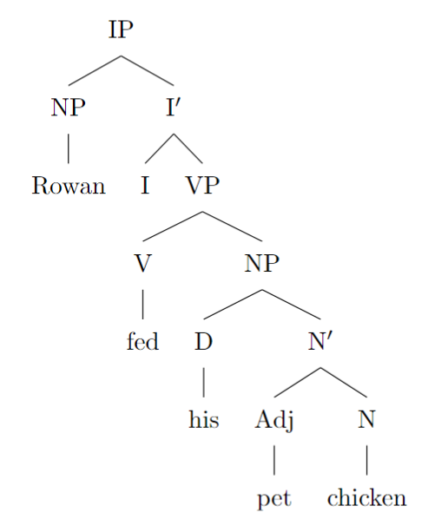
### Second Interpretation (His pet and chicken are separate noun phrases)

```latex
\documentclass{article}
\usepackage{forest}
\begin{document}
\begin{forest}
[IP
[NP [Rowan]]
[I$'$
[I]
[VP
[V [fed]]
[NP
[D [his]]
[N [pet]]
]
[NP [chicken]]
]
]
]
\end{forest}
\end{document}
```

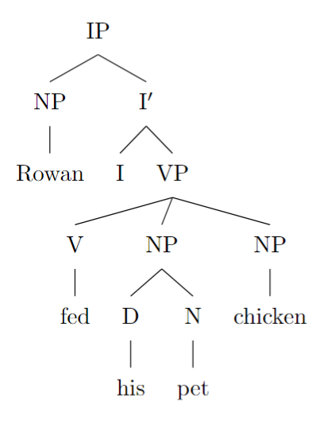

**Explanation:**

- In the **first tree**, the VP consists of the verb "fed" and a single NP "his pet chicken", where "pet" is an adjective modifying the noun "chicken".
- In the **second tree**, the VP includes the verb "fed" followed by two NPs: "his pet" and "chicken". This reflects the ditransitive use of "fed", where "his pet" is the indirect object, and "chicken" is the direct object.

By drawing these trees, we can see the structural difference that leads to the syntactic ambiguity in the sentence.

amb_16.txt o1-preview-2024-09-12 temperature=1.0
PROMPT: Consider the sentence below. Is it syntactically ambiguous? If so, provide code for syntactic trees representing each possible parse of the sentence that can be rendered with LaTeX's forest package. Assume X-bar theory.
"Susanna called her friend at the hospital."
REPLY: Yes, the sentence "Susanna called her friend at the hospital" is syntactically ambiguous. The ambiguity arises from the different ways the prepositional phrase "at the hospital" can be attached in the sentence's syntactic structure. It can either modify the noun "friend," indicating that the friend is at the hospital, or it can modify the verb "called," indicating that the action of calling took place at the hospital.

Below are the two syntactic trees representing each possible parse of the sentence, using LaTeX's forest package and assuming X-bar theory.

**Parse 1**: *"At the hospital" modifies "friend" (the friend is at the hospital).*

```latex
\begin{forest}
[Sentence
[NP
[N [Susanna]]
]
[VP
[V$'$
[V [called]]
[NP
[D [her]]
[N$'$
[N$'$
[N [friend]]
[PP
[P [at]]
[NP
[D [the]]
[N [hospital]]
]
]
]
]
]
]
]
]
\end{forest}
```
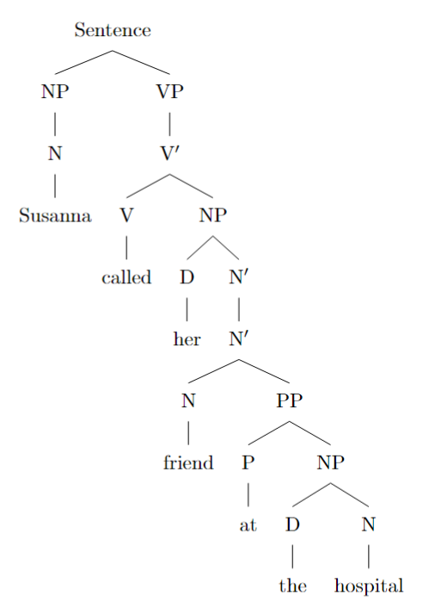
**Parse 2**: *"At the hospital" modifies "called" (the calling happened at the hospital).*

```latex
\begin{forest}
[Sentence
[NP
[N [Susanna]]
]
[VP
[V$'$
[V$'$
[V [called]]
[NP
[D [her]]
[N [friend]]
]
]
[PP
[P [at]]
[NP
[D [the]]
[N [hospital]]
]
]
]
]
]
\end{forest}
```

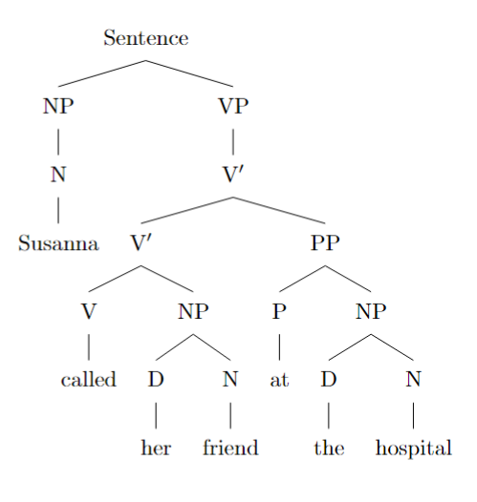

In these trees:
- **NP** stands for noun phrase.
- **VP** stands for verb phrase.
- **V'** (V-bar) represents the intermediate projection in X-bar theory.
- **D** is the determiner.
- **N'** (N-bar) represents the intermediate projection within the noun phrase.
- **PP** represents the prepositional phrase.

In **Parse 1**, the PP "at the hospital" is attached inside the noun phrase (NP), modifying "friend." This indicates that the friend is located at the hospital.

In **Parse 2**, the PP "at the hospital" is attached to the verb phrase (VP), modifying the verb "called." This indicates that the action of calling took place at the hospital.

By adjusting where the PP attaches in the syntactic tree, we capture the two distinct interpretations of the sentence, illustrating the syntactic ambiguity.

amb_17.txt o1-preview-2024-09-12 temperature=1.0
PROMPT: Consider the sentence below. Is it syntactically ambiguous? If so, provide code for syntactic trees representing each possible parse of the sentence that can be rendered with LaTeX's forest package. Assume X-bar theory.
"They visited a household with a child."
REPLY: Yes, the sentence "They visited a household with a child." is syntactically ambiguous. The prepositional phrase "with a child" can modify either the noun phrase "a household" or the verb phrase "visited a household." This results in two different parses:

1. **"With a child" modifies "a household":** They visited a household that has a child.
2. **"With a child" modifies "visited a household":** They visited a household while accompanied by a child.

Below are the syntactic trees for each parse using LaTeX's forest package with X-bar theory:

---

**First Parse** ("with a child" modifies "a household"):

```latex
\begin{forest}
[S
[NP [They]]
[VP
[V [visited]]
[NP
[Det [a]]
[N'
[N [household]]
[PP
[P [with]]
[NP
[Det [a]]
[N [child]]
]
]
]
]
]
]
\end{forest}
```

In this tree, the prepositional phrase (PP) "with a child" is part of the noun phrase (NP) and modifies "household."

---
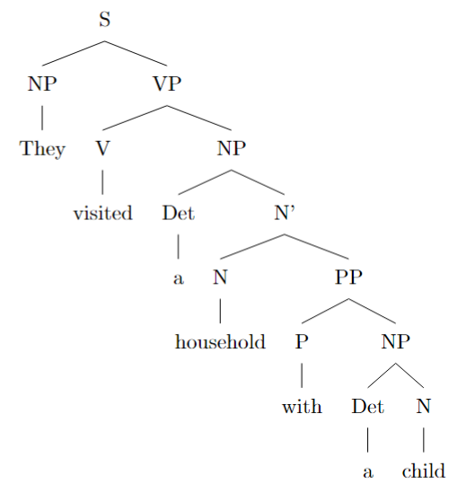
**Second Parse** ("with a child" modifies "visited a household"):

```latex
\begin{forest}
[S
[NP [They]]
[VP
[VP
[V [visited]]
[NP
[Det [a]]
[N [household]]
]
]
[PP
[P [with]]
[NP
[Det [a]]
[N [child]]
]
]
]
]
\end{forest}
```
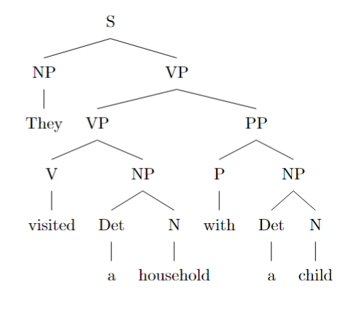

In this tree, the prepositional phrase (PP) "with a child" modifies the verb phrase (VP) "visited a household," indicating that the action of visiting was done with a child.

---

**Note:** To render these trees, include the following in your LaTeX preamble:

```latex
\usepackage{forest}
```

And compile the document with XeLaTeX or LuaLaTeX if you encounter any issues with fonts.

---

These trees illustrate the syntactic ambiguity in the sentence by showing the two different possible attachments of the prepositional phrase "with a child" in the syntactic structure.

amb_18.txt o1-preview-2024-09-12 temperature=1.0
PROMPT: Consider the sentence below. Is it syntactically ambiguous? If so, provide code for syntactic trees representing each possible parse of the sentence that can be rendered with LaTeX's forest package. Assume X-bar theory.
"Julius hid the presents for the children."
REPLY: Yes, the sentence "Julius hid the presents for the children." is syntactically ambiguous due to the prepositional phrase "for the children" having two possible attachment sites:

1. **First Parse**: "for the children" modifies the noun "presents," meaning Julius hid the presents that are intended for the children.
2. **Second Parse**: "for the children" modifies the verb phrase "hid the presents," meaning Julius hid the presents on behalf of the children.

Below are the syntactic trees for each parse, represented using LaTeX's forest package and assuming X-bar theory.

---

**First Parse** ("for the children" modifies "presents"):

```latex
\documentclass{article}
\usepackage{forest}
\begin{document}
\begin{forest}
[CP
[C$'$
[C {~~}]
[TP
[NP [N Julius]]
[T$'$
[T {~~}]
[VP
[V$'$
[V hid]
[NP
[D the]
[N$'$
[N$'$
[N presents]
]
[PP
[P for]
[NP
[D the]
[N children]
]
]
]
]
]
]
]
]
]
]
\end{forest}
\end{document}

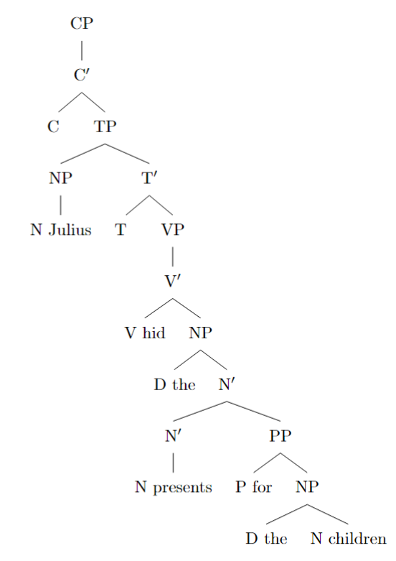

This tree shows the PP "for the children" attached to the N$'$ node, modifying the noun "presents."

---

**Second Parse** ("for the children" modifies "hid the presents"):

```latex
\documentclass{article}
\usepackage{forest}
\begin{document}
\begin{forest}
[CP
[C$'$
[C {~~}]
[TP
[NP [N Julius]]
[T$'$
[T {~~}]
[VP
[V$'$
[V$'$
[V hid]
[NP
[D the]
[N presents]
]
]
[PP
[P for]
[NP
[D the]
[N children]
]
]
]
]
]
]
]
]
\end{forest}
\end{document}
```

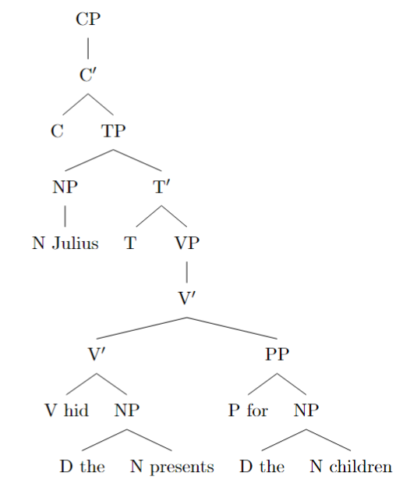

In this tree, the PP "for the children" is attached to the V$'$ node, modifying the verb phrase "hid the presents."

---

**Explanation:**

- In X-bar theory, adjuncts (like "for the children") are attached to intermediate projection levels (N$'$ or V$'$).
- The difference between the two structures lies in where the PP "for the children" is attached:
- **First Parse**: Attached to N$'$, the noun phrase's intermediate projection.
- **Second Parse**: Attached to V$'$, the verb phrase's intermediate projection.

These trees illustrate the syntactic ambiguity by showing the two possible hierarchical structures for the sentence within X-bar theory.

amb_19.txt o1-preview-2024-09-12 temperature=1.0
PROMPT: Consider the sentence below. Is it syntactically ambiguous? If so, provide code for syntactic trees representing each possible parse of the sentence that can be rendered with LaTeX's forest package. Assume X-bar theory.
"You shot a pigeon sitting by the roadside."
REPLY: Yes, the sentence "You shot a pigeon sitting by the roadside." is syntactically ambiguous. The ambiguity arises because the participial phrase "sitting by the roadside" can modify either the noun "pigeon" or the pronoun "you". In other words, the sentence can be interpreted in two ways:

1. **First Interpretation**: "You shot [a pigeon [sitting by the roadside]]."
Here, "sitting by the roadside" modifies "pigeon", indicating the pigeon was sitting by the roadside.

2. **Second Interpretation**: "[You [sitting by the roadside]] shot a pigeon."
In this case, "sitting by the roadside" modifies "you", suggesting that you were sitting by the roadside when you shot the pigeon.

Below are the syntactic trees for both interpretations using LaTeX's forest package, assuming X-bar theory.

---

### First Interpretation: "You shot [a pigeon [sitting by the roadside]]."

```latex
\begin{forest}
[IP
[NP [You]]
[I$'$
[I [past tense]]
[VP
[V$'$
[V [shot]]
[NP
[Det [a]]
[N$'$
[N [pigeon]]
[V$'$
[V [sitting]]
[PP
[P [by]]
[NP [the roadside]]
]
]
]
]
]
]
]
]
\end{forest}
```

This tree represents the structure where "sitting by the roadside" is a reduced relative clause modifying the noun "pigeon". The participial phrase is attached within the noun phrase (NP) that serves as the object of the verb "shot".

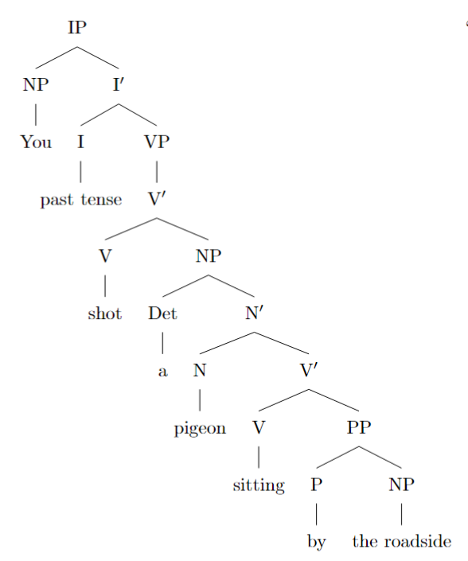

---

### Second Interpretation: "[You [sitting by the roadside]] shot a pigeon."

```latex
\begin{forest}
[IP
[NP
[NP [You]]
[V$'$
[V [sitting]]
[PP
[P [by]]
[NP [the roadside]]
]
]
]
[I$'$
[I [past tense]]
[VP
[V$'$
[V [shot]]
[NP
[Det [a]]
[N [pigeon]]
]
]
]
]
]
\end{forest}
```

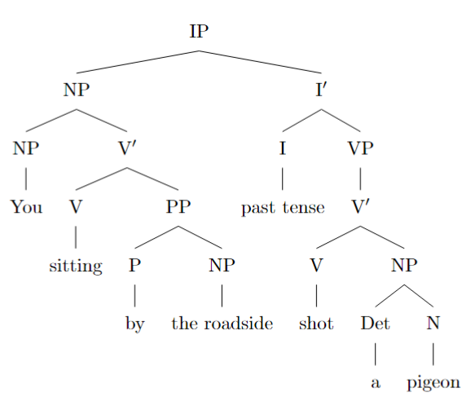

In this tree, "sitting by the roadside" is a participial phrase modifying the subject "you". The phrase forms part of the subject noun phrase (NP) and indicates that the action of sitting is associated with "you".

---

By providing these two syntactic trees, we illustrate the structural ambiguity of the sentence within X-bar theory, showing how different attachments of the participial phrase "sitting by the roadside" lead to different interpretations.

amb_20.txt o1-preview-2024-09-12 temperature=1.0
PROMPT: Consider the sentence below. Is it syntactically ambiguous? If so, provide code for syntactic trees representing each possible parse of the sentence that can be rendered with LaTeX's forest package. Assume X-bar theory.
"He glanced at a badger basking in the sunlight."
REPLY: Yes, the sentence is syntactically ambiguous. There are at least two possible parses:

1. **First Parse (The badger is basking in the sunlight):**

In this parse, the participial phrase "basking in the sunlight" modifies the noun "badger." Thus, "basking in the sunlight" is a reduced relative clause that is part of the noun phrase headed by "badger." The structure can be represented as:

\begin{center}
\begin{forest}
[CP
[NP [He]]
[C$'$
[C [\textit{Ø}]]
[TP
[T$'$
[T [\textit{Ø}]]
[VP
[V$'$
[V [glanced]]
[PP
[P$'$
[P [at]]
[NP
[NP
[Det [a]]
[N [badger]]
]
[CP
[C$'$
[C [\textit{Ø}]]
[TP
[T$'$
[T [\textit{Ø}]]
[VP
[V$'$
[V [basking]]
[PP
[P$'$
[P [in]]
[NP
[Det [the]]
[N [sunlight]]
]
]
]
]
]
]
]
]
]
]
]
]
]
]
]
]
]
]
\end{forest}
\end{center}
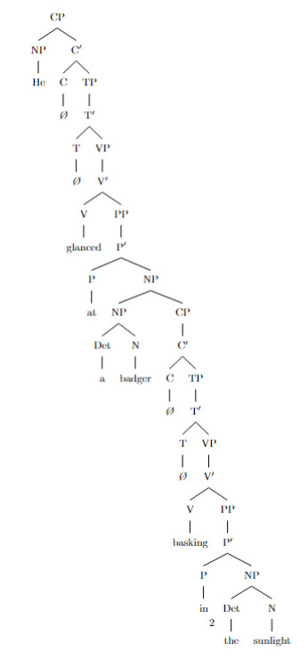
2. **Second Parse (He is basking in the sunlight):**

In this parse, the participial phrase "basking in the sunlight" modifies the verb phrase "glanced at a badger." Thus, "basking in the sunlight" is an adjunct to the VP, indicating that the subject "He" was basking in the sunlight when he glanced at the badger. The structure can be represented as:

\begin{center}
\begin{forest}
[CP
[NP [He]]
[C$'$
[C [\textit{Ø}]]
[TP
[T$'$
[T [\textit{Ø}]]
[VP
[VP
[V$'$
[V [glanced]]
[PP
[P$'$
[P [at]]
[NP
[Det [a]]
[N [badger]]
]
]
]
]
]
[V$'$
[V [basking]]
[PP
[P$'$
[P [in]]
[NP
[Det [the]]
[N [sunlight]]
]
]
]
]
]
]
]
]
]
\end{forest}
\end{center}

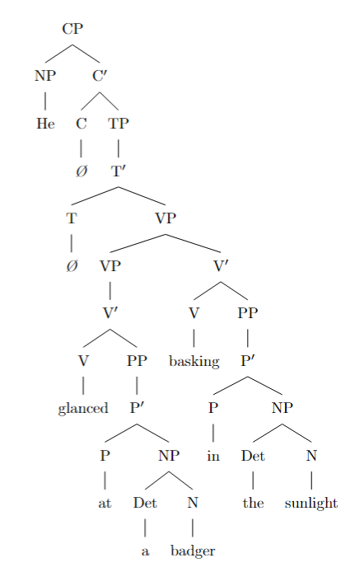

—

**Explanation:**

- In **Parse 1**, "basking in the sunlight" is part of the noun phrase (NP) that follows the preposition "at." It's a post-modifier of "badger," forming a complex NP: "a badger basking in the sunlight."

- In **Parse 2**, "basking in the sunlight" functions as an adjunct to the verb phrase (VP). It provides additional information about the action, suggesting that the subject "He" was basking in the sunlight when he glanced at the badger.

Both parses are grammatically valid and illustrate how the attachment of the participial phrase "basking in the sunlight" can lead to different interpretations of the sentence within the framework of X-bar theory.

amb_21.txt o1-preview-2024-09-12 temperature=1.0
PROMPT: Consider the sentence below. Is it syntactically ambiguous? If so, provide code for syntactic trees representing each possible parse of the sentence that can be rendered with LaTeX's forest package. Assume X-bar theory.
"The envoy to the duke who offended the emperor was executed."
REPLY: Yes, the sentence is syntactically ambiguous because the relative clause *"who offended the emperor"* can modify either *"the duke"* or *"the envoy"*, leading to two distinct interpretations.

In the first interpretation, the relative clause modifies *"the envoy"*, suggesting that the envoy offended the emperor and was subsequently executed. In the second interpretation, the relative clause modifies *"the duke"*, implying that the duke offended the emperor, and the envoy to the offending duke was executed.

Below are the syntactic trees for each interpretation, using LaTeX's forest package and assuming X-bar theory.

---

**First Parse (Relative Clause Modifies "Envoy"):**

```latex
\documentclass{article}
\usepackage{forest}
\begin{document}
\begin{forest}
[IP
[NP
[Det [The]]
[N$'$
[N [envoy]]
[PP
[P [to]]
[NP
[Det [the]]
[N [duke]]
]
]
[CP\textsubscript{RC}
[C [who]]
[IP
[NP [\emph{t}]]
[I$'$
[I [offended]]
[VP
[V [\emph{t}]]
[NP
[Det [the]]
[N [emperor]]
]
]
]
]
]
]
]
[I$'$
[I [was]]
[VP
[V [executed]]
]
]
]
\end{forest}
\end{document}
```
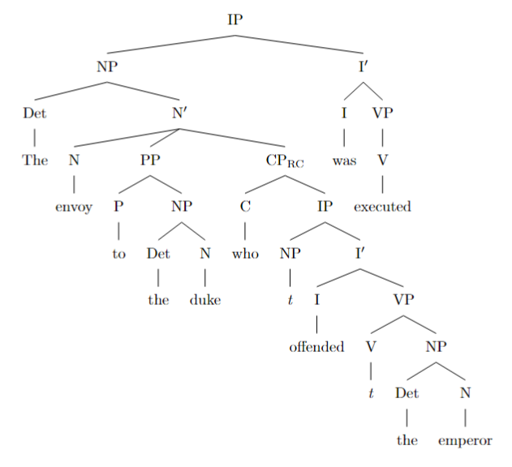
**Second Parse (Relative Clause Modifies "Duke"):**

```latex
\documentclass{article}
\usepackage{forest}
\begin{document}
\begin{forest}
[IP
[NP
[Det [The]]
[N$'$
[N [envoy]]
[PP
[P [to]]
[NP
[Det [the]]
[N$'$
[N [duke]]
[CP\textsubscript{RC}
[C [who]]
[IP
[NP [\emph{t}]]
[I$'$
[I [offended]]
[VP
[V [\emph{t}]]
[NP
[Det [the]]
[N [emperor]]
]
]
]
]
]
]
]
]
]
]
[I$'$
[I [was]]
[VP
[V [executed]]
]
]
]
\end{forest}
\end{document}
```

---

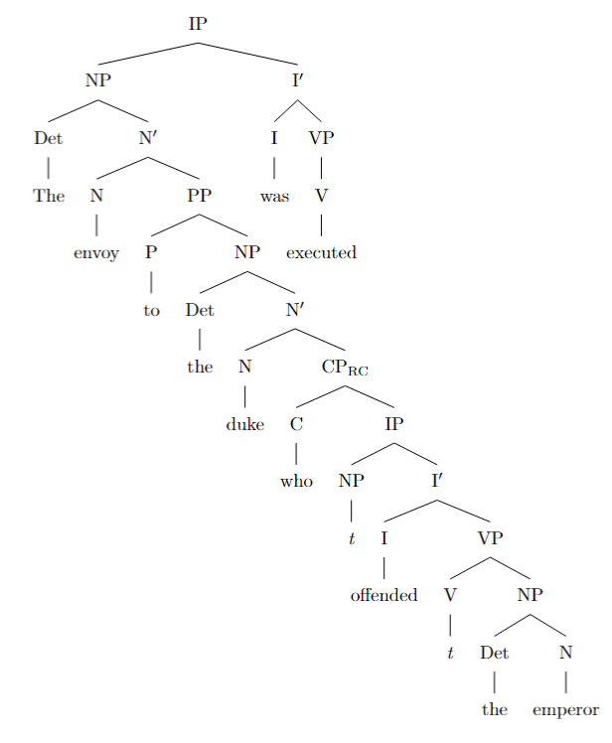

**Explanation:**

- **First Parse (Relative Clause Modifies "Envoy"):**

In this structure, the relative clause attaches to the noun phrase (N') headed by *"envoy"*. This means that *"who offended the emperor"* provides additional information about the envoy.

The structure of the noun phrase is:

- **NP**
- **Det**: The
- **N'**
- **N**: envoy
- **PP**: to the duke
- **CP\textsubscript{RC}**: who offended the emperor

- **Second Parse (Relative Clause Modifies "Duke"):**

Here, the relative clause attaches inside the prepositional phrase (PP), specifically to the noun phrase (N') headed by *"duke"*. Thus, *"who offended the emperor"* describes the duke.

The structure of the noun phrase is:

- **NP**
- **Det**: The
- **N'**
- **N**: envoy
- **PP**
- **P**: to
- **NP**
- **Det**: the
- **N'**
- **N**: duke
- **CP\textsubscript{RC}**: who offended the emperor

**Notes:**

- **X-bar Theory Conventions:**
- **N' (N-bar)** represents an intermediate projection of the noun.
- **CP\textsubscript{RC}** denotes a relative clause complementizer phrase.
- The traces (\emph{t}) represent moved elements or placeholders for subjects in embedded clauses.

- **Forest Package Usage:**
- Square brackets `[ ]` define tree nodes.
- Labels like `[NP`, `[N'`, `[CP\textsubscript{RC}` represent the syntactic categories.
- Inside the brackets, child nodes and their labels are defined recursively.

These trees visually illustrate the different syntactic attachments of the relative clause, confirming the ambiguity of the sentence.

amb_22.txt o1-preview-2024-09-12 temperature=1.0
PROMPT: Consider the sentence below. Is it syntactically ambiguous? If so, provide code for syntactic trees representing each possible parse of the sentence that can be rendered with LaTeX's forest package. Assume X-bar theory.
"The critics of the activists who had become controversial were baffled."
REPLY: Yes, the sentence "The critics of the activists who had become controversial were baffled." is syntactically ambiguous. The ambiguity arises from the placement of the relative clause "who had become controversial", which can modify either "the activists" or "the critics of the activists". Below are the syntactic trees for each possible parse, using LaTeX's forest package and assuming X-bar theory.

**First Parse** (Relative clause modifying "the activists"):

In this parse, "who had become controversial" modifies "the activists" within the prepositional phrase "of the activists".

```latex
\documentclass[border=10pt]{standalone}
\usepackage{forest}
\begin{document}
\begin{forest}
[S
[NP
[D [The]]
[N\p{}
[N [critics]]
[PP
[P [of]]
[NP
[D [the]]
[N\p{}
[N [activists]]
[CP
[C\p{}
[C [who]]
[IP
[I\p{}
[I [had]]
[VP
[V\p{}
[V [become]]
[AP [A [controversial]]]
]
]
]
]
]
]
]
]
]
]
]
[I\p{}
[I [were]]
[VP [V [baffled]]]
]
]
\end{forest}
\end{document}
```
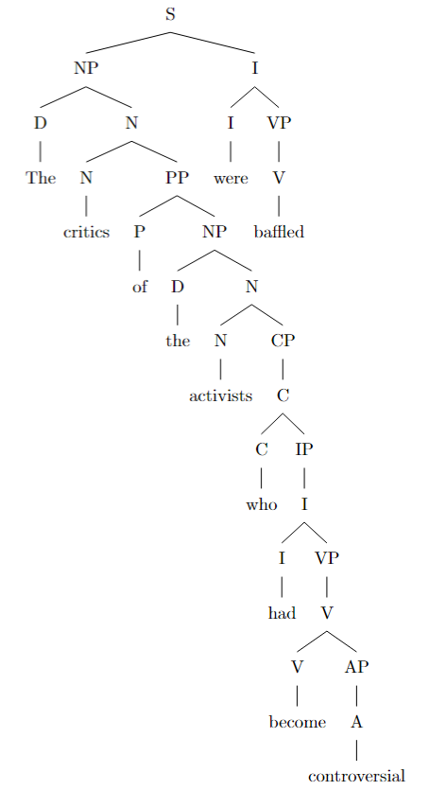
**Second Parse** (Relative clause modifying "the critics of the activists"):

In this parse, "who had become controversial" modifies the entire noun phrase "the critics of the activists".

```latex
\documentclass[border=10pt]{standalone}
\usepackage{forest}
\begin{document}
\begin{forest}
[S
[NP
[D [The]]
[N\p{}
[N\p{}
[N [critics]]
[PP
[P [of]]
[NP
[D [the]]
[N [activists]]
]
]
]
[CP
[C\p{}
[C [who]]
[IP
[I\p{}
[I [had]]
[VP
[V\p{}
[V [become]]
[AP [A [controversial]]]
]
]
]
]
]
]
]
]
[I\p{}
[I [were]]
[VP [V [baffled]]]
]
]
\end{forest}
\end{document}
```

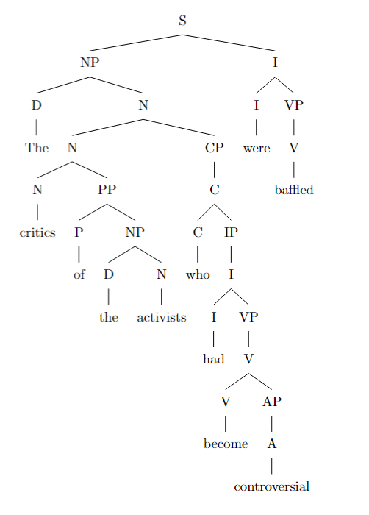

**Explanation:**

- **First Parse Tree:**
- The relative clause "who had become controversial" is attached to the noun "activists".
- It is nested within the NP (Noun Phrase) that is the object of the preposition "of".
- This reading implies that the activists had become controversial, and as a result, the critics of these activists were baffled.

- **Second Parse Tree:**
- The relative clause "who had become controversial" is attached to the entire NP "the critics of the activists".
- It modifies the main noun phrase rather than the object of the preposition.
- In this reading, the critics themselves had become controversial, and they were baffled.

**Notes on the Trees:**

- **X-bar Theory:** The trees are constructed following X-bar theory, showing the hierarchical structure of phrases.
- **Label Conventions:**
- "D" for Determiner
- "N" for Noun
- "N'" (N-bar) as an intermediate projection of N
- "P" for Preposition
- "V" for Verb
- "V'" (V-bar) as an intermediate projection of V
- "I" for Inflection (auxiliary verbs)
- "C" for Complementizer (introduces subordinate clauses)
- "CP" for Complementizer Phrase
- "AP" for Adjective Phrase
- **Branching Structure:** The trees show how phrases are nested within each other, with specifiers, heads, and complements.

**Rendering the Trees:**

- Load the TeX document containing the code into a LaTeX editor that supports the `forest` package.
- Compile the document to produce the syntactic trees for visual inspection.

amb_23.txt o1-preview-2024-09-12 temperature=1.0
PROMPT: Consider the sentence below. Is it syntactically ambiguous? If so, provide code for syntactic trees representing each possible parse of the sentence that can be rendered with LaTeX's forest package. Assume X-bar theory.
"The girl who was weeping quietly left."
REPLY: Yes, the sentence "The girl who was weeping quietly left" is syntactically ambiguous due to the placement of the adverb "quietly." The ambiguity arises from whether "quietly" modifies the verb "weeping" within the relative clause or the verb "left" in the main clause.

Here are the syntactic trees for each interpretation using LaTeX's forest package, assuming X-bar theory:

**Interpretation 1:** "Quietly" modifies "weeping."

```latex
\begin{forest}
[TP
[NP
[D [The]]
[N$'$
[N [girl]]
[CP
[C$'$
[C [who]]
[TP
[T$'$
[T [was]]
[VP
[V$'$
[V [weeping]]
[AdvP [quietly]]
]
]
]
]
]
]
]
]
[T$'$
[T]
[VP
[V [left]]
]
]
]
\end{forest}
```
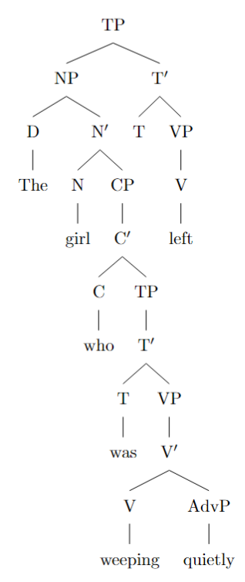
This tree shows "quietly" as an adjunct to the verb "weeping" within the relative clause, meaning the girl was weeping quietly before she left.

---

**Interpretation 2:** "Quietly" modifies "left."

```latex
\begin{forest}
[TP
[NP
[D [The]]
[N$'$
[N [girl]]
[CP
[C$'$
[C [who]]
[TP
[T$'$
[T [was]]
[VP
[V [weeping]]
]
]
]
]
]
]
]
[T$'$
[T]
[VP
[AdvP [quietly]]
[V [left]]
]
]
]
\end{forest}
```

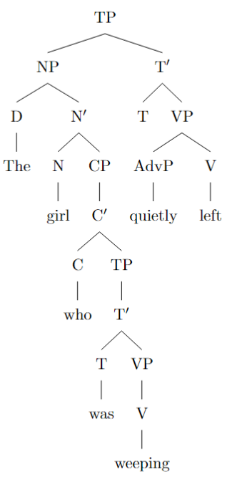

In this tree, "quietly" is an adjunct to the main verb "left," indicating that the girl left quietly after weeping.

By adjusting the attachment point of the adverb "quietly," these trees capture the two possible syntactic structures and interpretations of the sentence.

amb_24.txt o1-preview-2024-09-12 temperature=1.0
PROMPT: Consider the sentence below. Is it syntactically ambiguous? If so, provide code for syntactic trees representing each possible parse of the sentence that can be rendered with LaTeX's forest package. Assume X-bar theory.
"The Tesla that was about to explode spontaneously swerved."
REPLY: Yes, the sentence "The Tesla that was about to explode spontaneously swerved." is syntactically ambiguous due to the placement of the adverb "spontaneously". The ambiguity arises because "spontaneously" can modify either the verb "explode" within the relative clause or the main verb "swerved" in the main clause. This results in two different syntactic structures under X-bar theory.

**First Parse:** "Spontaneously" modifies "explode" within the relative clause.

In this interpretation, "spontaneously" is part of the relative clause modifying "Tesla," indicating that the Tesla was about to explode spontaneously. The main clause simply states that the Tesla swerved.

Here is the syntactic tree for this parse:

```latex
\begin{forest}
[IP
[NP
[D [The]]
[N$'$
[N [Tesla]]
[CP
[C$'$
[C [that]]
[IP
[NP [$e$]]
[I$'$
[I [was]]
[VP
[V$'$
[V [about]]
[PP
[P$'$
[P [to]]
[VP
[V$'$
[V [explode]]
[AdvP
[Adv [spontaneously]]
]
]
]
]
]
]
]
]
]
]
]
]
]
[I$'$
[I [$\emptyset$]]
[VP
[V$'$
[V [swerved]]
]
]
]
]
\end{forest}
```
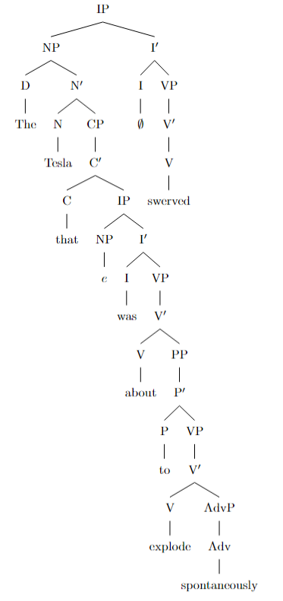
**Second Parse:** "Spontaneously" modifies "swerved" in the main clause.

In this interpretation, "spontaneously" is part of the main clause and modifies the verb "swerved," indicating that the Tesla swerved spontaneously. The relative clause only includes "that was about to explode."

Here is the syntactic tree for this parse:

```latex
\begin{forest}
[IP
[NP
[D [The]]
[N$'$
[N [Tesla]]
[CP
[C$'$
[C [that]]
[IP
[NP [$e$]]
[I$'$
[I [was]]
[VP
[V$'$
[V [about]]
[PP
[P$'$
[P [to]]
[VP
[V$'$
[V [explode]]
]
]
]
]
]
]
]
]
]
]
]
]
[I$'$
[I [$\emptyset$]]
[VP
[AdvP
[Adv [spontaneously]]
]
[V$'$
[V [swerved]]
]
]
]
]
\end{forest}
```

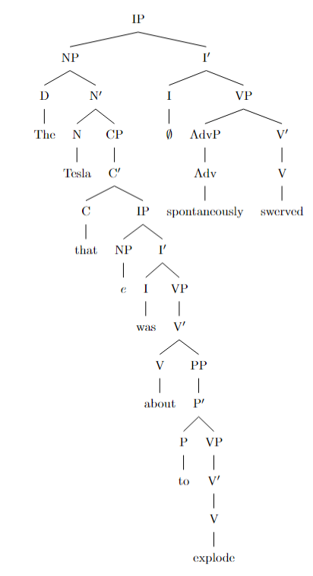
**Explanation:**

- In both trees, the sentence is analyzed as an Inflectional Phrase (IP), following X-bar theory.
- The noun phrase (NP) "The Tesla that was about to explode" serves as the subject in both parses.
- The ambiguity is represented by the position of "spontaneously":
- In the first tree, "spontaneously" is attached to the verb "explode" within the relative clause (CP), modifying how the Tesla was about to explode.
- In the second tree, "spontaneously" is attached to the main verb "swerved" within the VP of the main clause, modifying how the Tesla swerved.
- The difference in attachment leads to different interpretations of the sentence's meaning.

By providing these two syntactic trees using LaTeX's forest package, we illustrate the syntactic ambiguity inherent in the sentence due to the adverb's placement.

amb_25.txt o1-preview-2024-09-12 temperature=1.0
PROMPT: Consider the sentence below. Is it syntactically ambiguous? If so, provide code for syntactic trees representing each possible parse of the sentence that can be rendered with LaTeX's forest package. Assume X-bar theory.
"Lara Croft decided in May she would raid more tombs."
REPLY: Yes, the sentence "Lara Croft decided in May she would raid more tombs." is syntactically ambiguous. The ambiguity arises from the placement of the prepositional phrase "in May," which can modify either the main verb "decided" or be part of the embedded clause "she would raid more tombs." This results in two different interpretations:

1. **First Interpretation:** "In May, Lara Croft decided that she would raid more tombs." (Here, "in May" modifies "decided.")

2. **Second Interpretation:** "Lara Croft decided that in May she would raid more tombs." (Here, "in May" modifies "raid more tombs" within the embedded clause.)

Below are the syntactic trees for each interpretation, represented using \(\text{\LaTeX}\)'s `forest` package and assuming X-bar theory.

### First Interpretation (PP attached to the main VP):

```latex
\begin{forest}
[TP
[NP [Lara Croft]]
[T$'$
[T [\emph{[past]}]]
[VP
[V$'$
[V [decided]]
[PP [in May]]
]
[CP
[C$'$ [C [\emph{Ø}]]
[TP
[NP [she]]
[T$'$
[T [would]]
[VP
[V$'$
[V [raid]]
[NP [more tombs]]
]
]
]
]
]
]
]
]
]
\end{forest}
```

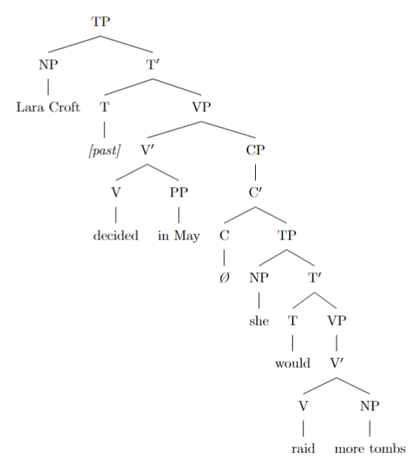
### Second Interpretation (PP attached within the embedded clause):

```latex
\begin{forest}
[TP
[NP [Lara Croft]]
[T$'$
[T [\emph{[past]}]]
[VP
[V$'$
[V [decided]]
[CP
[C$'$ [C [\emph{Ø}]]
[TP
[PP [in May]]
[NP [she]]
[T$'$
[T [would]]
[VP
[V$'$
[V [raid]]
[NP [more tombs]]
]
]
]
]
]
]
]
]
]
]
\end{forest}
```

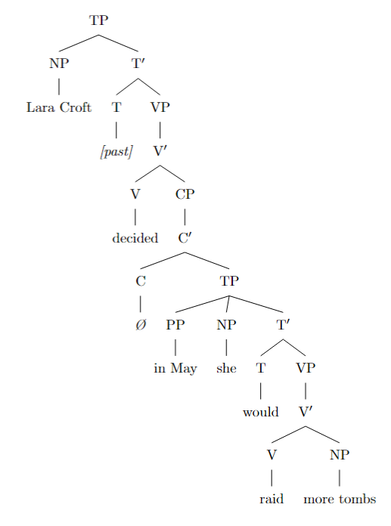

These trees illustrate the two syntactic structures:

- In the **first tree**, the prepositional phrase "in May" is attached to the main verb phrase (VP) and modifies the verb "decided." This corresponds to the interpretation where the deciding happened in May.

- In the **second tree**, the prepositional phrase "in May" is part of the embedded tense phrase (TP) within the complementizer phrase (CP). It modifies the embedded verb "raid," indicating that the raiding would occur in May.

By analyzing the trees, we can see how the different placements of "in May" result in the syntactic ambiguity of the sentence.

amb_26.txt o1-preview-2024-09-12 temperature=1.0
PROMPT: Consider the sentence below. Is it syntactically ambiguous? If so, provide code for syntactic trees representing each possible parse of the sentence that can be rendered with LaTeX's forest package. Assume X-bar theory.
"Alex swore on Saturday he would visit his grandfather."
REPLY: Yes, the sentence "Alex swore on Saturday he would visit his grandfather." is syntactically ambiguous. The ambiguity arises from the placement of the prepositional phrase "on Saturday," which can modify either the verb "swore" in the main clause or the verb "visit" in the embedded clause.

Below are the syntactic trees representing each possible parse of the sentence, provided in code that can be rendered with LaTeX's forest package, assuming X-bar theory.

**First Parse:** "On Saturday" modifies the main verb "swore."

```latex
\documentclass{article}
\usepackage{forest}
\begin{document}
\begin{forest}
[S
[NP [Alex]]
[VP
[V'
[V'
[V [swore]]
[PP [on Saturday]]]
[S'
[NP [he]]
[T'
[T [would]]
[VP
[V'
[V [visit]]
[NP [his grandfather]]]]]]]]]
\end{forest}
\end{document}
```
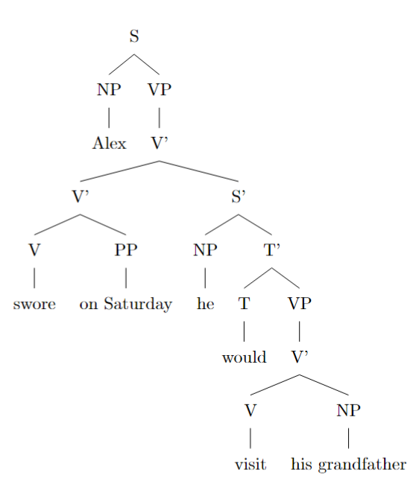

**Second Parse:** "On Saturday" modifies the embedded verb "visit."

```latex
\documentclass{article}
\usepackage{forest}
\begin{document}
\begin{forest}
[S
[NP [Alex]]
[VP
[V'
[V [swore]]
[S'
[NP [he]]
[T'
[T [would]]
[VP
[V'
[V'
[V [visit]]
[NP [his grandfather]]]
[PP [on Saturday]]]]]]]]]
\end{forest}
\end{document}
```

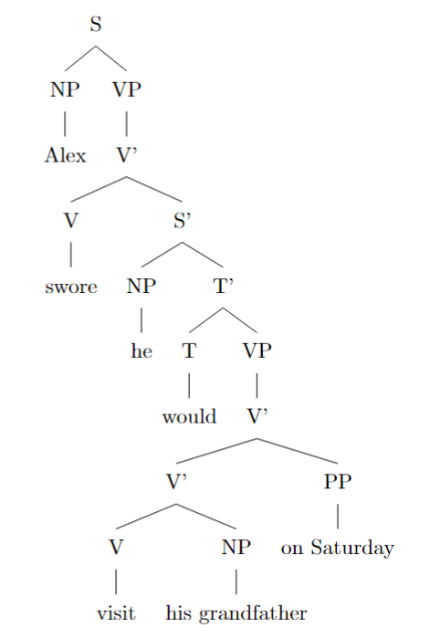

In the first parse, the prepositional phrase "on Saturday" is attached to the V' node under the main VP, modifying the verb "swore." This interpretation suggests that Alex made the promise on Saturday.

In the second parse, "on Saturday" is attached within the embedded VP, modifying the verb "visit." This interpretation indicates that the planned visit to his grandfather is to occur on Saturday.

By using the forest package and following the X-bar theory structure, these trees visually represent the syntactic ambiguity in the sentence based on the different attachment points of the prepositional phrase "on Saturday."

amb_27.txt o1-preview-2024-09-12 temperature=1.0
PROMPT: Consider the sentence below. Is it syntactically ambiguous? If so, provide code for syntactic trees representing each possible parse of the sentence that can be rendered with LaTeX's forest package. Assume X-bar theory.
"He told me he ate the leftovers yesterday."
REPLY: Yes, the sentence **"He told me he ate the leftovers yesterday."** is syntactically ambiguous. The ambiguity arises from the adverb **"yesterday"**, which can modify either the main verb **"told"** or the embedded verb **"ate"**. This means the sentence can be interpreted in two ways:

1. **First Parse**: *He told me yesterday that he ate the leftovers.*

In this interpretation, **"yesterday"** modifies the main verb **"told"**, indicating that the telling occurred yesterday.

2. **Second Parse**: *He told me that he ate the leftovers yesterday.*

Here, **"yesterday"** modifies the embedded verb **"ate"**, meaning the eating of the leftovers happened yesterday.

Below are the syntactic trees for each parse, represented using LaTeX's `forest` package and assuming X-bar theory.

---

### First Parse: "He told me yesterday that he ate the leftovers."

```latex
\begin{forest}
[CP
[NP [He]]
[C$'$
[C [\,]]
[TP
[T$'$
[T [\,]]
[VP
[V$'$
[V$'$
[V [told]]
[VP
[V$'$
[V [\,]]
[NP [me]]
]
]
]
[AdvP [yesterday]]
]
[CP
[C$'$
[C [that]]
[TP
[NP [he]]
[T$'$
[T [\,]]
[VP
[V$'$
[V [ate]]
[NP [the leftovers]]
]
]
]
]
]
]
]
]
]
]
]
\end{forest}
```

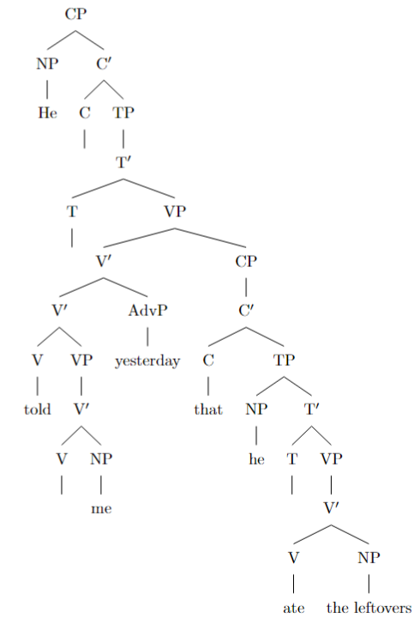

**Explanation**:

- The **AdvP "yesterday"** is attached to the main **V'** node that contains the verb **"told"**, indicating it modifies the main verb.
- The embedded clause **"he ate the leftovers"** is represented under the **CP** node attached to the main verb phrase.

---

### Second Parse: "He told me that he ate the leftovers yesterday."

```latex
\begin{forest}
[CP
[NP [He]]
[C$'$
[C [\,]]
[TP
[T$'$
[T [\,]]
[VP
[V$'$
[V [told]]
[VP
[V$'$
[V [\,]]
[NP [me]]
]
]
]
[CP
[C$'$
[C [that]]
[TP
[NP [he]]
[T$'$
[T [\,]]
[VP
[V$'$
[V$'$
[V [ate]]
[NP [the leftovers]]
]
[AdvP [yesterday]]
]
]
]
]
]
]
]
]
]
]
]
\end{forest}
```

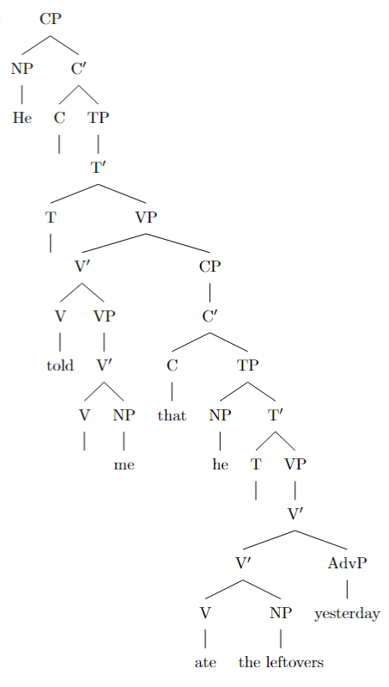

**Explanation**:

- The **AdvP "yesterday"** is attached to the embedded **V'** node that contains the verb **"ate"**, indicating it modifies the embedded verb.
- The main verb phrase **"told me"** does not include **"yesterday"** as an adjunct in this parse.

---

**Notes on the Trees**:

- **CP (Complementizer Phrase)**: Represents the entire sentence, possibly introduced by a complementizer like "that".
- **TP (Tense Phrase)**: Contains the tense and the main VP (Verb Phrase).
- **VP (Verb Phrase)**: Contains the verb and its complements.
- **V' (V-bar)** and **T' (T-bar)**: Intermediate projection levels in X-bar theory accommodating adjuncts like adverbs.
- **AdvP (Adverb Phrase)**: Represents adverbial phrases like "yesterday".
- Empty categories like **[\,]** represent implicit elements (e.g., an implied "that" in the main clause).

**Rendering the Trees**:

To render these trees in LaTeX, make sure to include the `forest` package and set the appropriate styles for X-bar notation. Here's how you can set up your LaTeX document:

```latex
\documentclass{article}
\usepackage{forest}
\useforestlibrary{linguistics}
\usetikzlibrary{positioning}
\forestset{
default preamble={
for tree={
align=center,
grow'=0,
child anchor=west,
parent anchor=south,
anchor=west,
calign=child edge,
inner sep=1pt,
l=0pt,
},
edge={line width=0.5pt},
where level=0{}{level distance=2\baselineskip},
}
}
\begin{document}
% Insert the tree code here
\end{document}
```

Place each tree code inside the `document` environment where indicated.

---

By carefully positioning **"yesterday"** in the syntactic trees, we capture the two possible interpretations of the sentence, illustrating the syntactic ambiguity arising from different attachment of the adverbial phrase.

amb_28.txt o1-preview-2024-09-12 temperature=1.0
PROMPT: Consider the sentence below. Is it syntactically ambiguous? If so, provide code for syntactic trees representing each possible parse of the sentence that can be rendered with LaTeX's forest package. Assume X-bar theory.
"He dreamed that he'd shown up to school late the day of a test."
REPLY: Yes, the sentence "He dreamed that he'd shown up to school late the day of a test." is syntactically ambiguous. The ambiguity lies in the attachment of the adverb "late" and the temporal phrase "the day of a test." There are two possible interpretations:

1. **First Interpretation**: "Late" modifies "shown up." Here, "late" is an adverb indicating that he arrived tardily. "The day of a test" is an additional temporal adjunct specifying when he showed up.

2. **Second Interpretation**: "Late the day of a test" forms a single temporal adverbial phrase that modifies "shown up to school." In this case, "late" combines with "the day of a test" to indicate he showed up late in the day on the day of a test.

Below are the syntactic trees for each interpretation, using LaTeX's forest package and assuming X-bar theory.

---

**First Interpretation Tree** (Adverb "late" modifies "shown up"):

```latex
\begin{forest}
[S
[NP [He]]
[VP
[V'
[V [dreamed]]
[CP
[C'
[C [that]]
[TP
[NP [he]]
[T'
[T [had]]
[VP
[V'
[V [shown up]]
[PP [P [to]][NP [school]]]
[AdvP [late]]
]
[AdvP [the day of a test]]
]
]
]
]
]
]
]
]
\end{forest}
```
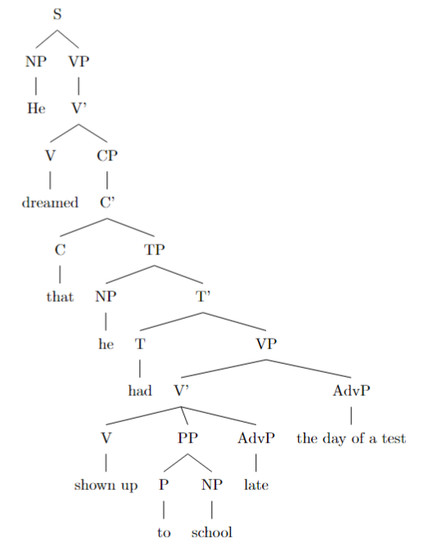

**Second Interpretation Tree** (Adverbial phrase "late the day of a test" modifies "shown up to school"):

```latex
\begin{forest}
[S
[NP [He]]
[VP
[V'
[V [dreamed]]
[CP
[C'
[C [that]]
[TP
[NP [he]]
[T'
[T [had]]
[VP
[V'
[V [shown up]]
[PP [P [to]][NP [school]]]
]
[AdvP [late the day of a test]]
]
]
]
]
]
]
]
]
\end{forest}
```

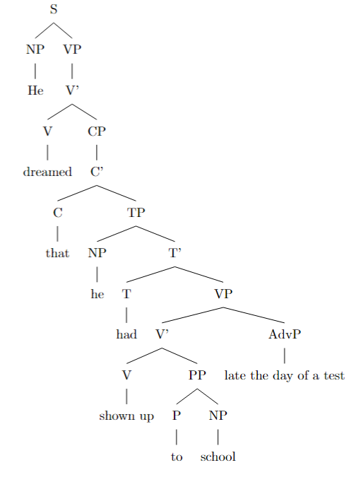

---

In the **first tree**, "late" is an adverbial phrase (AdvP) modifying the verb phrase (VP) "shown up to school," indicating that the action happened tardily. The temporal phrase "the day of a test" is a separate AdvP, providing additional information about when the action occurred.

In the **second tree**, "late the day of a test" is a single AdvP attached to the VP "shown up to school." This phrase collectively specifies the timing of the action, implying that he showed up late in the day on the day of a test.

These trees reflect the syntactic ambiguity in the sentence based on the different attachments of "late" and "the day of a test" within the structure of the sentence.

amb_29.txt o1-preview-2024-09-12 temperature=1.0
PROMPT: Consider the sentence below. Is it syntactically ambiguous? If so, provide code for syntactic trees representing each possible parse of the sentence that can be rendered with LaTeX's forest package. Assume X-bar theory.
"I knew I wanted to speak to my lawyer but she was away from the phone."
REPLY: Yes, the sentence is syntactically ambiguous. The ambiguity arises from the attachment of the coordinating conjunction "but" and whether the clause "but she was away from the phone" is part of the complement of "knew" or conjoined at a higher level. Below are the syntactic trees for each possible parse, represented with LaTeX's `forest` package, assuming X-bar theory.

**Option 1: "But she was away from the phone" is within the complement of "knew".**

In this parse, the clause "but she was away from the phone" is attached inside the complement clause of "knew". The coordinating conjunction "but" connects two VPs within the embedded clause.

```latex
\begin{forest}
[S
[NP [I]]
[VP
[V [knew]]
[CP
[C$'$
[C [\emph{null}]]
[TP
[NP [I]]
[T$'$
[T [wanted]]
[VP
[VP [V$'$ [V [to speak to my lawyer]]]]
[ConjP
[Conj [but]]
[VP [V$'$ [V [she was away from the phone]]]]
]
]
]
]
]
]
]
]
\end{forest}
```
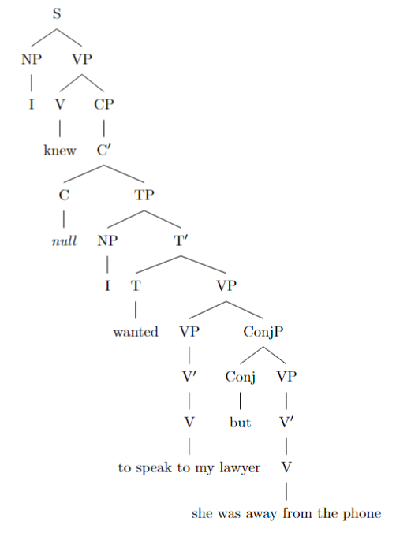

**Option 2: "But she was away from the phone" is at the level of the main clause.**

In this parse, the clause "but she was away from the phone" is conjoined with the main clause "I knew I wanted to speak to my lawyer" at the highest level. The coordinating conjunction "but" connects two S nodes.

```latex
\begin{forest}
[ConjP
[S
[NP [I]]
[VP
[V [knew]]
[CP
[C$'$
[C [\emph{null}]]
[TP
[NP [I]]
[T$'$
[T [wanted]]
[VP [V$'$ [V [to speak to my lawyer]]]]
]
]
]
]
]
]
[ConjP
[Conj [but]]
[S
[NP [she]]
[VP [V$'$ [V [was away from the phone]]]]
]
]
]
\end{forest}
```

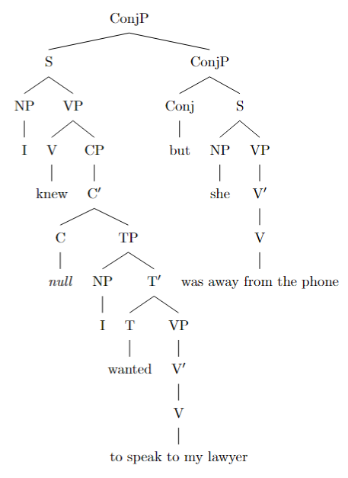

**Explanation:**

- **Option 1** interprets "but she was away from the phone" as part of the complement clause of "knew". Here, "but" connects two verb phrases (VPs) within the embedded clause.

- **Option 2** interprets "but she was away from the phone" as a separate clause coordinated at the main clause level. Here, "but" connects two sentences (Ss), the entire main clause and the additional clause.

These trees reflect the structural ambiguity in the sentence, showing two different hierarchical organizations according to X-bar theory.

amb_30.txt o1-preview-2024-09-12 temperature=1.0
PROMPT: Consider the sentence below. Is it syntactically ambiguous? If so, provide code for syntactic trees representing each possible parse of the sentence that can be rendered with LaTeX's forest package. Assume X-bar theory.
"Francisco believed his peers were idiots and they resented him."
REPLY: Yes, the sentence is syntactically ambiguous. The ambiguity arises from the attachment of the conjunction "and" either within the complement clause of "believed" or at the level of the main clauses. In the first interpretation, "and" coordinates two embedded clauses inside Francisco's belief (he believes both that his peers were idiots **and** that they resented him). In the second interpretation, "and" coordinates two main clauses: the clause about Francisco's belief and the clause about his peers resenting him.

Below are the syntactic trees representing each possible parse, using LaTeX's `forest` package and assuming X-bar theory.

**First interpretation** (coordination within the complement of "believed"):

```latex
\documentclass{article}
\usepackage{forest}

\begin{document}

% Tree for the first interpretation
\begin{forest}
[IP
[NP [Francisco]]
[I$'$
[I [believed]]
[CP
[CP
[C$'$
[C [\textit{that}]]
[IP [his peers were idiots]]
]
]
[ConjP
[Conj [and]]
[CP
[C$'$
[C [\textit{that}]]
[IP [they resented him]]
]
]
]
]
]
]
\end{forest}

\end{document}
```

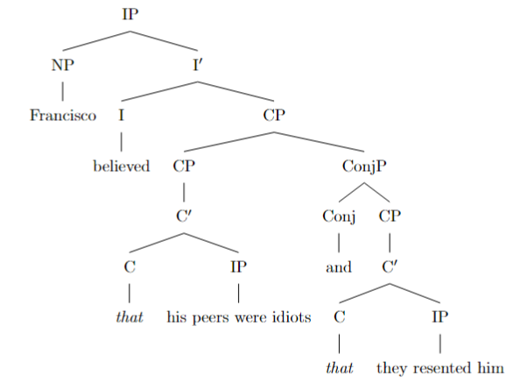

**Second interpretation** (coordination at the level of main clauses):

```latex
\documentclass{article}
\usepackage{forest}

\begin{document}

% Tree for the second interpretation
\begin{forest}
[Coordinated IP
[IP
[NP [Francisco]]
[I$'$
[I [believed]]
[CP
[C$'$
[C [\textit{that}]]
[IP [his peers were idiots]]
]
]
]
]
[ConjP
[Conj [and]]
[IP
[NP [they]]
[I$'$
[I [resented]]
[NP [him]]
]
]
]
]
\end{forest}

\end{document}
```

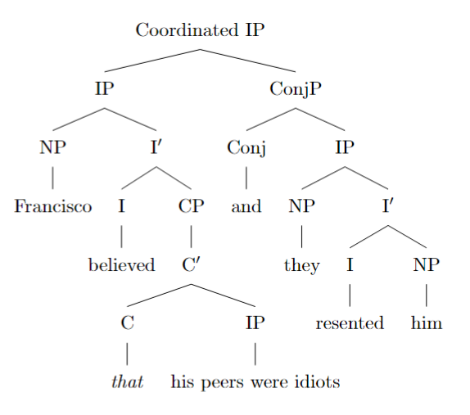

**Explanation**:

- In the **first interpretation**, the verb "believed" takes a single complement clause (CP) that includes a coordination of two embedded clauses. The conjunction "and" connects two CPs within the complement of "believed".

- In the **second interpretation**, the conjunction "and" connects two independent clauses at the IP (Inflectional Phrase) level. The first IP is "Francisco believed his peers were idiots," and the second IP is "they resented him."

By representing both structures, we illustrate the syntactic ambiguity of the sentence.

Messages generated with 97403 tokens

